Asia-Pacific Telecommunity

APT Report on

Introduction to Green ICT Activities

APT/ASTAP/REPT 1

Edition: October 2011

Adopted by
The 19th ASTAP Forum (ASTAP-19)
24-26 October 2011, Manila, Philippines
Source: ASTAP-19/OUT-09

Table of Contents

1. Scope ................................................................................................................................................. 4
2. Terms and Definitions ....................................................................................................................... 4
3. Important Role of ICT to Counter Climate Change .......................................................................... 6
3.1. Assessment of the environmental impacts of ICT............................................................................. 8
4. Related National Policies and Plans .................................................................................................. 8
4.1. Green Innovation of Japan ................................................................................................................ 8
4.1.1.1. Using ICT to reduce environmental burden (Green by ICT)................................................. 8
4.1.1.2. Improving the environmental performance of ICT itself (Green of ICT) ............................. 9
4.1.2. Effect of Green ICT on CO2 Reductions .................................................................................. 9
4.2. Green Growth Strategy of Korea..................................................................................................... 10
4.2.1. Background .................................................................................................................................. 10
4.2.2. Korea‘ Five Years National Green Growth Strategy ................................................................... 10
4.2.3. Korea‘s Five Years Green ICT Strategy ...................................................................................... 11
4.2.3.1. Green of ICT ............................................................................................................................. 11
4.2.3.2. Green by ICT............................................................................................................................. 12
4.2.4. Expected Result of Green ICT in Korea ...................................................................................... 13
4.3. Government Administration Policy of Thailand ............................................................................. 13
4.4. Malaysia‘s National Green Technology Policy............................................................................... 13
5. Related International Activities ....................................................................................................... 14
5.1. Activities in SDOs ........................................................................................................................... 14
5.1.1. ITU .......................................................................................................................................... 14
5.1.1.1. ITU-R ................................................................................................................................... 14
5.1.1.2. ITU-D................................................................................................................................... 15
5.1.1.3. ITU-T ................................................................................................................................... 15
5.1.1.4. Other related groups............................................................................................................. 18
5.1.2. ISO........................................................................................................................................... 19
5.1.2.1. ISO TC 207 .......................................................................................................................... 19
5.1.2.2. ISO TC 242 .......................................................................................................................... 24
5.1.3. IEC........................................................................................................................................... 24
5.1.3.1. IEC TC 100 .......................................................................................................................... 24
5.1.3.2. IEC TC 108 .......................................................................................................................... 25
5.1.3.3. IEC TC 111 .......................................................................................................................... 25
5.1.4. ISO/IEC JTC 1 ........................................................................................................................ 26
5.1.4.1. ISO/IEC JTC 1 SWG on Planning....................................................................................... 26
5.1.4.2. ISO/IEC JTC 1 Study Group on Green ICT ........................................................................ 27
5.1.4.3. ISO/IEC JTC 1 Study Group on Energy Efficiency of Data Centers .................................. 28
5.1.4.4. ISO/IEC JTC 1 Special Working Group on Smart Grid...................................................... 29
5.1.5. ETSI......................................................................................................................................... 30
5.1.6. ATIS ........................................................................................................................................ 31
5.1.7. Ecma International .................................................................................................................. 32
5.1.8. GHG Protocol Initiative .......................................................................................................... 33
5.1.9. BSI ........................................................................................................................................... 33
5.2. Activities in Non-Standard Bodies .................................................................................................. 34

5.2.1. OECD ...................................................................................................................................... 34
5.2.2. WWF ....................................................................................................................................... 35
5.2.3. SMART 2020 .......................................................................................................................... 36
5.2.4. AIM Project ............................................................................................................................. 37
5.2.5. EC-JRC handbooks ................................................................................................................. 38
6. Standards map of environmental impact assessment methodologies .............................................. 39
7. Performance Indicators.................................................................................................................... 41
7.1. Data Center Performance Indicator ................................................................................................. 41
7.1.1. Data Center Operators ............................................................................................................. 41
7.1.2. Datacenter Performance Per Energy ....................................................................................... 44
7.1.3. ASP/SaaS Operators ................................................................................................................ 45
8. Use Cases of Green ICT .................................................................................................................. 45
8.1. Case #1: Teleworking...................................................................................................................... 45
8.1.1. Teleworking............................................................................................................................. 45
8.1.1.1. Objective of experiment....................................................................................................... 46
8.1.1.2. Functional unit ..................................................................................................................... 46
8.1.1.3. System boundary.................................................................................................................. 46
8.1.1.4. Results of the evaluation ...................................................................................................... 46
8.2. Case #2: Plant Farm ........................................................................................................................ 48
8.3. Case #3: Green BTS Energy and Equipment and Green Office ..................................................... 49
8.4. Case #4: Green Data Centers........................................................................................................... 51
8.4.1. Basis Bay Green Data Center Initiatives ................................................................................. 51
8.4.2. Basis Bay Green Data Center Design...................................................................................... 51
8.5. Case #5: E-health............................................................................................................................. 53
8.5.1. E-health – life cycle assessment of ICT enablement potential ................................................ 53
8.5.1.1. Objective .............................................................................................................................. 53
8.5.1.2. Scope.................................................................................................................................... 53
8.5.1.3. Result ................................................................................................................................... 54
8.6. Case #6: Mobile money................................................................................................................... 55
8.6.1. Mobile money Kenya – life cycle assessment of ICT enablement potential .......................... 55
8.6.2. Objective ................................................................................................................................. 55
8.6.3. Scope ....................................................................................................................................... 55
8.6.4. Result ....................................................................................................................................... 56
9. Reference Documents List .............................................................................................................. 57

1. Scope

This White Paper aims at providing information on:

• Impacts of ICT in mitigation of the Climate Change problems;
• National policies to deploy and promote Green ICT activities;
• Green ICT activities of various SDOs, consortia and fora;
• Performance indicators to facilitate Green ICT; and
• Green ICT use cases to reduce energy consumption and improve energy efficiency.

This document intends to help Green ICT stakeholders such as government, SDOs, companies, and
R/D engineers understand current status on Green ICT deployment and standardization activities.

2. Terms and Definitions

This document uses the following terms defined elsewhere:

• Accreditation: third-party attestation related to a validation or verification body conveying formal demonstration of its competence to carry out specific validation or verification tasks [ISO 14065]
• Baseline scenario: hypothetical reference case that best represents the conditions most likely to occur in the absence of a proposed GHG project [ISO 14064-2]
• Carbon dioxide equivalent, CO2e: a quantity that describes, for a given mixture and amount of greenhouse gas, the amount of CO2 that would have the same Global Warming Potential (GWP), when measured over a specified timescale (generally, 100 years).
• Environmental aspect: element of an organization's activities, products or services that can interact with the environment [ISO 14040]
• Environmental declaration or environmental label: claim which indicates the environmental aspects of a product or service [ISO 14025]
• Environmental impact: any change to the environment, whether adverse or beneficial, wholly or partially resulting from an organization's environmental aspects [ISO 14001]
• Facility: single installation, set of installations or production processes (stationary or mobile), which can be defined within a single geographical boundary, organizational unit or production process [ISO 14064-1]
• GHG: gaseous constituent of the atmosphere, both natural and anthropogenic, that absorbs and emits radiation at specific wavelengths within the spectrum of infrared radiation emitted by the
Earth's surface, the atmosphere, and clouds. [Note] GHGs include carbon dioxide (CO2), methane (CH4), nitrous oxide (N2O), hydrofluorocarbons (HFCs), perfluorocarbons (PFCs) and sulfur hexafluoride (SF6). [ISO 14064-1]
• GHG assertion: declaration or factual and objective statement made by the responsible party
[ISO 14064-1]
• GHG emission: total mass of a GHG released to the atmosphere over a specified period of time [ISO 14064-1]
• GHG project: activity or activities that alter the conditions identified in the baseline scenario which cause GHG emission reductions or GHG removal enhancements [ISO 14064-1]
• GHG removal: total mass of a GHG removed from the atmosphere over a specified period of time [ISO 14064-1]

• Life cycle: consecutive and interlinked stages of a product system, from raw material acquisition or generation from natural resources to final disposal [ISO 14040]
• Organization: company, corporation, firm, enterprise, authority or institution, or part or combination thereof, whether incorporated or not, public or private, that has its own functions and administration [ISO 14064-1]
• PCR: set of specific rules, requirements and guidelines for developing Type III environmental declarations for one or more product categories [ISO 14025]
• Product: any goods or service [Note 1] The product can be categorized as follows: services (e.g. transport); software (e.g. computer program, dictionary); hardware (e.g. engine mechanical part); and processed materials (e.g. lubricant). [Note 2] Services have tangible and intangible elements. Provision of a service can involve, for example, the following: an activity performed on a customer-supplied tangible product (e.g. automobile to be repaired); an activity performed on a customer-supplied intangible product (e.g. the income statement needed to prepare a tax return); the delivery of an intangible product (e.g. the delivery of information in the context of knowledge transmission); and the creation of ambience for the customer (e.g. in hotels and restaurants). Software consists of information and is generally intangible and can be in the form of approaches, transactions or procedures. Hardware is generally tangible and its amount is a countable characteristic. Processed materials are generally tangible and their amount is a continuous characteristic. [ISO 14040]
• Product category: group of products that can fulfill equivalent functions [ISO 14025]
• Responsible party: person or persons responsible for the provision of the GHG assertion and the supporting GHG information [ISO 14064-1]
• Self-declared environmental claim: environmental claim that is made, without independent third-party certification, by manufacturers, importers, distributors, retailers or anyone else likely to benefit from such a claim [ISO 14021]
• Type III environmental declaration: environmental declaration providing quantified environmental data using predetermined parameters and, where relevant, additional environmental information [ISO 14025]
• Type III environmental declaration programme: voluntary programme for the development and use of Type III environmental declarations, based on a set of operating rules [ISO 14025]
• Validation: systematic, independent and documented process for the evaluation of a GHG
assertion in a GHG project plan against agreed validation criteria [ISO 14064-1]
• Verification: systematic, independent and documented process for the evaluation of a GHG
assertion against agreed verification criteria [ISO 14064-1]
• Validation body: body that performs validations of GHG assertions in accordance with ISO
14065 [ISO 14065]
• verification body: body that performs verifications of GHG assertions in accordance with ISO
14065 [ISO 14065]

This document defines the following terms:

• Carbon footprint: GHG emission total during the life cycle of a product [Note 1] This terminology is being defined by ISO/WD 14067-1 of which initial definition is “parameter by which greenhouse gas emissions of a process, a system of processes or a product system is quantified in order to indicate their contribution to climate change.” [Note 2] A carbon footprint result should not be included in the GHG accounting for organizations and GHG projects. Because the carbon footprint assessment covers the life cycle of a product but the GHG accounting does not cover such life cycle but assess all relevant activities in a yearly basis within the boundaries of an organization and GHG project.
• Green data center: is an energy efficiency-improved data center.
• Green ICT: consists of the Green of ICT and the Green by ICT.
• Green of ICT: means the environmental protection activity of the ICT sector with

incorporating avoidance of the use of hazardous materials, recycling of defunct ICT products and ICT wastes, and maximization of energy efficiency into the ICT industry.
• Green by ICT: means the environmental protection activity of other business sectors with utilizing ICT technologies and products.

3. Important Role of ICT to Counter Climate Change

The greenhouse gas emissions‘ growth, caused by increasing energy consumptions, is the well- known critical reason to climate change. To counter climate change, the Green ICT is concerned.
The amount of a country‘s total energy consumption is tremendously; for example, Cook Islands, Korea, Japan, and Indonesia consumed 55,075 TOE in 2006, 18,290 kTOE, 351,724 kTOE, and
124,400 kTOE in 2008, respectively. Furthermore, the amount of the total electricity energy consumption per year (MWh/year) of Korea, Japan, and Indonesia in 2008 is 106,754,000 MWh/year,
964,000,000 MWh/year, and 128,720 MWh/year, respectively. In 2003, Cook Islands consumed
24,826 MWh/year. Moreover, the baseline CO2 emissions of Indonesia in 2005 are estimated as 2.1
GtCO2e. It is expected to be grown by 1.9 percent annually, reaching to 2.5 GtCO2e in 2020 and 3.3
GtCO2e in 2030 in Indonesia. Hence, Indonesia has the total reduction potential of 2.3 GtCO2e, approximately 70% of its projected business as usual emissions such as 3.2 GtCO2e in 2030.
The energy consumption and electricity energy consumption are expected to be increased with respect to population. For instance, the population of Korea, Macau, and Indonesia is 48,875 thousand,
550 thousand, and 238,000 thousand in 2010, respectively. In 2008, the population of Japan is 127,700 thousand. In the middle of 2009, there are 24,000 people in Cook Islands.
Meanwhile, the target GHG reduction of Korea, Japan, and Cook Islands is 30% of Business-As- Usual (BAU) from 2005, 25% of the amount of GHG emission in 1990, and 50% of that in 1990 in
2020, respectively. In 2050, the target GHG reduction of Korea is 50% of BAU and that of Japan is
80% of the amount of GHG emission in 2005. However, the amount of target GHG emissions of
Korea is 569 MtCO2e in 2020. Korea, Japan, and Cook Islands expect 8.13 GtCO2e, 1.4 GtCO2e, and
84 tCO2e of GHG emissions in 2020, respectively. Japan and Cook Islands also expect 1.9 GtCO2e and 283 MtCO2e in 2050 with respect to the BAU scenario. In the case of Indonesia, it is expected to be increased from 1.72 in 2000 to 2.95 GtCO2e in 2020 even though the government has the GHG emission reduction scenario as 26%.
In 2008, total final energy consumption in Malaysia was 44,901 kTOE. The industrial sector was the biggest final energy user at 18 667 kTOE, or 42.6% of total final energy consumption, Transport sector at 16,395 kTOE, or 36.9%, Commercial and residential sector at 6,205 kTOE, or 13.8% and Other sectors (agriculture, and non-energy) at 3,163 kTOE. Total electricity energy consumption for Malaysia in 2008 is 94,305,000 MWh/year. Malaysian population is 29,845,448 in 2010 with an average annual population growth rate of 2.17% for the 2000–2010 periods. Malaysia targets 40% reduction of GHG intensity of GDP from 2005 level by 2020.
Therefore, the Green of ICTs is the most significant target to save energy consumption and reduce ICT-sector GHG emissions [1]. The Green by ICTs can save more energy consumption and reduce GHG emissions. Hence, the ICT sector has a powerful role to play in tackling climate change by enabling other sectors, such as transport, buildings, power and industry, to become more efficient [2]. The Global eSustainability Initiative (GeSI) found that ICTs could reduce global carbon emissions by
7.8 GtCO2e by 2020 (from the assumed total amount of 51.9 GtCO2e if we remain on a BAU trajectory), which is five times larger than its own carbon footprint [3]. Savings from avoided electricity and fuel consumption would reach $946.5 billion, which shows that the opportunities of ICT can reduce GHG emissions in ICT sector [3].
The Green ICT is being considered from two viewpoints in its market: ―Green of ICTs‖ which means the environmental improvement of ICTs for themselves within the ICT sector, and ―Green by ICTs‖ which means the environmental improvement of other sectors by using ICT technologies and

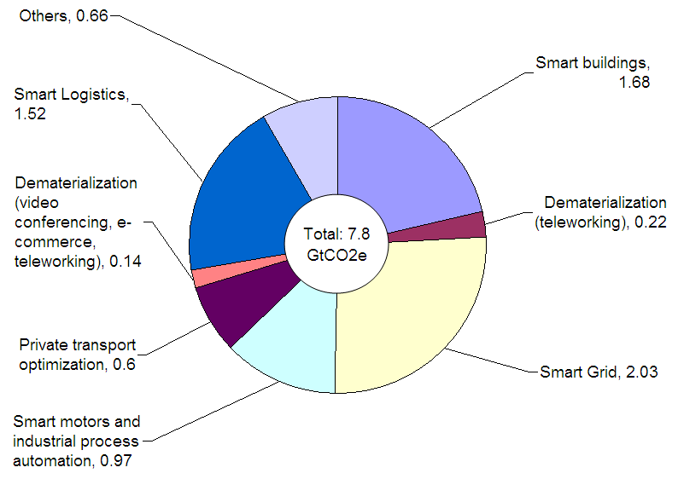
products where the environmental improvement is accomplished by the four green factors described below.

Figure 1 Possible ICT-enabled savings in GHG emissions 2020, GtCO2e

The ―Green‖ of ICTs covers four goals to protect the environment and abate ICT sector‘s own GHG
emissions such as [4]:

• Reducing the use of hazardous materials;
• Recycling defunct ICT products and ICT wastes;
• Reusing ICT products; and
• Maximizing energy efficiency.

The ―Green‖ by ICTs deals with how to bring ICT technologies and products into other business sectors for energy savings. Therefore, the Green ICT industry should care for all those four objectives by the Green of ICTs and the Green by ICTs.
The European Union (EU) has tackled the three environmental ICT targets since 2003 and forced relevant Directives. The Restriction of Hazardous Substances Directive (RoHS Directive, 2002/95/EC) restricts the use of six hazardous materials (i.e. Lead, Mercury, Cadmium, Hexavalent chromium (Cr6+), Polybrominated biphenyls (PBB), and Polybrominated diphenyl ether (PBDE)) in the manufacture of various types of electronic and electrical equipment. The Waste Electrical and Electronic Equipment Directive (WEEE Directive, 2002/96/EC) sets collection, recycling and recovery targets for all types of electrical goods and imposes the responsibility for the disposal of waste electrical and electronic equipment on the manufacturers of such equipment. The Energy using Products Directive (EuP Directive, 2005/32/EC) requires improvements in energy efficiency throughout a products lifecycle, from the mining of the raw material through to recycling of end-of- life. It is focused on the design phase since it is considered that the determining stage affects the resources used in a product. The EuP Directive does not apply to means of transport (planes, cars etc.), but which is apart from this, the scope is deliberately broad, covering, in principle, any product when in use depends on generating, transferring or measuring energy (electricity, fossil fuel or renewable).

3.1. Assessment of the environmental impacts of ICT

For assessing the environmental impact of ICT it is important to have a holistic approach throughout the whole life cycle of ICT goods, network and services. Life Cycle Assessment (LCA) is a cradle-to-grave approach and addresses the environmental aspects and potential environmental impacts throughout the whole life cycle from raw material acquisition, through production, use and end-of-life treatment. The ISO 14040 and ISO 14044 standards are acknowledged as the basic LCA standards, but there is work ongoing in both ITU-T SG5 Q18 and ETSI to provide supplementary methodology for evaluating the environmental impact of ICT. LCA is a powerful, systematic methodology which gives an understanding of the relative importance of the different life cycle stages. However, it is important to be aware that LCA is a model based assessment method and not a measurement method. The ISO 14040 clearly states that LCA addresses potential environmental impact and not predict absolute or precise environmental impacts. This is because the assessment results are based on assumptions, models and scenarios and there is inherited uncertainty in modeling environmental impacts.

4. Related National Policies and Plans

Many Asia-Pacific countries have national policies and plans on ICT and climate change.

4.1. Green Innovation of Japan
Importance of Green ICT Policies

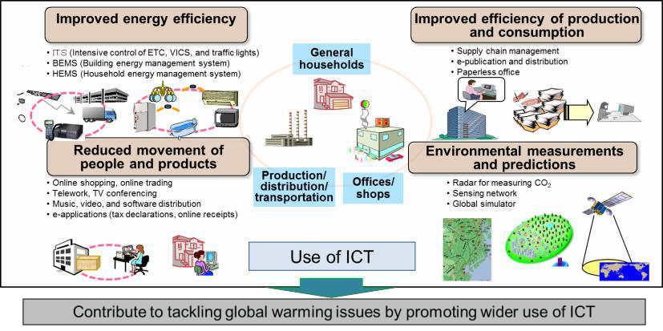
4.1.1.1. Using ICT to reduce environmental burden (Green by ICT)

Figure 2 Using ICT to reduce environmental load (Green by ICT)

In corporate and general household activities, ICT can be used to measure and forecast environmental information, as well as improving the efficiency of energy consumption, reducing the volume and elevating the efficiency of production and consumption of goods, and reducing the need for movement of people and products, all of which reduces the volume of CO2 emissions. Widespread

use of ICT throughout society, leading to such CO2 emission reductions, is known as ―using ICT to
reduce environmental load (Green by ICT)‖ as shown in Figure 2.
MIC, Japan is promoting pilot projects on teleworking, BEMS, HEMS, and smart grid to maximize positive effects of ICTs.

4.1.1.2. Improving the environmental performance of ICT itself (Green of ICT)

If the use of ICT to reduce environmental burden (Green by ICT) progresses, while CO2 emissions can be reduced drastically in the directly affected fields and sectors, the volume of data and traffic involved in environmental measurement and forecasting will increase above that of conventional methods, leading to an accelerating rise in power consumption and CO2 emissions from ICT itself. In addition, henceforth the wider use of cloud computing technology will lead to increasing centralization in data centers of information and communications facilities previously dispersed at individual companies. This could potentially lead to a rise in electric power consumption and CO2 emissions at these data centers (for lighting, heating and cooling, etc.). In order to resolve this state of affairs, it is necessary to build on technological innovations to reduce the electricity consumption and environmental burden of ICT itself (Green of ICT) and halt a potential rise in the volume of CO2 emissions.
MIC, Japan is conducting R&D (such as optical communication network technology), and demonstration experiments on ecological ICT equipment and data centers, and promoting cloud computing for reducing power consumption of ICT sector.

4.1.2. Effect of Green ICT on CO2 Reductions

In November 2009, the MIC, Japan inaugurated an ICT policy task force for a global era in order to investigate new ICT policies so as to contribute to find solutions to the various economic and social issues being faced by Japan and many other countries through the effective use of ICTs. In the division of this task force dedicated to investigating global issues, investigations are carried out so as to overcome the regional and global issues that are facing countries, such as environmental problems and medical care problems. From December 2009 through March 2010, a working group on environmental issues was held under the auspices of this division with the aim of promoting ―Green of ICT‖ and
―Green by ICT,‖ ICT-based ―green decentralization reform,‖ and international contributions, compromises and standardization efforts. This working group analyzed the impact of the ICT sector on climate change through 2020. In terms of the CO2 emissions reductions accompanying Green by ICT (use of ICT to reduce environmental burden), the implementation of various ICT-dependent measures such as introduction of smart grids, building energy management, paperless operations in a wide range of sectors, could potentially reduce emissions by up to 150 million tons by 2020 in Japan. This is equivalent to a 12.3% reduction in CO2 emissions compared to 1990 levels. As for the CO2 produced from the use of ICT itself, if no particular measures are taken, by 2020 the electricity consumption in various sectors and the continued society-wide penetration of ICT will have produced a major jump in emissions. However, if measures including research and development (R&D) and testing of optical fiber networks and technology for efficient use of frequency resources, more energy- efficient ICT devices and data centers, and promotion of the cloud paradigm are taken, it is possible to keep 2020 emissions more or less equivalent to 2012 levels. The net reduction in CO2 emissions through Green ICT thus comes to approximately 125 million tons (Figure 3), equivalent to around
10% of Japan‘s 1990 CO2 emissions.

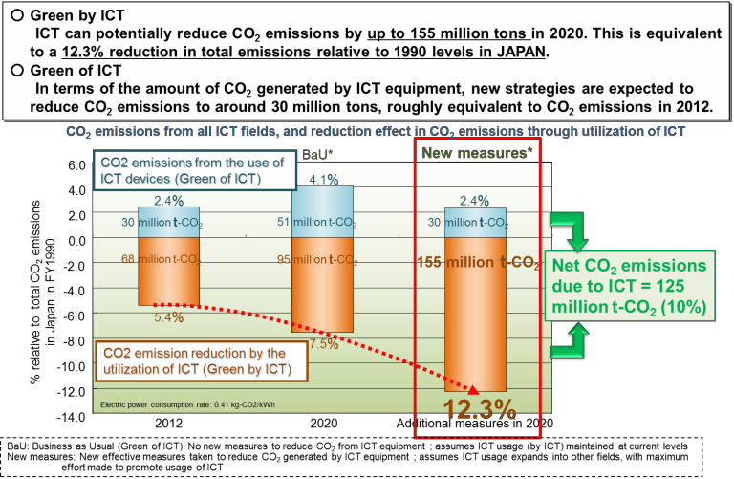

Figure 3 CO2 emissions reductions through Green ICT [Source: MIC taskforce]

4.2. Green Growth Strategy of Korea

4.2.1. Background

The president of Korea proclaimed ―Low Carbon Green Growth‖ as the Korea‘s new vision for next
60 years in August 2008. He also established Presidential Committee on Green Growth named as
―Green Growth Committee‖ in February 2008.

4.2.2. Korea’ Five Years National Green Growth Strategy

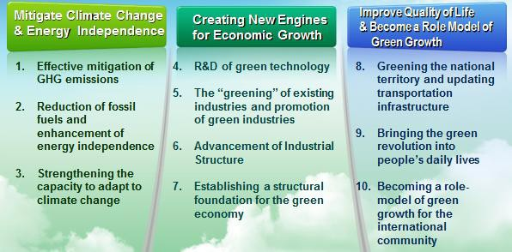
Figure 4 Korea’s Five Years National Green Growth Plan

Figure 4 shows the framework of Korea's Five Years National Green Growth Plan.
The plan has three objectives and 10 key policy items. The key policies are GHG mitigation, Green Technologies R&D, Evolution of Industrial Structure to low carbon, and so on. According to this plan, Korean government will invest 86 billion US$ until 2013.

4.2.3. Korea’s Five Years Green ICT Strategy

Figure 5 shows the framework of Korea's Five Years National Green Growth Plan.

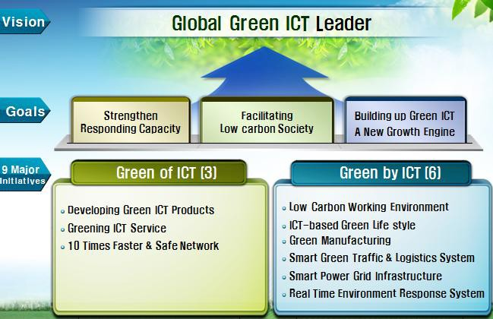
Figure 5 Korea’s Five Years Green ICT Plan

To be a green ICT leading country, Korean government set three policy goals and nine policies. Three policies are related to green of ICT and six policies are related to green by ICT.

4.2.3.1. Green of ICT

According to a research, ICT devices contribute to around 3% of Korea's CO2 emissions. It is a little bit higher percentage than the world average. Among ICT products, PCs, printers, servers and displays (including monitors and Digital TV) cover the major portion. Although power consumption of Printers is high, it is difficult to develop a low-power technology. So, printers are excluded. Korean government expects over 20% of energy reduction by developing low power, high efficient ICT devices. Internet data center (IDC) is a major electricity power hog and the power consumption of IDC doubles every five years. Electric power consumption of tele-communication is also increasing by
16% annually. To solve those problems, Korean government is trying to develop and deploy energy efficient servers and network technologies. By 2013, 40% of reducing the power consumption are expected to be reduced by green IDC and cloud computing. The demand for video conference and integrated information management for environment monitoring and disaster detection are expected to

be increased. To satisfy those demands, much faster and safer networks should be constructed. This network will fulfill 10 times faster speed and converge various communication networks.

4.2.3.2. Green by ICT

From the early 1990s, Korea‘s ICT sector has experienced rapid technological and industrial progress. However, the adoption of tele-working in Korea is very low at just about 1 %. Energy savings rate by green buildings is 8% which falls behind developed countries. Korean government is trying to adopt Green ICT to develop and expand ICT-based energy efficient working environment.
Green ICT can be utilized in schools, hospitals and home. High cost of private education is a major social problem in Korea because Korean parents want their children to get high quality of education. Therefore, Korean government tries to expand various ICT services to every aspect of life. Through those efforts, it is expected that 10% of cost for private education can be reduced by tele-education and
30% of hospital visits by u-health. Moreover, food wastes will be reduced by 20% through RFID based waste disposal management. Energy efficiency may be raised by 20% by home energy management system.
Korean government tries to build a green environment for industrial complexes and the manufacturing industry. Production related energy use is 57% of the total energy use in Korea, and
17% of industrial complexes are older than 20 years. Despite the high rate of awareness, the actual investments in green business are long way to go. Korean government will try to build up green manufacturing, green industrial complex and green business management by ICT.
Despite the wide use of traffic related systems such as telematics and navigation, the cost of traffic congestion is still over 2% of GDP. At major logistics points, ICT adoption level is still low and logistics‘ information is not shared. The primary concern regarding traffic and logistics is the effective and integrated information sharing among traffic and logistics related agencies. Therefore, after developing intelligent system of major logistics points; for example, ports, airports, railroad, etc., those systems will be connected by ICT solutions such as RFID ubiquitous technology.
In recent years, there has been a growing concern about Korea‘s electricity networks in order to
meet the demands of consumers. As a step toward Smart Grid, a pilot project has been progressed in Jeju Island. From public and private sectors, 170 organizations and companies are collaborating to implement smart grid system such as smart electricity, electronics, transportation, green car and communication. By this smart grid, it is expected that 6% of domestic electricity power consumption is conserved by 2030.
Korea also prepares to establish an aggressive preventive and response system. The Korean government still believes the information collected from the environment is very small both in quantitative and qualitative aspects. To solve this problem, sensor-based real time environment monitoring system is strengthened and an advanced disaster detection and response system are developed. Korea established a green certification system as the frame for energy saving. The certification system is categorized into green technology, green business, and green venture enterprise. In addition, Korea prepared a plan to develop an ultra-broadband green network in areas of broadcasting, communication, and convergence. Meanwhile, Korea makes an effort to implement green networks. By transforming to all-IP or optical-based environment, electrical power can be saved with the reduced communication base stations. It solves a coverage problem by solving technical problems. Korea also fulfills the Green IDC. It is minimizing the power loss occurring while transforming IDC infrastructure‘s electrical power system from AC to DC. Furthermore, more effectiveness will be available through the computing technology and other methods in place. The smart grid is developed to maximize energy efficiency. Currently, Jeju Island was designated as the test bed area. Korea has developed a greenhouse gas management system to save energy and is currently in the middle of an inventory system development project to verify it.

4.2.4. Expected Result of Green ICT in Korea

The expected results can be summarized into 5 areas as: (1) reduction of the energy consumption; (2) development of an environmental management system; (3) systemization of the lifestyle to practice energy savings; (4) establishment of a basis for green growth; and (5) creation of new jobs.

4.3. Government Administration Policy of Thailand

The Royal Thai Government recently adopted a Government Administration Policy which aimed, among others, Thailand to have a balanced and strong economic structure with a quality and sustainable economic growth
The Government, via its environmental policy, aims to bring Thailand into a low-carbon society, by promoting urban development and activities that are reducing Greenhouse Gas emissions, and by appropriate regulatory measures well-balanced between industrial development and environment protection.
The Government will promote and fully drive the concept of complete-cycle energy conservation, targeting the 25% reduction of energy consumption per productivity within 20 years. It also promotes exploitation of highly efficient products and buildings, and supports clean energy development mechanism to reduce GHG emissions and mitigate the effects of global warming. It will raise consumer awareness in saving energy consumption continuously and systematically, in all sectors including manufacturing, transportation and household.
In its economic policy, ICT is recognized to be one of the key contributing factor and the driving force in achieving those goals, both in ICT sector itself and in other related industrial sectors.
The Government will utilize ICTs to support those policy objectives by developing affordable, universal and good-quality ICTs broadband infrastructure to bring Thailand toward knowledge-based and innovative economy.
The Thailand Information and Communication Technology Policy Framework (2011-2020), the Second Thailand ICT Master Plan (2009-2013) and the National Broadband Policy will be further aligned to reflect the newly adopted Government Administration Policy as mentioned above.

4.4. Malaysia’s National Green Technology Policy

Malaysia launched National Green Technology Policy in 2009 predicated on four primary pillars of
Energy, Environment, Economy and Social perspective with five main objectives:

A. Decreasing growth of energy consumption while enhancing economic development;
B. Facilitating growth of the Green Technology industry and enhancing its contribution to the national economy;
C. Increasing national capability and capacity for innovation in Green Technology development and enhancing Malaysia‘s Green Technology competitiveness in the global arena;
D. Ensuring sustainable development and conserving the environment for future generations; and
E. Enhancing public education and awareness on Green Technology and encouraging its widespread use.

The policy is complemented by the National Waste Minimization Master Plan and Action Plan, National Strategic Plan for Solid Waste Management, Small Renewable Energy Power Programme (SREP) and Green Technology Financing Scheme.
Malaysia's Feed-In-Tariff (FIT) scheme is expected to come into effect in December 2011. The FIT
rates for photovoltaic starts at RM1.23 per kilowatt-hour (p/kWh) for installations of four kilowatts-

peak or less and RM0.85 p/kWh for installation greater than 10 megawatts (MW). Installations larger than 30 MW are not qualified for FITs.

5. Related International Activities

5.1. Activities in SDOs

5.1.1. ITU

UN has been dealing with the climate change issue since 1994 in UNFCC. UN secretary-general remarked like as “ITU is one of the most important stakeholders in terms of climate change (June
2007).” ITU started activity against the climate change issue since 2008 by publishing a special report of ―ICTs and Climate Change‖, which explained ―Role of ITU and UN‖ and ―Object to do in ITU‖ [5].
The main roles of ITU against the climate change are described as followings:

• ITU-R: Monitoring Climate Change
• ITU-D: Collaboration with other SDO
• ITU-T : Using ICT to mitigate the Climate Change effect

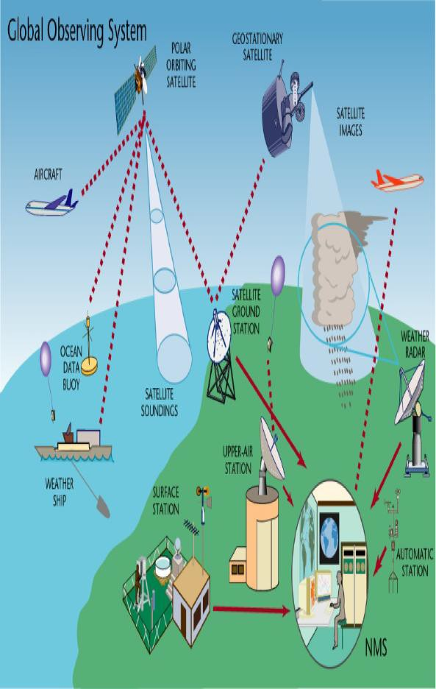
5.1.1.1. ITU-R

Figure 6 Global Observing System

The main directions of ITU-R are two categories:

• Monitoring climate change
- Using remote sensing applications (sensor equipment, wireless/wired networks …)
a. Subject: water management, air quality, pollution control, agriculture, fishing…

• Prediction & detection of disasters
- Analyzing data from the environment
- Giving early warning disaster to the authorities and the general public

ITU-R allocated additional spectrum for systems involved in disaster prediction/detection and emergency communications (WRC-07). The main standardizing work items are the call priority & alert message delivery. ITU-R also incorporates with WMO (World Meteorological Organization) for prediction & detection of disasters. Figure 6 explains the activities of ITU-R in summary [6].

5.1.1.2. ITU-D

The World Telecommunication Development Conference (Hyderabad, June 2010) accepted APT
common proposal as a RESOLUTION of WTDC-10.
ITU-D Study Group (SG) 2 studies “ ICT & Climate Change” according to RESOLUTION
[COM3/6] [7]. The first meeting of ITU-D SG2 was held in Geneva, September 13~17, 2010. The detailed work items will be discussed at that time.
The main RESOLUTION [COM3/6] [7] is shown in the below:

• Instructs the Telecommunication Development Advisory Group
- Changes to working methods such as the use of electronic means, virtual conferencing, teleworking, etc.
- For example, ITU Virtual International Symposium on ICTs and Climate Change (Co- organized by ITU and Korea Communications Commission (KCC) at the 2009 TSAG meeting).
• Instructs the Director of the Telecommunication Development Bureau
- Taking into account the needs of developing countries,
- Cooperating closely with the other two sectors & ITU-D SG 2 [8]

5.1.1.3. ITU-T

ITU-T SG5 is responsible for studies on methodologies for evaluating the ICT effects on the climate change and publishing guidelines for using ICTs in an eco-friendly way. Under its environmental mandate, SG5 is also responsible for studying design methodologies to reduce environmental effects; for example, recycling ICT facilities and equipment.
ITU-T SG5 consists of three Working Parties such as WP1, WP2 and WP3. The WP3 deals with those Green ICT matters and consists of seven Questions, Q.17, Q.18, Q.19, Q.20, Q.21, Q.22 and Q.23 as follows to develop ICT&CC standards [9]:

• Q 17/5 : Coordination and planning of ICT&CC related standardization
• Q 18/5 : Methodology of environmental impact assessment of ICT
• Q 19/5 : Power feeding systems
• Q 21/5 : Environmental protection and recycling of ICT equipment/facilities
• Q 22/5 : Setting up a low cost sustainable telecommunication infrastructure for rural communications in developing countries
• Q 23/5 : Using ICTs to enable countries to adapt to climate change

The first Recommendations of ITU-T SG5 WP3 was published on March 16, 2010 as ITU-T L.1000 (Universal power adapter and charger solution for mobile terminals and other ICT devices). It is for the universal power adapter solution for mobile phone (L.adapter of Q.21). The main purpose is to reduce the number of power adapters and chargers by using a universal adapter.

The second Recommendation is L.1400 (Overview and general principles of methodologies for assessing the environmental impact of ICTs) published on February 2011. ITU-T L.1400 presents the general principles on assessing the environmental impact of ICTs and outlines the different methodologies that are being developed:

• Assessment of the environmental impact of ICT goods, networks, and services
• Assessment of the environmental impact of ICT projects
• Assessment of the environmental impact of ICT in organisations
• Assessment of the environmental impact of ICT in cities
• Assessment of the environmental impact of ICT in countries or group of countries

Each Question of ITU-T SG5 WP3 is developing the following work items:

A. Q.17/5 activities

ITU-T Q.17/5 (coordination and planning of ICT&CC related standardization) is developing the following work items:

• L.M&M (energy efficiency metrics & measurement for telecom equipments): This work item contains the definition of energy efficiency metrics, related class-specific test procedures, methodologies and measurement profiles required to assess energy efficiencies for telecommunication equipments. Metrics and measurement methods are defined for wired broadband access, wireless access, transport, router, switch and mobile core network equipments. These metrics could allow comparisons among the equipment within the same class; comparison of metrics for the equipment in different classes is out of the scope of this work item.
• L.metric_infra (energy efficiency metrics for telecom infrastructure): This work has not started yet but only the work item is agreed.
• L.measure_infra (energy efficiency measurement for telecommunication infrastructure): Initially this work aims at supporting benchmarking current performance of greening data centers and determining their levels of maturity for greening data centers. The maturity model touches upon every aspect of the data center including building construction, power, cooling, compute, storage and network. This work may cover more specification items for energy efficiency of telecommunication infrastructure.
• L.DC (green data centers development best practices): This work item specifies methodologies aimed at realizing ―greener‖ data centers. The intention of the document is to provide a set of best practices for a correct conscious design of future data centers. These best practices and methodologies covers data center utilization, management and planning; ITC equipment and services; cooling; data center power equipment; and data center building. All these best practices have been numerated in order to represent an easy reference.
• Handbook_Metrics (metrics for data collection on energy efficiency): This work has not started yet but only the work item agreed.
• Handbook_Quest (questionnaires on topics of interest in order to collect energy efficiency related data on relevant network elements): This work has not started yet but only the work item agreed.
• Handbook_Analysis (handbook related to analysis of questionnaires issued previously and practical case studies on energy saving approaches): This work has not started yet but only the work item agreed.

B. Q.18/5 activities

ITU-T Q.18/5 (methodology of environmental impact assessment of ICT) is developing the following work items:

• L.methodology ICT goods, networks and services (methodology for environmental impact assessment of ICT goods, networks and services): This work item aims to provide supplementary methodology for evaluating the environmental impact of ICT goods, networks and services objectively and transparently, which is based upon the Life Cycle Assessment (LCA) that has been standardized in the ISO 14040 and ISO 14044. The purposes of this work item are to provide methodological framework on assessing environmental impact of ICT goods, networks and services for the whole lifecycle; to provide lifecycle inventory analysis procedures for ICT goods, networks and services with credibility; to provide how to interpret LCA studies on ICT goods, networks and services; and to provide how to report the results of LCA to facilitate communication fairly and transparently. For these purposes, ISO 14040 and ISO 14044 are recognized as normative references in this work. The first version of this Recommendation will focus on energy consumption and GHG emissions of ICT goods, network and services. Practitioners are however encouraged to also consider other environmental aspects in accordance with ISO 14040 and 14044.
• L.methodology ICT in organisations (methodology for environmental impact assessment of ICT within organisations): This work item will provide a methodology to assess energy consumption and GHG emissions of ICTs within organisations, over a certain period of time; for instance, one year. It will also provide a methodology to assess energy consumption and GHG emissions of ICT organisations, and guidance on how to report the assessed impact of ICT GHG mitigation or energy savings activities carried out or planned within an organisation.
• L.methodology ICT projects (methodology for environmental impact assessment of ICT projects): This work item specifies how to account for the amount of reduction and removal enhancements of energy consumption or GHG emissions from an ICT project which is defined as a GHG project using mainly ICT goods, networks and services, aiming at GHG emission reductions and GHG removal enhancements; or a project using mainly ICT goods, networks and services, aiming at energy consumption savings and energy efficiency improvements. Where GHG removal enhancement corresponds to quantified GHG removal achieved by an activity or set of activities intended for GHG capture and closure. The usage of ICT may result in some removals. This Recommendation specifies principles, concepts, requirements and methods with guidance for quantifying, monitoring and reporting GHG emission reductions or removal enhancements from an ICT project in compliance with ISO
14064-2:2006 (greenhouse gases — Part 2: Specification with guidance at the project level for quantification, monitoring and reporting of greenhouse gas emission reductions or removal enhancements).
• L.methodology ICT in cities (methodology for environmental impact assessment of ICTs within cities): This work provides a methodology which accounts for the positive and negative impacts of ICTs in cities. ICTs can be an important modulator of the overall GHG emissions attributable to a city.
• L.methodology ICT in countries (methodology for environmental impact assessment of ICTs within countries): Work scope - This work provides a method of GHG emission reporting which accounts for the positive and negative impacts of ICTs in countries or group of countries and aligns with relevant initiatives concerning GHG emissions. ICTs can be an important modulator of the overall GHG emissions attributable to a country.

C. Q.19/5 activities

ITU-T Q.19/5 (power feeding systems) is developing the following work items:

• L.specDC (specification of DC power feeding system interface): This work item deals with compatibility between the DC power supply and ICT equipment installed at telecommunications centers and data centers. The compatibility covers the requirements for the output of the power supply equipment and the input of the ICT equipment. Its normal voltage range of DC is from 240 V to 400 V.
• L.safePowerfeed (safety for humans and equipment of the power feeding system): This work has not started yet but only the work item agreed.
• L.architecture (system configuration, architecture, and cable distribution including feeding, lightning protection, EMC, earthing, and bonding of the power feeding system): This work has not started yet but only the work item agreed.
• L.performance (methodologies for evaluating the performance of energy feeding and its environmental impact): This work has not started yet but only the work item agreed.

D. Q.21/5 activities

ITU-T Q.21/5 (environmental protection and recycling of ICT equipment/facilities) is developing the following work items:

• L.1000-revision (universal power adapter and charger solution for mobile terminals and other ICT devices): This work item was initiated by telecom service providers representing GeSI (Global e-Sustainability Initiative) to request three key features: Micro USB interface, minimum 1000 mA output current and detachable cable.
• L.adapter Phase2 (phase 2 of L.1000): This work item aims at providing standardized power adapters for other ICT devices such as MP3 players, navigation terminals, and laptop computers. IEC TC 100 also started a similar work dedicated to laptop computers. Both groups agreed to collaborate on the development work.
• L.rareMetals (communication formats for recycling information of rare metals in ICT products): This work item specifies a method to provide recycling information of rare metals contained in ICT goods. It explains some introduction of rare metals and importance of rare metal recycling, recycling procedure for rare metal recycling, and communication format for providing recycling information of rare metals in ICT goods.

E. Q.22/5 and Q.23 activities

ITU-T Q.22/5 (setting up a low cost sustainable telecommunication infrastructure for rural communications in developing countries) and Q.23/5 (using ICTs to enable countries to adapt to climate change) were established at the November 2010 meeting of ITU-T SG5 and these new Questions were endorsed by ITU-T TSAG (Telecommunication Standardization Advisory Group) in its February 2011 meeting.

5.1.1.4. Other related groups

A. Cloud computing (ITU-T Focus Group)

ITU-T established the focus group of ―cloud computing‖ (February 11, 2010 in accordance with Recommendation ITU-T A.7) in the need for new levels of flexibility in networks & accommodate unforeseen and elastic demands. It is expected that the cloud computing offers several key benefits in the view of energy saving because of fast/simple deployment. For this reason, many enterprises, governments and network/service providers in the world are now considering to adopt the cloud computing into their services in order to provide more efficient and cost effective network services [10].

The first meeting was held on June 14~16, 2010 in Geneva. There are one chairperson (Russia) and five vice-chairpersons (France, Korea, China, USA, and Japan) with the following two working groups:

• WG1: Cloud computing benefits & requirements
- Definition, Use cases, Cloud security, Networks, Middleware
• WG2: Gap Analysis and Roadmap on Cloud Computing Standards development in ITU-T
- Overview of other SDOs, Gap analysis & Action Plan for development

B. Smart grid (ITU-T Focus Group)

ITU-T established the focus group of ―smart grid‖ (February 11, 2010 in accordance with Recommendation ITU-T A.7) in the need for efficient uses of energy and energy saving/monitoring. Smart grid may use not only current ICTs but also electric power technology for control, metering and charging etc. The focus group will involve interaction with these various research activities [11].
The first meeting was held on June 14~16, 2010 in Geneva. There are one chairperson (Germany)
and four vice-chairpersons (Korea, China, USA, and Japan).
The objectives are to make document results about:

• Vision & value proposition of smart gird
• Terminology, requirements,
• Use cases and roadmap to guide further development.

5.1.2. ISO

5.1.2.1. ISO TC 207

ISO TC 207 was formed in 1993 and covers standardization in the field of environmental management tools and systems. It is the umbrella committee under which the ISO 14000 series of environmental management standards are being developed.
The ICT sector may need to refer to the following types of International Standards of ISO TC 207:

• Environmental labels and declarations: the ICT sector has a variety of ICT products; e.g., laptop computers, modems, set-top boxes, facsimiles, cell phones, smart phones, and routers/switches. One single specification cannot cover every type of ICT products. ISO
14025 provides a guidance to develop a category-specific documentation for the environmental assessment.
• LCA: the ICT sector has to refer to the relevant standards for assessment of environmental impacts of ICT products according to their life cycle phases.
• Greenhouse gases: the ICT sector has to refer to the relevant standards to account for GHG emissions and reductions, and energy consumption made by ICT organizations and ICT products.

A. Standards status on the environmental labels and declarations

The following International Standards have already been published:

• ISO 14020:2000 (―Environmental labels and declarations – general principles‖) defines guiding principles for the development and use of environmental labels and declarations. It is intended that other applicable standards in the ISO 14020 series be used in conjunction with this international standard. It is not intended for use as a specification for certification and registration purposes. Here are some example principles: Principle 1 – ―Environmental

labels and declarations shall be accurate, verifiable, relevant and not misleading‖, Principle
2 – ―Procedures and requirements for environmental labels and declarations shall not be prepared, adopted, or applied with a view to, or with the effect of, creating unnecessary obstacles to international trade‖, and Principle 3 – ―Environmental labels and declarations shall be based on scientific methodology that is sufficiently thorough and comprehensive to support the claim and that produces results that are accurate and reproducible.‖
• ISO 14021:1999 (―Environmental labels and declarations – self-declared environmental claims (Type II environmental labeling)‖) specifies requirements for self-declared environmental claims, including statements, symbols and graphics, regarding products. It further describes selected terms commonly used in environmental claims and gives qualifications for their use. This international standard also describes a general evaluation and verification methodology for self-declared environmental claims and specific evaluation and verification methods for the selected claims in this standard. Self-declared environmental claims may be made by manufacturers, importers, distributors, retailers or anyone else likely to benefit from such claims. Environmental claims made in regard to products may take the form of statements, symbols or graphics on product or package labels, or in product literature, technical bulletins, advertising, publicity, telemarketing, as well as digital or electronic media, such as the Internet.
• ISO 14024:1999 (―Environmental labels and declarations – Type I environmental labeling – Principles and procedures‖) establishes the principles and procedures for developing Type I environmental labeling programmes, including the selection of product categories, product environmental criteria and product function characteristics, and for assessing and demonstrating compliance. This international standard also establishes the certification procedures for awarding the label. Type I labels are awarded to products by a third party – either government or private. Products meeting a set of predetermined criteria earn the label. Criteria are established for distinct product categories by the labeling body and deal with multiple environmental aspects of the product. These labels are sometimes directed at specific types of products, such as the Environmental Choice 1 label for paints and surface coatings, or Energy Star for lighting and appliances. These labels indicate that a product is environmentally preferable, in order to increase the demand for environmentally preferable products. These labels are usually represented by a logo on the product or product packaging.
• ISO 14025:2006 (―Environmental labels and declarations – Type III environmental declarations – principles and procedures‖) establishes the principles and specifies the procedures for developing Type III environmental declaration programmes and Type III environmental declarations. Type III environmental product declarations provide environmental data about a product. These declarations are produced by the organization making the product, and are often certified by a third party. They usually take the form of brochures, rather than a simple label or logo. The declaration is typically based on a life cycle study with the use of ISO 14040 and 14044. The declaration contains quantified data from various life cycle stages of the product, including material extraction, production, transportation, use and end-of-life disposal or recycling. The declaration may also contain qualitative data about the product and the organization. Type III declarations allow consumers to compare products based on all of their environmental impacts and make their own decision about which product is preferable. Competition among organizations on environmental grounds is encouraged by this kind of declaration.

[Note] The ICT sector may refer to ISO 14025 because this standard covers a life cycle for an ICT product and can account for the GHG emission total of the ICT product. But ISO 14025 is a business sector-neutral standard and the ICT sector needs a sector-specific information to incorporate the standard which defines ―Product Category Rules (PCR)‖ for this purpose. The PCR means set of specific rules, requirements and guidelines for developing Type III environmental declarations for one or more product categories which are group of products that can fulfill equivalent functions. That is, the ICT sector may utilize ISO 14025 to specify PCRs for ICT product categories.

The following work item is being developed:

• ISO 14021:1999/Amd1: this on-going item is an amendment to ISO 14021:1999. Its current stage is final draft amendment, which means the draft is at the final stage for approval as an amendment.

B. Standards status on the life cycle assessment

The following International Standards have already been published [12]:

• ISO 14040:2006 (―Environmental management – life cycle assessment – principles and framework‖) describes the principles and framework for LCA including a) the goal and scope definition of the LCA; b) the life cycle inventory (LCI) analysis phase; c) the life cycle impact assessment (LCIA) phase; d) the life cycle interpretation phase; e) reporting and critical review of the LCA; f) limitations of the LCA; g) relationship between the LCA phases, and h) conditions for use of value choices and optional elements
• ISO 14044:2006 (―Environmental management – life cycle assessment – requirements and guidelines‖) has the same specification scope with ISO 14040 but specifies requirements and provides guidelines for LCA. It includes the methodological framework for LCA and reporting of LCA results.
• ISO/TS 14048:2002 (―Environmental management – life cycle assessment – data documentation format‖) provides the requirements and a structure for a data documentation format, to be used for transparent and unambiguous documentation and exchange of LCA)and LCI) data, thus permitting consistent documentation of data, reporting of data collection, data calculation and data quality, by specifying and structuring relevant information. The data documentation format specifies requirements on division of data
documentation into data fields, each with an explanatory description. The description of each data field is further specified by the structure of the data documentation format. This Technical Specification is applicable to the specification and structuring of questionnaire forms and information systems. However, it can also be applied to other aspects of the management of environmental data. This Technical Specification does not include requirements on completeness of data documentation. The data documentation format is independent of any software or database platform for implementation. This Technical Specification does not require any specific sequential, graphic or procedural solutions for the presentation or treatment of data, nor does it describe specific modeling methodologies for LCI and LCA data.

The following standards were obsoleted by ISO 14040:2006 and ISO 14044:2006:

• ISO/TR 14047:2003 (―Environmental management – life cycle impact assessment – Examples of application of ISO 14042‖) provides examples to illustrate current practice in carrying out a life cycle impact assessment in accordance with ISO 14042. These are only examples of the total possible "ways" to satisfy the provisions of ISO 14042. They reflect the key elements of the LCIA phase of the LCA. The examples presented in ISO/TR
14047:2003 are not exclusive; other examples exist to illustrate the methodological issues described.

[Note] ISO 14042:2000, ―Environmental management – Life cycle assessment – Life cycle impact assessment,‖ was revised by ISO 14040:2006 and ISO 14044:2006.

• ISO/TR 14049:2000 (―Environmental management – Life cycle assessment – Examples of application of ISO 14041 to goal and scope definition and inventory analysis‖)

[Note] ISO 14041:1998, ―Environmental management – Life cycle assessment – Goal and scope definition and inventory analysis,‖ was revised by ISO 14040:2006 and ISO 14044:2006.

The following work items are under development and will target ISO 14040 and 14044 because ISO
14041 and 14042 were obsoleted by ISO 14040 and 14044:

• ISO/DTR 14047 (“Environmental management – life cycle impact assessment – examples
of application of ISO 14042”) revises ISO 14047:2003.
• ISO/DTR 14049 (“Environmental management – life cycle assessment – examples of
application of ISO 14041 to goal and scope definition and inventory analysis”) revises ISO
14049:2000.

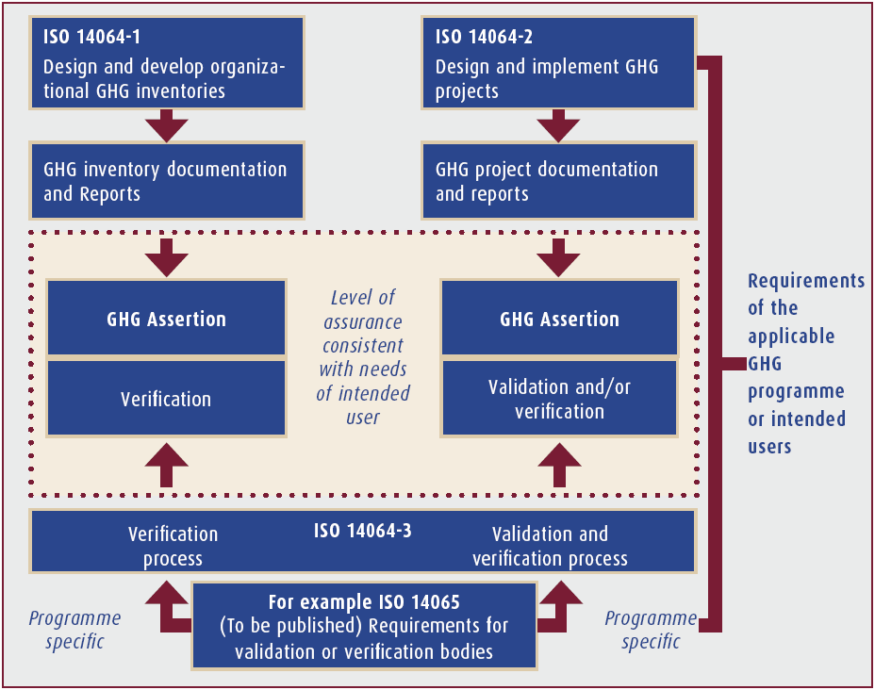
C. Standards status on the greenhouse gases management

Figure 7 Relationships among the three parts of ISO 14064 and ISO 14065

The following International Standards have already been published [13]:

• ISO 14064 (Greenhouse gases) was developed to enhance environmental integrity by promoting consistency, transparency and credibility in GHG quantification, monitoring, reporting and verification. It enables organizations to identify and manage GHG-related liabilities, assets and risks. It also facilitates the trade of GHG allowances or credits. ISO

14064 comprises three parts, respectively detailing specifications and guidance for the organizational and project levels, and for validation and verification.

- ISO 14064-1:2006 (“Greenhouse gases – Part 1: Specification with guidance at the organization level for quantification and reporting of greenhouse gas emissions and removals”) specifies detail principles and requirements for designing, developing, managing and reporting organizational- or company-level GHG inventories. It includes requirements for determining organizational boundaries, GHG emission boundaries, quantifying an organization‘s GHG emissions and removals, and identifying specific organization actions or activities aimed at improving GHG management. It also includes requirements and guidance on inventory quality management, reporting, internal auditing and the organization‘s responsibilities in verification activities. Part 1 is consistent with best practice established in the Corporate Accounting and Reporting Standard developed by the WRI/WBCSD.

- ISO 14064-2:2006 (“Greenhouse gases – Part 2: Specification with guidance at the project level for quantification, monitoring and reporting of greenhouse gas emission reductions and removal enhancements”) focuses on GHG projects or project-based activities specifically designed to reduce GHG emissions or increase GHG removals. It includes principles and requirements for determining project baseline scenarios and for monitoring, quantifying and reporting project performance relative to the baseline scenario and provides the basis for GHG projects to be validated and verified.

- ISO 14064-3:2006 (“Greenhouse gases – Part 3: Specification with guidance for the validation and verification of greenhouse gas assertions”) details principles and requirements for verifying GHG inventories and validating or verifying GHG projects. It describes the process for GHG-related validation or verification and specifies components such as validation or verification planning, assessment procedures and the evaluation of organization or project GHG assertions. ISO 14064 Part 3 can be used by organizations or independent parties to validate or verify GHG assertions.
• ISO 14065:2007 (―Greenhouse gases – requirements for greenhouse gas validation and verification bodies for use in accreditation or other forms of recognition‖) specifies requirements to accredit or otherwise recognize bodies that undertake GHG validation or verification using ISO 14064 or other relevant standards or specifications.
• ISO 14066:2011 (―Greenhouse gases – competency requirements for greenhouse gas validators and verifiers document‖) specifies competency requirements for GHG validators and verifiers. The standard details personal attributes, knowledge and skill (competency) requirements, required levels of proficiency and methods to evaluate competencies for GHG validators and verifiers by areas of competence. ISO/CD 14067 (“Greenhouse gases – carbon footprint of products”) was initiated from the end of 2008 and had been developed as two parts until 2010. Now the two parts agreed to be combined in a single standard. This work item specifies requirements for the quantification and communication of greenhouse gases associated with the whole life-cycle or specific stages of the life cycle of products. It is intended to promote the monitoring, reporting, and tracking of progress in the mitigation of GHG emissions. The carbon footprint may show quantitative comparisons between different products and affect consumers when they choose products with the lowest climate impacts. While GHG emissions are reported at global, national or company levels, ISO 14067 addresses emissions that arise from processes which constitute the life cycle of a product, in different organisations and independent from national boundaries. ISO/WD 14069 (“Greenhouse gases – quantification and reporting of GHG emissions for organizations (carbon footprint of organization) – Guidance for the application of ISO 14064-1”) describes a guidance for use of ISO 14064-1 to analysis the GHG inventory of organizations. Since ISO 14064-1 specifies only generic processes of the GHG inventory

analysis and relevant requirements, its specification seems quite vague for applying to a
GHG inventory analysis. The purpose of ISO 14069 is to produce an actual guidance to ISO
14064-1.

Those LCA and GHG management standards are industry-neutral ones and specify general principles and requirements. The ICT sector also may utilize them, but sector-specific guidance such as ITU-T L.1410 and L.1420 may be needed to help organizations get easier understanding.

5.1.2.2. ISO TC 242

ISO TC 242 was established in 2008 and deals with standardization in the field of energy management; for example, energy efficiency, energy performance, and energy supply, procurement practices for energy using equipment and systems, and energy use. Its standards will also address measurement of current energy usage, implementation of a measurement system to document, report, and validate continual improvement in the area of energy management.
ISO TC 242 has developed ISO 50001 so far which was approved as a Final Draft International
Standard (FDIS). ISO 50001 is expected to be published as an International Standard by 2011.
ISO 50001 aims at providing a general management framework for energy usage and energy efficiency, affecting all types of organizations (industrial, commercial, institutional, large residential, and transportation sectors) as well as emerging economies and Small and Medium Enterprises (SMEs) to manage their energy usage. The standard addresses the following items:

• A framework for integrating energy efficiency into management practices
• Making better use of existing energy-consuming assets
• Benchmarking, measuring, documenting, and reporting energy intensity improvements and their projected impact on reductions in greenhouse gas (GHG) emissions
• Transparency and communication on the management of energy resources
• Energy management best practices and good energy management behaviors
• Evaluating and prioritizing the implementation of new energy-efficient technologies
• A framework for promoting energy efficiency throughout the supply chain

Energy management improves in the context of GHG emission reduction projects.

5.1.3. IEC

5.1.3.1. IEC TC 100

IEC TC 100 works on standardization for audio, video and multimedia applications for end-user networks. It has considered development of an international system of energy consumption classes including a labeling scheme to determine the energy consumption and energy efficiency of consumer electronic products such as TV sets, set-top boxes, cable modems, DSL routers, etc. It also takes into account both stand-by losses and off-mode losses in its product standards. This requires external power supplies (AC/DC converters) to be considered as integral parts of the pertinent appliances.
The stand-by loss means power consumption by a power consuming source, when connected to an external power supply, while not performing its primary functions or while awaiting instructions to provide full services. The off-mode loss means power consumption by a power consuming source, when its internal circuit still consumes stand-by power to wait for external cord/cordless signals even though a consumer switches off the power of the power consuming source.
TC 100 is going to develop a standard for energy saving system for home appliances and home network devices to tackle those energy losses.

5.1.3.2. IEC TC 108

IEC TC 108 works on safety of electronic equipment within the field of audio/video, information technology and communication technology equipment. It also deals with requirements for methods of measurement of energy efficiency of ICT equipment, including power conservation.
With a close cooperation relationship with the Ecma International, IEC TC 108 published IEC
62075, “Audio/video, information and communication technology equipment – Environmentally conscious design,” which identifies design practices for the following product attributes throughout a product life cycle: energy efficiency, material efficiency, consumables and batteries, chemical and noise emissions, extension of product lifetime, end of life considerations, substances and preparations needing special attention, product packaging, and documentation. IEC 62075 is equivalent to the 3rd edition of ECMA-341, “Environmental design considerations for ICT & CE products.” This standard applies to all audio/video, information and communication technology equipment referred to products, specifying requirements and recommendations for the design of environmentally sound products regarding life cycle thinking aspects, material efficiency, energy efficiency, consumables and batteries, chemical and noise emissions, extension of product lifetime, end of life, hazardous substances/preparations, and product packaging. This standard covers only criteria directly related to the environmental performance of the product. Criteria such as safety, ergonomics and electromagnetic compatibility (EMC) are outside the scope of this standard.
IEC TC 108 is cooperating with the Ecma International to develop ECMA-383, “Measuring the Energy Consumption of Personal Computing Products” which is planned to be released in the title of “Measuring the Energy Consumption of Desktop and Notebook Computers” as IEC 62623 in June
2012. This standard defines a test procedure to enable the measurement of the power and/or energy consumption in each of the EUT‘s power modes; formulas for calculating the TEC (Typical Energy Consumption) for a given period (normally annual); and a majority profile that should be used with this Standard which enables conversion of average power into energy within the TEC formulas. Additionally it provides a standardized results reporting format The standard requires the user to measure and record a set of energy, power, time, and capability results (using a Benchmark), not a single metric of energy efficiency.

5.1.3.3. IEC TC 111

IEC TC 111, ―Environmental standardization for electrical and electronic products and systems,‖ started in 2005 development of standards that cover test methods for hazardous substances and help manufacturers declare which materials they are using in their products. The standards were very significant for the global electronics industry because of increasing legislation around the world such as the California Electronic Waste Recycling Act of 2003 and the European Union‘s RoHS and WEEE Directives. The standard for test methods is to give manufacturers a way to prove which substances their electrical and electronic products contain. The second will make importing and exporting those products easier through a uniform means of declaration which customs agents can use to ensure that products entering the market adhere to legislation concerning restricted substances, such as lead and cadmium.

It published following standards [14]:

• IEC 62321 (2008-12), Electrotechnical products – Determination of levels of six regulated substances (lead, mercury, cadmium, hexavalent chromium, polybrominated biphenyls, polybrominated diphenyl ethers)
• IEC 62430 (2009-02), Environmentally conscious design for electrical and electronic products
• IEC/PAS 62545 (2008-01), Environmental information on Electrical and Electronic
Equipment (EIEEE)

• IEC/PAS 62596 (2009-01), Electrotechnical products – Determination of restricted substances
– Sampling procedure – Guidelines

Its on-going works are:

• Communication formats on recycling for electrotechnical equipment between manufacturers and recyclers
• Electrotechnical products - Sampling and determination of certain substances – Part 1: General aspects of sampling strategy
• Material Declaration for Electrical and Electronic Equipment – Proposed as horizontal standard
• Guidance for evaluation of product with respect to substance use restrictions in electrical and electronic equipment
• Environmental standardization for electrical and electronic products and systems –
Standardization of environmental aspects – Glossary of terms
• End of life recyclability calculation for electrotechnical equipment

Furthermore, IEC TC 111 established an ad-hoc group on Greenhouse Gasses and carbon footprinting for electrical and electronic products and systems in order to find new standardization initiatives. The group finally made two recommendations for development of relevant standards: Quantification methodology of CO2e emission for electrical and electronic products and systems, and Quantification methodology of CO2e emission reduction for electrical and electronic products and systems from the project baseline.
The first item may be developed by referring to ISO 14067 (Carbon Footprint of Products), ISO
14040 and 14044 (LCA), ISO 14025 (Type III environmental declarations - Principles and procedures) published by ISO TC 207, and Product Life Cycle Accounting and Reporting Standard published by WBSCD/WRI.
The other item may be developed by referring to ISO 14064-2 by ISO TC 207 and GHG accounting for projects by WBSCD/WRI. The ad-hoc group has already recognized ITU-T SG 5 activities and expects some collaboration with ITU-T SG 5.
After consideration of the two recommendations, IEC TC 111 finally agreed to conduct approval procedures and the two New Work Item Proposals have passed. The first meeting for development of the two new work items is scheduled in May 2011.

5.1.4. ISO/IEC JTC 1

5.1.4.1. ISO/IEC JTC 1 SWG on Planning

At its plenary meeting in 2009, ISO/IEC JTC 1 has identified the following areas of standardization to explore for possible future actions toward JTC 1 by forming study groups in the following areas:

• Digital Content Management and Protection
• Energy Efficiency of Data Centers
• Green ICT with a special focus on ―green by ICT‖
• Cloud computing under SC38

In addition, the JTC 1 SWG-Planning has identified the following areas for further study within the
SWG, again for possible future actions toward JTC 1:

• Web Collaboration and Social Networking

• Green ICT with a special focus on ―green of ICT‖

At its June 2010 meeting, the JTC 1 SWG-Planning made a recommendation to the ISO/IEC JTC 1 with regard to the Green of ICT as follows:

“SWG-P recognizes that energy efficiency is an important area of focus for ICT standardization and further notes that efforts to measure and improve the energy efficiency of ICT products should comprehend the interaction between usage and energy consumption.

Recognizing the substantial JTC 1 expertise in ICT product usage and design, SWG-P recommends to
JTC 1 that JTC 1 entities
• undertake development of standards that define measurement methods of energy efficiency (incl. energy consumption) of ICT products that are related to their work considering cooperation with and use of standards developed by IEC/TC 108, IEC/TC 100, ITU-T SG 5 and possibly others;
• undertake development of standards that define energy saving features and methods for products that are related to their work; and
• consider energy efficiency as an important topic when developing standards.”

5.1.4.2. ISO/IEC JTC 1 Study Group on Green ICT

This Study Group1 was reconstituted at the 2010 ISO/IEC JTC 1 Plenary meeting with its title change as ―Study Group on Green ICT (SG-GICT) as the Study Group on Green by ICT‖ to make the work scope focus specifically on the Green by ICT. The SG-GICT was instructed to study three topics as follows:

A. Smart buildings by:

• Assessing more specific use case scenarios;
• Understanding implementation and deployment status;
• Evaluating ICT technologies, products and systems applied to them;
• Determining service and functional requirements;
• Assessing the current state of standardization within JTC 1 and in other SDOs, consortia and fora; and
• Considering other relevant issues.

B. E-education and e-learning by:

• Assessing more specific use case scenarios;
• Understanding implementation and deployment status;
• Evaluating ICT technologies, products and systems applied to them;
• Determining service and functional requirements;
• Assessing the current state of standardization within JTC 1 and in other SDOs, consortia and fora; and
• Considering other relevant issues.

1 The Study Group is the conventional name of the ad-hoc group and both groups are the same. The ad-hoc group cannot develop any standards but review and study coordination and management issues as well as technical, strategic and procedural issues, and moreover any topic instructed by its ToR. That is, the ad-hoc group and the Study Group are identical and usually this kind of groups works until the next Plenary meeting of ISO/IEC JTC 1 and shall report its activities and achievements to the Plenary meeting. If a further study is needed, the group may be re-established. The SWG is a coordination group with other groups as well as Study Groups on any topic instructed by its ToR, and has no duration. Thus it does not have to be re-established at every Plenary meeting.

C. Best practices for green technology development by:

• Surveying best practices for green technology development; and
• Documenting recommended attributes for JTC 1 standards development

The study goal of SG-GICT is to produce recommendations to JTC 1 to deal with those topics for the future standardization initiative of JTC 1.

5.1.4.3. ISO/IEC JTC 1 Study Group on Energy Efficiency of Data Centers

This Study Group on Energy Efficiency of Data Centers (SG-EEDC) also was reconstituted at the
2010 ISO/IEC JTC 1 Plenary meeting. The SG-EEDC was instructed to deliver work item proposals addressing the following key items:

• A taxonomy providing terms and definitions which cover the topic of data centers and energy efficiency for use in subsequent standardization activity;
• Universally accepted Key Performance Indicators (KPIs), or algorithms that use the KPIs to create a figure of merit, that reflect the purpose and business model operated within the data center; and
• Practices which holistically balance the use of the energy efficient standardised products/solutions with the needs and capabilities of the data center to use them.

With regard to the last study item, the SG-EEDC has identified the following consideration issues:

• Geographical Location
• Building
• Layout on Airflow Management and Thermodynamic Metrics
• IT Equipment on Utilization, Power/Performance, Operating Range EE features, Energy
Star, and Operating hours
• Software on Utilization, Performance, and Bloat
• Consolidation
• Virtualization
• Resilience on 2N Power and Data Duplication
• Plant Equipment on COP Chiller, AHU, etc. and UPS efficiency
• Efficiency Metrics
• Measurement
• Monitoring
• Management
• Instrumentation
• Control
• Interfaces
• Security
• Renewables
• Re-use of waste heat

For the gap analysis on those issues, the Study Group has identified the following relevant consortiums, forums and organizations:

• The Green Grid
• European Environmental Agency

• Environmental Protection Agency
• Distributed Management Task Force
• ECMA International
• Ecma any other relevant activities
• Smart Grid
• Green ICT
• Cloud Computing JTC1 SC 38
• IEC Smart Grid SMB Strategic G3
• LEED (Buildings)
• HQE (Buildings)
• Green IT Promotion Council
• SNIA
• ITU-T Study Group 5
• US Department of Energy
• Power Utilities
• ETSI (STF 362)
• CENELEC TC 215 WG2 (EN 50174-2)
• CENELEC TC 215 WG3 (EN 50600 series)
• CLC/BT WG132-2 Green Data Centers
• EU Code of Conduct DCEE
• EU Mandate
• ISO/IEC JTC1 SC25 WG3 (ISO/IEC 14763-2)
• ATIS
• GreenTouch
• Lawrence Berkeley Lab.
• Data Center Energy Efficiency Project
• Climate Savers
• EPEAT
• US Government Climate Portal
• 80 Plus

5.1.4.4. ISO/IEC JTC 1 Special Working Group on Smart Grid

This Special Working Group also was established by the ISO/IEC JTC 1 Plenary meeting in 2009. Its work items consist of:

• To identify market requirements and standardization gaps for smart grid with particular attention to standards supporting the interoperability of smart grid technology and needed international standardization;
• To encourage JTC 1 SCs to address the need for ISO/IEC smart grid International Standards;
• To promote JTC 1 developed International Standards for smart grid and encourage them to be recognized and utilized by the industry and SDOs;
• To coordinate JTC 1 Smart Grid activities with IEC, ISO, ITU-T and other SDOs that are developing standards for Smart Grid, especially the IEC SMB Strategic Group 3 on Smart Grid;
• To periodically report results and recommendations to JTC 1 SWG-Planning and coordinate ongoing work with related plans; and
• To provide a written report of activities and recommendations in advance of the 2010 JTC 1
Plenary meeting in Belfast.

It is setting up an experts group from JTC 1 SCs and WGs to clarify their technical associations with existing Smart Grid technologies and relevant standardization activities.

5.1.5. ETSI

The European Telecommunications Standards Institute (ETSI) recognized climate change was a global concern and required efforts from all industry sectors, including the ICTs. ETSI is strengthening its efforts by improving the tools for electronic work, introducing a check list that energy saving is considered for all new work items, and initiating a number of new work items in the ICT and environment area. ETSI has published a few deliverables and has a few on-going work items as follows [15]:
Here are published deliverables:

• TR 102 530, “Reduction of energy consumption in telecommunications equipment and related infrastructure”: This document reports some techniques and some aspects to take in account during the evaluation of the possible reduction of energy consumption at equipment level and at installation level. The first version of this document refers principally at broadband equipment.
• TR 102 531 (2007-04), “Better determination of equipment power and energy consumption for improved sizing”: This document gives guidance on a more appropriate determination of equipment energy consumption with the goal to be able to realize a good design of power station and related power distribution network. A correct design help to have a better energy efficiency of power station with impact on the energy saving and with a not oversized dimensioning of power network permits to reduce the use of material (copper) and as consequence a minor impact on the environmental and a cost reduction.
• TS 102 532 (2009-06), “Environmental Engineering (EE) – The use of alternative energy sources in telecommunication installations”: The use of alternative energy sources in the telecommunication installation/application such as solar, wind, and fuel cell is considered.
• TS 102 533 (2008-06), “Measurement Methods and limits for Energy Consumption in Broadband Telecommunication Networks Equipment”: This document establishes an energy consumption measurement method for broadband telecommunication network equipment; give contributions to fix target energy consumption value for wired broadband equipment including ADSL and VDSL.
• TS 102 706 (2009-08), “Environmental Engineering (EE) – Energy efficiency of wireless access network equipment”: This work will establish wireless access network energy efficiency metrics, which define efficiency parameters and measurement methods for wireless access network equipment. In the first phase GSM/EDGE, WCDMA/HSPA and WiMAX are addressed. Other systems, such as LTE, will be added when a stable system data is available.
• EN 300 132-3 (2003-8), “Power supply interface at the input to telecommunications equipment; Part 3: Operated by rectified current source, alternating current source or direct
current source up to 400 V”: This document standardizes a new power interface able to supply both telecom and ICT equipment. This solution permits to build only a power network, with backup, to supply energies at all type of equipment present in a data center without using UPS or AC/DC converters at 48 V so the global energetic efficiency of the entire system is greater than other solutions contributing and the energy saving.
• TR 105 175, “Access, Terminals, Transmission and Multiplexing (ATTM);
Broadband Deployment - Energy Efficiency and Key Performance Indicators”
- Part 2: Network sites
⬧ Sub-part 1 (TR 105 174-2-1): Operator sites (2009-10)
- Part 4 (TR 105 174-4): Access networks (2009-10)
- Part 5: Customer network infrastructures

⬧ Sub-part 1 (TR 105 174-5-1): Homes (single-tenant) (2009-10)
⬧ Sub-part 2 (TR 105 174-5-2): Office premises (single-tenant) (2009-10)
• TS 105 175, “Access, Terminals, Transmission and Multiplexing (ATTM); Broadband Deployment - Energy Efficiency and Key Performance Indicators”
- Part 1 (TS 105 174-1): Overview, common and generic aspects (2009-10)
⬧ Sub-part 1 (TR 105 174-1-1): Generalities, common view of the set of documents
(2006-06)
- Part 2: Network sites
⬧ Sub-part 2 (TS 105 174-2-2): Data centers (2009-10)
- Part 3 (TS 105 174-3): Core, regional metropolitan networks (WG approval is planned on
2010-09)
- Part 4: Customer network infrastructures
⬧ Sub-part 3 (TS 105 174-5-3): Industrial premises (single-tenant) (WG approval is planned on 2010-09)
⬧ Sub-part 4 (TS 105 174-5-4): Data centers (customer) (2009-10) Here are on-going work items:
• DTR/EE-00006, “Environmental Engineering (EE) – Environmental consideration for equipment installed in outdoor location”: It is planned to write a technical report on the applicability of ETSI environmental classes to equipment installed in outdoor cabinet. Also acoustics noise emission will be considered.
• DTR/ATTM-06002, “Power Optimization for xDSL transceivers”: Possibilities to optimize the power consumption of the xDSL transceiver are investigated. These investigations may include power modes that are beyond the currently existing modes. The potential influence of power optimization schemes on the stability and performance of each line of the network due to power optimization, e.g. non-stationary noise, will be an important part of this work.

ETSI also has more work items as follows:

• DES/EE-00014, “Life Cycle Assessment (LCA) of ICT equipment, ICT network and ICT
service: General definition and common requirement”
• DES/EE-00015, “Measurement method and limits for energy consumption in broadband telecommunications equipment”
• DES/EE-00018, “Measurement methods and limits for Energy consumption of End-user
Broadband equipment (CPE)”

5.1.6. ATIS

The Alliance for Telecommunications Industry Solutions (ATIS) Network Interface, Power and Protection (NIPP) committee intends to produce a document or suite of documents for use by ICT service providers to assess the true energy needs of equipment at time of purchase such as:

• Energy use as a function of traffic
• Energy use as a function of environmental conditions
• Cooling requirements
• Suitability of a product for use with renewable energy sources
• Improvements in environmental footprint through Life Cycle Assessments
• Standby and off-mode definitions
• Standby and off-mode losses

It provides the methodology to be used by vendors and third party test laboratories in the formation of a Telecommunications Energy Efficiency Ratio (TEER). In general, each TEER will follow the formula below:

Where:

TEER =
Useful Work
Power

Useful Work = Defined in the supplemental standard based on the equipment function. Examples could be, but are not limited to: data rate, throughput, processes per second, etc. Power = Power in Watts (dependent on the equipment measurement).

The TEER standards consist of five parts:

• ATIS-0600015.2009 (Energy Efficiency for Telecommunications Equipment: Methodology for Measurement and Reporting – General Requirements)
• ATIS-0600015.01.2009 (Energy Efficiency for Telecommunications Equipment: Methodology for Measurement and Reporting – Server Requirements)
• ATIS-0600015.02.2009 (Energy Efficiency for Telecommunications Equipment: Methodology for Measurement and Reporting – Transport Requirements)
• ATIS-0600015.03.2009 (Energy Efficiency for Telecommunications Equipment: Methodology for Measurement and Reporting – Router and Ethernet Switch Products)
• ATIS-0600015.04.2010 (Energy Efficiency for Telecommunications Equipment: Methodology for Measurement and Reporting – DC Power Plant – Rectifier Requirements)

The general requirements document serves as the ATIS base standard for determining telecommunications energy efficiency. It provides a uniform methodology to measure equipment power and defines energy efficiency ratings for telecommunication equipment. In this document, equipments have been classified based on the application and the location in the network with classifications such as core, transport and access. The latter two documents (server requirements, and transport system or network configuration requirements) are part of an ongoing series to define the telecommunications energy efficiency of various telecommunications components [16].

5.1.7. Ecma International

The Ecma International is working on Green of ICT issues in the following projects:

• ECMA-328, “Determination of chemical emission rates from electronic equipment”: this standard specifies methods to determine chemical emission rates of analyte from ICT and CE equipment during intended operation in an Emission Test Chamber (ETC). The methods comprise preparation, sampling (or monitoring) in a controlled ETC, storage and analysis, calculation and reporting of emission rates. This standard includes specific methods for equipment using consumables, such as printers, and equipment not using consumables, such as monitors and PC‘s.
• ECMA-341, “Environmental Design Considerations for ICT & CE Products”: This standard applies to all audio/video, information and communication technology equipments referred to products, specifying requirements and recommendations for the design of environmentally

sound products regarding life cycle thinking aspects, material efficiency, energy efficiency, consumables and batteries, chemical and noise emissions, extension of product lifetime, end of life, hazardous substances/preparations, and product packaging. This standard covers only criteria directly related to the environmental performance of the product. Criteria such as safety, ergonomics and electromagnetic compatibility (EMC) are outside the scope of this standard. ECMA-341 was adopted as IEC 62075 in 2008.
• ECMA-370, “The Eco Declaration”: this standard specifies environmental attributes and measurement methods for ICT and CE products according to known regulations, standards, guidelines and currently accepted practices. The standard is also applicable to products used as subassemblies, components, accessories and/or optional parts. The standard addresses company programs and product related attributes, not the manufacturing processes and logistic aspects. Although the declarations as defined in Annex A and B are optimized for application in the European Union, this Standard is intended for global use.
• ECMA-383, “Measuring Energy Consumption, Performance and Capabilities of ICT and CE Products”: This standard intends to apply to desktop computers and notebook computers, defining how to evaluate and report energy consumption, performance and capabilities being the vital factors for the energy efficient performance of testing targets, i.e. those computers. Additionally it provides a standardized results reporting format. The standard requires the user to measure and record a set of energy, power, time, and capability results (using a Benchmark), not a single metric of energy efficiency. ECMA-383 is planned to be published as IEC 62623 in 2011.
• ECMA-xxx, “Network proxying of ICT devices to reduce energy consumption”: This on- going work develops standards and technical reports for network proxying; a proxy is an entity that maintains network presence for a sleeping higher-power ICT device. It will specify:
- the protocols that network proxies must handle to maintain connectivity while hosts are asleep;
- the proxy behaviour including ignoring packets, generating packets and waking up host systems; and
- the information exchanged between hosts and proxies.
[Note] the information syntax and exchange methods are out of scope.

5.1.8. GHG Protocol Initiative

WRI/WBCSD has developed the following standards under the GHG Protocol Initiative as follows
(two standards were published and the other three documents are still at the draft stage [17]:

• Corporate accounting and reporting standard
• The GHG Protocol for project accounting
• Draft stage, Product accounting and reporting standard
• Corporate value chain (Scope 3) accounting and reporting standard – Supplement to the
GHG Protocol corporate accounting and reporting standard
• GHG Protocol Product Life Cycle Standard
• Draft stage, ICT Sector Guidance to support GHG Protocol Product Standard

5.1.9. BSI

The BSI (British Standards Institution) released the following standard to support the carbon footprinting of products:

• PAS 2050:2008, ―Specification for the assessment of the life cycle greenhouse gas emissions of goods and services‖

5.2. Activities in Non-Standard Bodies

5.2.1. OECD

The Organisation for Economic Co-operation and Development (OECD) has studied the Green ICT so far with recognition of ICT as an efficient solution to improve environmental performance and address climate change across the economy. It is going to hold a conference on ―Smart ICTs and Green Growth‖ on 29 September 2010 which will discuss environmental opportunities, existing barriers and some potential risks to the wider roll-out of smart infrastructures. Focus areas include: smart technologies, smart life-styles and electric mobility. The OECD has held many other conferences such as ―Green ICT‖ side-event at the UN Climate Change talks, Barcelona, 2-6
November 2009; a virtual meeting with video conferencing technology on the sidelines of COP15 in Copenhagen on the topic, ―The role of ICTs for climate change. Lead role or supporting act?‖ and an OECD conference, ―ICTs, the environment and climate change", Helsingr, Denmark, 27-28 May 2009 [18].
Various study results of the OECD have been released as OECD reports as follows:

• Smart Sensor Networks: Technologies and Applications for Green Growth: Published in December 2009, this report gives an overview of sensor technology and fields of application of sensors and sensor networks. It discusses in detail selected fields of application that have high potential to reduce greenhouse gas emissions and reviews studies quantifying the environmental impact. The review of the studies assessing the impact of sensor technology in reducing greenhouse gas emissions reveals that the technology has a high potential to contribute to a reduction of emissions across various fields of application. Whereas studies clearly estimate an overall strong positive effect in smart grids, smart buildings, smart industrial applications as well as precision agriculture and farming, results for the field of smart transportation are mixed due to rebound effects. In particular intelligent transport systems render transport more efficient, faster and cheaper. As a consequence, demand for transportation and thus the consumption of resources both increase which can lead to an overall negative effect [19].
• Towards Green ICT Strategies: Assessing Policies and Programmes on ICT and the Environment: Governments and business associations have introduced a range of programmes and initiatives on ICT and the environment to address environmental challenges, particularly global warming and energy use. Some government programmes also contribute to national targets set in the Kyoto. Business associations have mainly developed initiatives to reduce energy costs and to demonstrate corporate social responsibility. Published in June 2009, this report analyses 92 government programmes and business initiatives across 22 OECD countries plus the European Commission. Fifty of these have been introduced by governments and the remaining 42 have been developed by business associations, mostly international. Over two-thirds of these focus on improving performance in the ICT industry. Only one third focus on using ICT across the economy and society in areas where there is major potential to dramatically improve performance, for example in ―smart‖ urban, transport and power distribution systems, despite the fact that this is where ICT have the greatest potential to improve environmental performance.

The OECD has three on-going works as follows [20]:

• Developing a framework for analysis of ICT and environmental challenges. The aim is to comprehensively model environmental effects of ICT production, use and their application across industry sectors.
• Analysing existing indicators and statistics on the relationship between ICT and the environment with the aim of improving availability and comparability of official statistics.

• Identifying priority areas for policy action including life cycle analysis of ICT products and impact assessments of smart ICT applications. This work covers the potential of sensor-based technologies and broadband networks to monitor and address climate change and facilitate energy efficiency across all sectors of the economy.

5.2.2. WWF

The World Wide Fund For Nature (WWF 2 ) considers ICT as a tool that constitutes a new infrastructure, changing the way our societies function, while ICT applications will give us totally new opportunities to both preserve the best elements of our society, and develop new and better solutions to our existing problems. As a whole, ICT is best viewed as a catalyst that can speed up current negative trends, or alternatively contribute to a shift towards sustainable development [21]. The WWF devoted a lot of efforts to study on the Green ICT and published the following reports:

• Sustainability at the speed of light: the WWF invited experts to describe the future role of ICT for sustainable development and summarize the most important challenges for the future. This report was published in July 2002 and the result of invited contributions. The report was an attempt to bridge the gap between ICT experts and policy makers in politics and business, as well as other stakeholders in society [22].
• Saving the Climate at the speed of light: this report describes a potential to allow the ICT sector to provide leadership for structural changes in infrastructure, lifestyles and business practice to achieve dramatic reductions of CO2. It describes the opportunity of ICT services to reduce CO2 emissions such as videoconference, audio-conference, virtual answering machine, online phone billing, web-taxation, flexi-work, and so on. Then it suggests two-phase roadmap for actions [23]:
- The first phase is a concrete (numerical) target for 2010 of 50 million tonnes CO2 annually. This target is based on the implementation of several strategic ICT applications, e.g. virtual meetings, e-dematerialisation and flexi-work. This also includes some additional tasks like policy revision (e.g. energy, tax, transport, innovation, etc.) and supplementary, parallel actions.
- The second phase is a target for 2020. This target should be set before 2010 and should include more services and system solutions, where a number of services are combined, as well as a more ambitious target for CO2 reduction. Possible focus areas for the second phase are sustainable consumption, production, city planning and community development.
• Outline for the first global IT strategy for CO2 reductions: this report is a shorter report than just the below one and presents ten strategic ICT solutions that help accelerate the first billion tonnes of CO2 reductions and begin the transformation towards a low-carbon society. It describes low vs. high-carbon feedback scenarios for the ten ICT solutions [24].
• The potential global CO2 reductions from ICT use: this report addresses ten ICT solutions that can help accelerate the reduction of CO2 emissions. It identifies one billion tonnes of strategic CO2 reductions based on a bottom up approach with concrete solutions. These reductions are equivalent to more than one quarter of EU‘s total CO2 emissions. The ten solutions areas are smart city planning, smart buildings, smart appliances, dematerialisation services, smart industry, I-optimisation, smart grid, integrated renewable solutions, smart work, and intelligent transport [25].

The WWF made the following achievements also:

2 When it was found in 1961, WWF stood for the World Wildlife Fund. But the legal name became the World Wide Fund for Nature during the 1980s by expanding its work to conserve the environment as a whole, except in North America where the old name was retained.

• Communication Solutions for Low Carbon Cities: Helping cities to reduce CO2 with existing low carbon ICT solutions [26]
• A five-step-plan for a low carbon urban development: Understanding and implementing low carbon ICT/telecom solutions that help economic development while reducing carbon emissions [27]
• From Workplace to Anyplace: assessing the global opportunities to reduce greenhouse gas emissions with virtual meetings and telecommuting [28]
• From fossil to future with innovative ICT solutions: increased CO2 emissions from ICT
needed to save the climate [29]
• From coal power plants to smart buildings at the speed of light: How urbanization in emerging economies could save the climate [30]

5.2.3. SMART 2020

The SMART 2020 is a report by the Climate Group on behalf of the GeSI [3]. This study was initiated by feeling a responsibility to estimate the GHG emissions from the ICT industries and to develop opportunities for ICT to contribute to a more efficient economy. The ―SMART 2020 – Enabling the low carbon economy in the information age‖ presents the case for a future-oriented ICT industry to respond quickly to the challenge of global warming.
This report has quantified the direct emissions from ICT products and services based on expected growth in the ICT sector. It also looked at where ICT could enable significant reductions of emissions in other sectors of the economy and has quantified these in terms of CO2e emission savings and cost savings. In total, ICT could deliver approximately 7.8 GtCO2e of emissions savings in 2020. This represents 15% of emissions in 2020 based on the BAU estimation. It represents a significant proportion of the reductions below 1990 levels that scientists and economists recommend by 2020 to avoid dangerous climate change. It is an opportunity that cannot be overlooked.
The report identified some of the biggest and most accessible opportunities for ICT to achieve these savings as follows:

• Smart motor systems: A review of manufacturing in China has identified that without optimisation, 10% of China‘s emissions (2% of global emissions) in 2020 will come from China‘s motor systems alone and to improve industrial efficiency even by 10% would deliver up to 200 Mt CO2e savings. Applied globally, optimised motors and industrial automation would reduce 0.97 GtCO2e in 2020.
• Smart logistics: Through a host of efficiencies in transport and storage, smart logistics in Europe could deliver fuel, electricity and heating savings of 225 MtCO2e. The global emissions savings from smart logistics in 2020 would reach 1.52 GtCO2e, with energy savings.
• Smart buildings: A closer look at buildings in North America indicates that better building design, management and automation could save 15% of North America‘s buildings emissions. Globally, smart buildings technologies would enable 1.68 GtCO2e of emissions savings.
• Smart grids: Reducing T&D losses in India‘s power sector by 30% is possible through better monitoring and management of electricity grids, first with smart meters and then by integrating more advanced ICT into the so-called energy internet. Smart grid technologies were the largest opportunity found in the study and could globally reduce 2.03 GtCO2e.

5.2.4. AIM Project
The AIM project 3 aimed at developing a household appliances management architecture for modeling, virtualizing and managing the energy consumption of household appliances, supporting Europe‘s Action Plan on Energy Efficiency of using the opportunities offered by ICT to achieve technology-driven energy efficiency gains. The AIM was a consortium of eleven partner organizations from five different European countries.
Energy consumption at home accounts for one of the most crucial forms of energy consumption along with gas utilization and electricity spending in commercial buildings. According to the American Council for an energy-efficient economy, the residential and commercial sector-homes and buildings consume 38.8 percent of the energy used in the US. People use energy to heat and cool buildings to light them and to operate appliances and office machines, while the cost of using such appliances averages more than $1,200 per year.
Given the energy waste problem and the consequent need for energy optimal use, the main concept of the project is to foster a harmonized technology for managing in real time the energy consumption of appliances at home, interworking this information to communication devices over the home network and virtualizing it with the final aim of making it available to users through home communication networks in the form of standalone or network operator services.
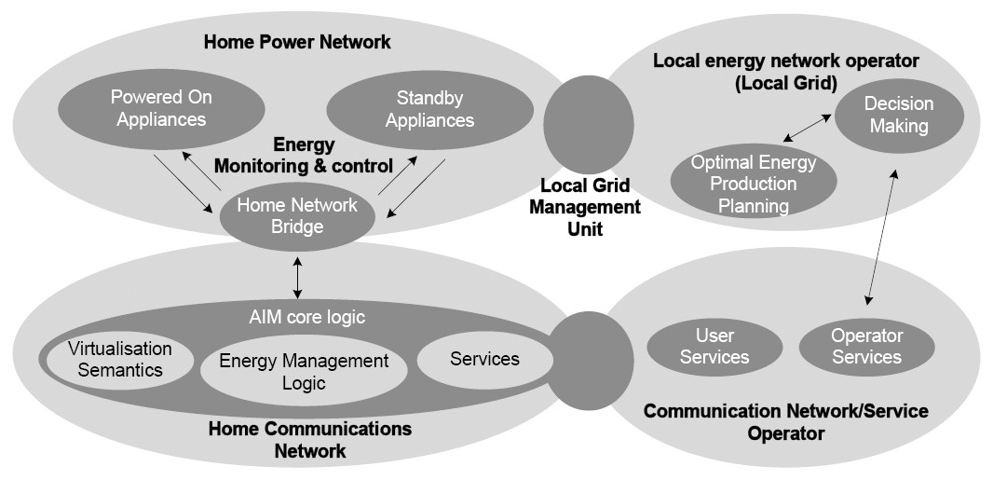
Behind this concept, the main goal is to provide a generalized method for managing the energy consumption of household appliances that are either powered on or in stand-by state.

Figure 8 Management of energy consumption of household appliances

The project addresses three household appliance types to be supported:

• White goods (e.g., refrigerators, kitchens, washing machines, and driers)
• Communication devices (e.g., cordless phones and gateways for domestic use)
• A/V (audiovisual) equipment (e.g., TV Sets and Set-top-boxes)

3 Source: www.ict-aim.eu

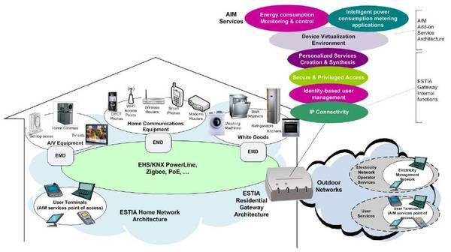
Figure 9 The AIM architecture

A detailed diagram of the overall AIM architecture is illustrated as shown in Figure 9. To realize inter-working with the home network, AIM introduces a dedicated functional entity, called Energy Management Device (EMD) that will implement, in a generic way and for all the appliance types, monitoring and control power consumption functions. This architecture will convey logic for both active and stand-by appliances and will feature generic communication interfaces to the home network, towards the power consumption management logic of the residential gateway and the appliances on which EMDs will be attached [31]. The EMD constitutes the local hub of the energy control system. It is conceived as an independent functional entity that conveys control logic for both active and stand- by appliances and energy management functions integrated through multimodal communication interfaces with the home network and the residential gateway, hosting the service logic. The EMD is controlled by the residential gateway, using a bus interface that grants access to multiple EMDs from a single access-point, either locally or remotely via an operator network. The residential gateway selects and conduits information to the proper device interface, applies the necessary centralized control logic, and enforces rigorous communication encryption [32].

5.2.5. EC-JRC handbooks

The Joint Research Centre of the European Commission has released in March 2010 the International Reference Life Cycle Data System (ILCD) Handbook to provide a practice guidance on how to conduct a Life Cycle Assessment to calculate a product's total environmental impact in terms of GHG emissions, resources consumed and the pressures on the environment and human health that can be attributed to a product.

• ILCD (International Reference Life Cycle Data System) Handbook: Analysis of existing
Environmental Impact Assessment methodologies for use in Life Cycle Assessment
• ILCD (International Reference Life Cycle Data System) Handbook: General guide for Life
Cycle Assessment – Detailed guidance
• ILCD (International Reference Life Cycle Data System) Handbook: General guide for Life
Cycle Assessment – Provisions and action steps

• ILCD (International Reference Life Cycle Data System) Handbook: Framework and requirements for Life Cycle Impact Assessment models and indicators
• ILCD (International Reference Life Cycle Data System) Handbook: Review schemes for Life
Cycle Assessment
• ILCD (International Reference Life Cycle Data System) Handbook: Specific guide for Life
Cycle Inventory data sets
• ILCD (International Reference Life Cycle Data System) Handbook: Reviewer qualification for Life Cycle Inventory data sets

6. Standards map of environmental impact assessment methodologies

―Most of ISO, IEC, WRI/WBCSD, BSI (British Standards Institution), ETSI, EC-JRC (Joint Research Centre of the European Commission) and ITU-T methodology standards may be described as the following overall map for which analysis targets are only products, organizations and projects. Clarification factors for the analysis targets are:

• Inventory: it means a type of GHG inventory that is developed for a variety of GHG sources and sinks in order to account for the GHG emission total of an organization. It applies usually to organizations. But here GHG projects for GHG reductions and removal enhancements are located in the inventory area because GHG reductions and removal enhancements should be quantified from a GHG inventory conducted by various project activities.
• Carbon footprint: it is defined as the total sum of GHG emissions and GHG removals during the life cycle phases of a product, expressed as net global warming impact in CO2e.
• Life Cycle Assessment: it is a methodology for compilation and evaluation of the inputs, outputs and the potential environmental impacts of a product system throughout its life cycle.
• Environment-conscious design for products: it deals with requirements and procedures to integrate environmental aspects into design and development processes of products, including combination of products, and the materials and components of which they are composed. It also requires manufacturers to demonstrate how they have integrated life cycle thinking into the product design and development process to minimize the significant environmental impacts of the product across its life cycle stages.
• Labelling by evaluation: it means a claim which indicates the environmental aspects of a product. An environmental label may take the form of a statement, symbol or graphic on a product or package label, in product literature, in technical bulletins, in advertising or in publicity, amongst other things.
• Validation and verification: it is the process for evaluation of GHG assertions against agreed validation and verification criteria. The validation is the ex-ante process and the verification is the ex-post process.

Table 1 Standards map of environmental impact assessment methodologies
Categories | Products | Organizations | Projects | Properties
Inventory | - | ISO 14064-1 | ISO 14064-2 | General procedure and requirements
 | - | ISO 14069 | - | Practice guidance
 | - | ITU-T L.methodology ICT in organizations | ITU-T L.methodology ICT projects | Sectoral guidance
 | - | - | IEC 62726
 | - | GHG Protocol | GHG Protocol | General procedure and requirements

 |  | corporate accounting and reporting standard, (details for Scope 1 and Scope 2) | for project accounting
 | - | GHG Protocol corporate value chain (Scope 3) accounting and reporting  standard | - | Life cycle considered | General procedure and requirements
Carbon footprint | ISO 14067 and part of ISO 14025 (Product Category Rules) | - | - |  | General procedure and requirements
 | GHG Protocol product accounting and  reporting standard | - | - |  | General procedure and requirements
 | ICT sector guidance for GHG Protocol product accounting | - | - |  | Sectoral guidance
 | PAS 2050 | - | - |  | General procedure and requirements
 | IEC 62725 | - | - |  | Sectoral guidance
LCA | ISO 14040 | - | - |  | General procedure and requirements
 | ISO 14044 | - | -
 | ILCD Handbook | - | - |  | Practice guidance
 | L.methodology ICT goods, networks and services | - | - |  | Sectoral guidance
 | ETSI DTS/EE  00014 | - | - |  | Sectoral guidance
Product eco- design | IEC 62430 | - | - |  | General procedure and requirements
Labeling | ISO 14025 (Type III) | - | - |  | General procedure and requirements, and 3rd party evaluation required
 | ISO 14021 (Type II) | - | - | General procedure and requirements, and Self-declaration purpose
 | ISO 14024 (Type I) | - | - | General procedure and requirements, and 3rd party evaluation purpose
Validation and verification | ISO 14064-3 |  |  | 3rd party evaluation required | Validation and verification procedure
 | ISO 14065 |  |  |  | Evaluation for validation and verification bodies
 | ISO 14066 |  |  |  | Competency evaluation for

validation and verification teams
[Note 1] Where “-” means none of relevant standards.
[Note 2] Various combination cases may be derived from the above table. Identified features by any combination case are valid. For examples, at the row of LCA above, there are three LCA standards which apply to products and there is none to organizations and projects. ISO 14044 is an LCA methodology which applies to products, covers the life cycle of a product and specifies the general assessment procedure and the execution requirements.”

7. Performance Indicators

7.1. Data Center Performance Indicator

Setting environmentally conscious indexes is one approach that may motivate data center operators and ASP/SaaS operators to try to reduce GHG emissions.
In other words, if users are provided with some types of indexes for comparing the energy efficiency of data centers and ASP/SaaS, they can select operators from the viewpoint of energy saving as well as services.
Such indexing enables those operators who are working hard to improve energy efficiency to advertise their environmentally conscious management. It also turns the environmentally conscious management of data centers and ASP/SaaS from qualitative to quantitative. Lastly, public organization activities and various environmental protection assistance activities are expected to utilize the indexes.
Such indexing may be represented as a label of energy efficiency.

7.1.1. Data Center Operators

For data center operators, there are a few candidates for energy efficiency evaluation such as Power Usage Effectiveness (PUE) and Data Center infrastructure Efficiency (DCiE) 4 . The Green Grid proposed the use of Power Usage Effectiveness (PUE) and its reciprocal, Datacenter Efficiency (DCE) metrics5, which enable data center operators to quickly estimate the energy efficiency of their data centers, compare the results against other data centers, and determine if any energy efficiency improvements need to be made. Since then PUE has received broad adoption in the industry but DCE has had limited success due to the misconception of what data center efficiency really means. As a result, the Green Grid re-affirms the use of PUE but redefines its reciprocal as data center infrastructure efficiency (DCiE). This refinement will avoid much of the confusion around DCE and will now be called DCiE.

Power Usage Effectiveness (PUE)
Data centers as ICT infrastructure have spread rapidly in recent years. It is not easy to compare the environmental awareness and energy use efficiency of operations among operators. In the United States, Data Center Density (DCD) has been widely used as an index for relatively evaluating the environmental consciousness of data centers.

DCD ＝
(Power Consumption of All Equipment on the Free-access Floor of a Data Center) (Area of the Free-access Floor)

4 Source: The Grin Grid, ―The Green Grid Data Center Power Efficiency Metrics: PUE and DCiE‖, http://www.thegreengrid.org/sitecore/content/Global/Content/white-papers/The-Green-Grid-Data-Center-Power- Efficiency-Metrics-PUE-and-DCiE.aspx
5 ATTENTION: The Grind Grid stated for the metrics, “ All rig hts re served . No p a rt o f this p ub lica tio n m a y b e used ,
reproduced, photocopied, transmitted or stored in any retrieval system of any nature, without the written permission
o f the c o p yrig ht o wner. ” Thus, a written permission is required to keep this text included in the report.

DCD is the power consumption of all data center equipment divided by the total floor space used for data center operations (i.e. free-access floor space). It indicates the performance of a data center with the power consumption per area. This value depends on the floor area and power consumption. Therefore, DCD reflects the reduction of GHG emissions in each ICT device but it does not show the efficiency of an entire data center including air-conditioning facilities.

Reduction of Power Usage by Auxiliary

Air-conditioning, 44%
CPU, Memory, and HDD, 32%

Power Supplies,

Reduction of Power Usage by IT Devices

Facilities
UPS Power
Distributions,
7%
13%

Fans, 4%
Themselves

Figure 10 Power Consumption of a Data Center6

Figure 10 shows a general breakdown of the power consumption in a data center. It indicates that auxiliary facilities (e.g. air conditioners) consume as much as ICT devices themselves (e.g. CPUs and memories). It follows that DCD on its own is not an appropriate index. Instead, Power Usage Effectiveness (PUE), which is an index that includes auxiliary facilities, is more effective. This index is defined by the following formula; the PUE for the breakdown in the above figure is 2.04 (= 100/49;
49 is the total percentage of the CPU/memory (32), fans (4), and power supply (13)).

PUE ＝
Total facility power consumption

ICT equipment power consumption

The total facility power consumption is defined as the power consumption measured at the utility meter, that is, the power consumption dedicated solely to the data center (this is important in mixed- use buildings that house data centers as one of a number of consumers of power). This includes everything that supports the IT equipment load such as:

• Power delivery components such as UPS, switch gear, generators, PDUs, batteries, and distribution losses external to the IT equipment.

• Cooling system components such as chillers, computer room air conditioning units (CRACs), direct expansion air handler (DX) units, pumps, and cooling towers.

• Compute, network, and storage nodes.

• Other miscellaneous component loads such as datacenter lighting.

The ICT equipment power consumption is defined as the equipment that is used to manage, process, store, or route data within the data center. This includes the load associated with all of the ICT equipment, such as compute, storage, and network equipment, along with supplemental equipment such as KVM switches, monitors, and workstations/laptops used to monitor or otherwise control the

datacenter. Figure 11 shows the results of a PUE survey conducted by EPA. A data center of Hitachi, Japan reported its PUE as 1.6 which is said as the top.

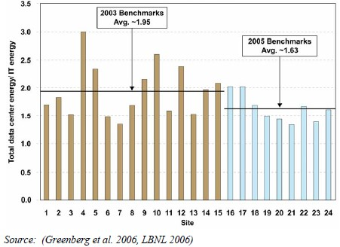
Source: US EPA, Report to Congress on Server and Data Center Energy Efficiency
Public Law 109-431
The PUE of typical data centers is 2.3 to 2.5. A PUE value of 2.0 or lower implies excellent power use efficiency6.
Figure 11 PUE Comparison among Data Centers

An uninterrupted power supply (UPS) that provides power during an outage is an indispensable device for data centers. However, its AC-DC-AC conversion causes energy loss. Since the utility power is AC, it is impossible to reduce this loss to zero. However, the final conversion stage (DC to AC) can be eliminated by adapting the servers to DC power supply.
For air-conditioning, the optimal layout of data center equipment, resolving hot spots by monitoring with temperature sensors, improving performance by liquid cooling, and natural air-cooling are candidate schemes. Needless to say, the power consumption for cooling should be closer to zero.
The reciprocal of PUE is Data Center infrastructure Efficiency (DCiE). It is an index recommended by The Green Grid, a data center industry group in the United States. Its characteristics are the same as PUE. However, it is often preferred because its presentation as a percentage is clearer than a ratio.

DCiE ＝
1 x 100 (%)

PUE

6 NEDO Kaigai (Overseas) Report No.1013 (December 12, 2007)

Regardless of the size of a data center, PUE and DCiE are useful indexes for comparing different data centers. Moreover, by tracing these indexes in a time series, it is possible to quantitatively evaluate the power saving measures (e.g. introduction of power-saving servers, improvement of air- conditioning facility) taken by the data center operator.
As data centers are generally equipped with functions that boost energy consumption such as redundancy for improving reliability, it is preferable to quantitatively evaluate the power consumption by applying the indexes to services, security, and reliability.
In a hosting service that accepts user devices in a data center, the user installs the devices in a rack and wires them. If the installation and wiring work is not appropriate, hot spots and inefficient cooling airflow may occur. Therefore, publishing energy saving measures that can be taken by data center users and evaluations by data center operators on the status of these measures may help cut energy consumption.

7.1.2. Datacenter Performance Per Energy

The recognition and visualization of PUE are accelerating energy saving for facilities. However, PUE is a specialized metric for facility efficiency at data centers and the Green IT Promotion Council of Japan claims it is not satisfactory for representing the overall efforts for energy savings made by data centers. The Council prepared a complementary performance indicator, DPPE (Datacenter Performance Per Energy).

1 1
DPPE = ITEU × ITEE ×—————— × ——————
PUE 1 - GEC

ITEU (IT Equipment Utilization) is essentially the average utilization factor of all IT equipment included in a data center. However, the adoption of a method using the ratio of total measured power to total rated power of IT equipment is under review by examining the ease of measurement in a concrete calculation.

ITEU = Total measured power of IT equipment / Total rated power of IT equipment

ITEE (IT Equipment Energy Efficiency) is defined as the value obtained by dividing the total capacity of IT equipment by the total rated power of the said IT equipment. This metric aims to promote energy saving by encouraging the installation of equipment with high processing capacity per unit electric power.

Total server capacity + total storage capacity + total NW equipment capacity
ITEE = ————————————————————————————————————
Rated power of IT equipment

Where IT equipment that configures a data center is defined as consisting of the following three types: server, storage, and NW equipment. ―total capacity of IT equipment‖ is defined as the total of all the capacities of the server, storage, and NW equipment.

GEC (Green Energy Coefficient) is a value obtained by dividing Green Energy produced and used in a data center by total power consumption (Fig. 8). Introduced to promote the use of Green Energy, from a power consumption reduction point of view it is positioned differently than the other three metrics defined above.

Green Energy
GEC = ———————————————
DC total power consumption

7.1.3. ASP/SaaS Operators

When users evaluate and select ASP/SaaS and other services in general, they look at the characteristics of the services such as fees, contents, reliability, and guarantees. Given global warming parameters on power consumption and GHG emissions, for example, users could select service operators based on their environmental attitude. The parameters could also be used by service operators to promote themselves. Thus, the global warming parameters are advantageous for both users and operators. The environmental impact basic unit, which represents the power consumption or GHG emissions per unit of service, is considered to be a useful parameter.
Therefore, if the amount of GHG emissions (or power consumption) per unit of ASP/SaaS service can be indicated quantitatively in a clear format, it would be an effective index for evaluating and selecting operators from an environmental perspective. The following formula is one example.

Environmental Impact Basic Unit for ASP/SaaS Services

= GHG Emissions (or Power Consumption) per Unit of ASP/SaaS Service

= (Annual GHG Emissions (or Power Consumption) from the Target Service) (Annual Service Supply)

ASP/SaaS services are diverse but it is not necessary to indicate the environmental impact basic unit for every service; it may be sufficient to show the environmental impact basic units in a common usage environment for some typical ASP/SaaS services.
In general, the above formula seems to give a purely logical estimation by dividing the annual power consumption of the equipment of an ASP/SaaS operator under certain conditions by the total amount of services provided. However, as described in the previous section, the PUE and GHG emissions factor of the data center where the equipment is installed affects the calculation. Therefore, it is necessary to undertake calculations and evaluations based on the actual data over a certain period of time.
Therefore, it would be preferable to review an effective way to indicate and check environmental impact by means of basic units, such as defining the process of calculation and evaluation under an actual environment for a certain period, and in some cases, providing a mechanism for performing reliable verifications by third parties.
With a view to introducing methods that establish basic units for the definition and assessment of environmental impact with respect to ASP/SaaS services, it would be preferable for specialists to conduct detailed examinations at ITU.

8. Use Cases of Green ICT

8.1. Case #1: Teleworking

8.1.1. Teleworking

This section shows as an example of provisionally calculating the proving test result of the reducing environmental load decrease before and after the teleworking introduction into small and medium manufacturers in Japan with two or more domestic branches and overseas offices.

8.1.1.1. Objective of experiment

The amount of the CO2 emission when telecommuting and the teleconferencing are done by using the teleworking system in case of the case to execute the business in the office is calculated.
The comparison verification in the effect of the reducing environmental load decrease by the teleworking system introduction is done by measuring and estimating the change in the reducing environmental load when doing by using the teleworking system in case of the case to do the business in the office in the remote place (teleworking base in home and an overseas office, etc.) as well as the business in the office.

8.1.1.2. Functional unit

A. Office work / Telecommuting

In Tech wing, the production department of display equipment manufacturing sales companies and business of 43 days of 16 employees of management section are experiencing telecommuting.

B. Business trip conference / Teleconferencing

Six conferences at which Toyama headquarters and each branch (Tokyo business branch, Osaka business branch, Nagoya business branch, Fukuoka business branch, and Thailand business branch) participates.

8.1.1.3. System boundary

The teleworking system that introduces it is ubiquitous VPN, and Software as a Service type video conference system.

• The proving test period: 17 in January, 2012～March 11, 2012
• Area：Toyama(Headquarters),Tokyo,Osaka,Nagoya,Fukuoka,Thailand(Bangkok)
- Before introducing the teleworking
• Office : ICT equipment, air-conditioning, lighting, commuting (business trip)
- After introducing the teleworking
• Home : ICT equipment, network, air-conditioning, and lighting
• Office : ICT equipment, network, air-conditioning, lighting, commuting (business trip)

8.1.1.4. Results of the evaluation

Two of the teleworking (telecommuting and the teleconferencing) were evaluated. The amount of the CO2 emission of the public transportation facility (airplane, train, and bus) by the car that was a substantial load that it was a movement and was the reduction potential was calculated.

A. Office work / Telecommuting

Figure 12 shows the evaluation result of the reducing environmental load before and after the teleworking introduction.
140 people in total executed telecommuting in 43 days, and 15 people in 16 people use and are commuting to telecommuting the car. In the fuel consumption mileage of the movement car of each one, 8.6～25 l/km and moved distance are one way 4～32 km. The reducing environmental load by
running of the car was reduced because the commuting movement was good that the teleworker did not do, and the effect of the reduction was about 260 kgCO2. It was assumed that the ICT equipment

of the office, air-conditioning, and the amount of the lighting of the CO2 emission were the same in this evaluation before and after the introduction. Therefore, the amount of the CO2 emission with the ICT equipment, air-conditioning, and the lighting used at home increases.
The value of the commuting movement before it introduces it contains the load of the car that 16 teleworkers used for the commuting movement in 43 days. The effect reduced because the commuting movement is good to the value of the commuting movement after it introduces it that the teleworker is not included.
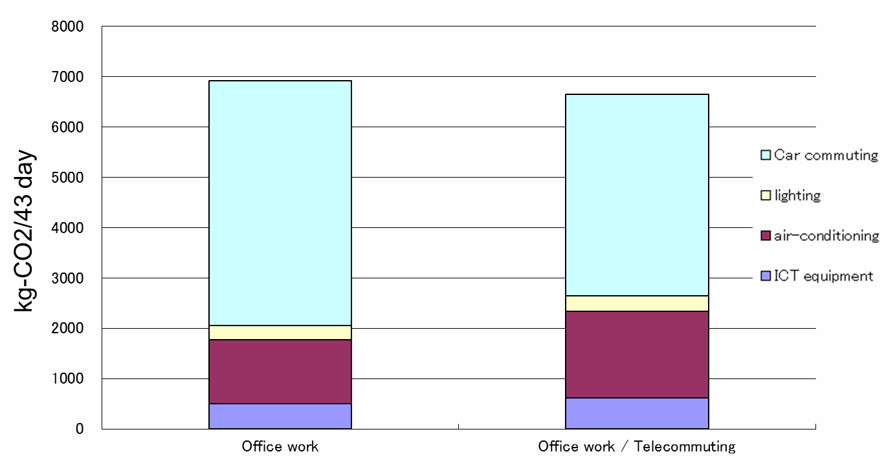
Because the reducing environmental load by the commuting movement was reduced, it became the result of achieving the effect of the reduction of about 260 kgCO2 though the reducing environmental load of the ICT equipment, air-conditioning, and the lighting increased after it had introduced it compared with before it introduced it.

Unit: kg-CO2/43 day
 | ICT equipment | air-conditioning | lighting | Car commuting | Total
Office work | 499.00 | 1273.84 | 275.33 | 4865.32 | 6913.49
Office work / Telecommuting | 615.73 | 1719.36 | 309.73 | 4006.27 | 6651.08
Figure 12 Amount of CO2 emission in office work and telecommuting

B. Business trip conference / Teleconferencing

Figure 13 shows the evaluation result of the reducing environmental load of the business trip conference and the reducing environmental load of the teleconferencing.
The participation frequency and the number of participation total at six conferences from each branch are as follows. Tokyo business branches are six times (thirteen people). Nagoya business branches are three times (three people). Osaka business branches are two times (two people). Fukuoka business branches are four times (four people). Thailand business branches are two times (two people).
Moved distance is one way 300～4500 km. The load of the car (Osaka business branch and Nagoya
business branch) moved to gather from each business branch to the office headquarters and the public transportation facilities (Tokyo business branch, Fukuoka business branch, and Thailand business branch) is included in the value of the commuting movement when conferring on the business trip. Because the movement at the teleconferencing is not generated, the load of the movement is 0.

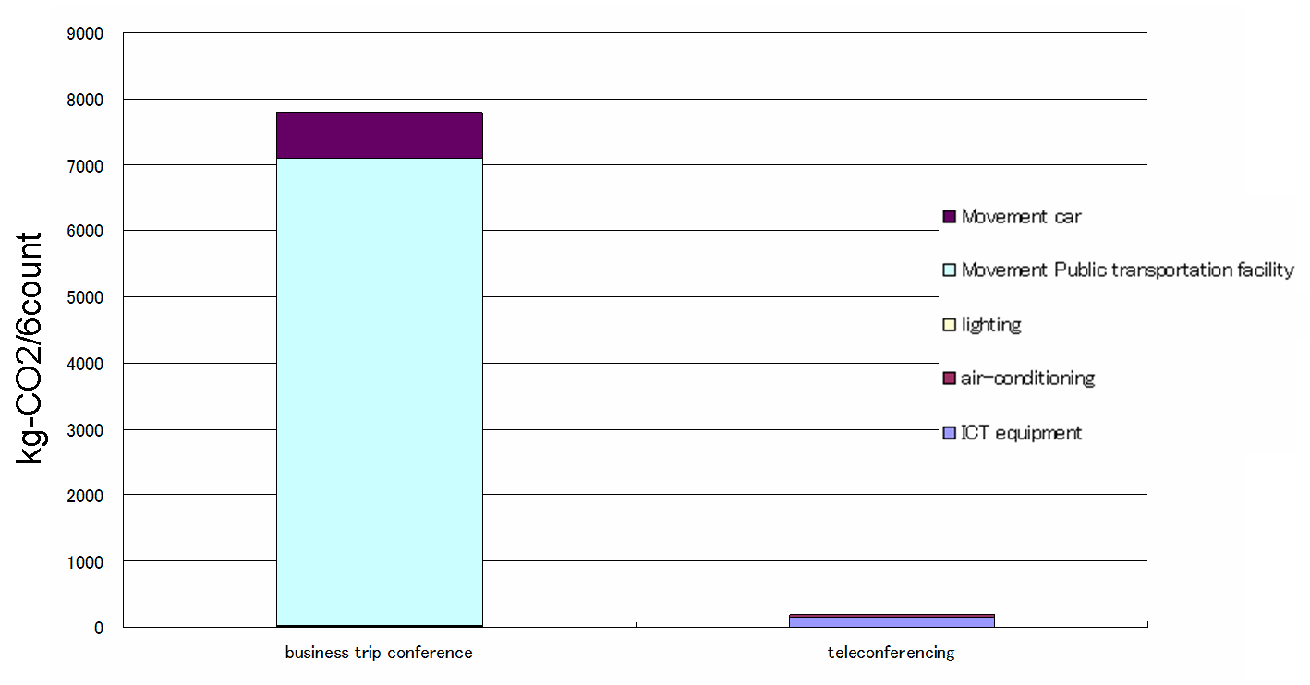
Unit： kg-CO2/6count
 | ICT equipment | air-conditioning | lighting | Movement |  | Total
 |  |  |  | Public transportation facility | car
business trip conference | 11.44 | 25.30 | 0.12 | 7062.21 | 692.55 | 7791.63
teleconferencing | 154.16 | 38.10 | 5.34 | 0.00 | 0.00 | 197.61
Figure 13 Amount of CO2 emissions in business trip conference and teleconferencing

After it had introduced it compared with the business trip conference before it introduced it, the effect of the reduction of about 7,600 kgCO2 was achieved because the reducing environmental load according to the business trip movement was reduced though the amount of the CO2 emission of air- conditioning and the lighting that the employee at the ICT equipment and each business branch to do the teleconferencing used increased.
In the breakdown of the reducing environmental load of the movement (Figure 12), the reducing environmental load by the use of the public transportation facility is about 7,062 kgCO2, and the reducing environmental load by the use of the car is about 690 kgCO2.
The reducing environmental load in the public transportation facility is reducing environmental load reduction potential.
It is a reducing environmental load for the number of service of airplanes and the operation number of the train to decrease in the future because the number of users of public transportation facilities decreases, and to be able to expect the reduction though the reducing environmental load doesn't reduce the reducing environmental load reduction potential at once.
It becomes possible to show the effect of the reducing environmental load reduction when the progress of a substantial effect of the reducing environmental load reduction and the world is considered by separately evaluating the reducing environmental load in the public transportation facility (airplane, train, and bus) that it is a movement and is the reduction potential by the car that is a substantial like this reducing environmental load.

8.2. Case #2: Plant Farm

Plant factory is a highly efficient system which can continuously and systematically produce plant by using automation of cultivation process, optimal control of environment such as light, temperature, humidity, speed of air and nutriment in the closed space. Meanwhile, Smart farm is a cultivation

method that can save the cost of production and enforce the quantity and quality of plant by making data into knowledge and elaborate remote control and monitoring with ICT [33]. Korea Telecom developed a remote control and motoring solution for smart farm. KT combines the smart farm for the plant factory with ICT, which can solve problems such as global warming, soil pollution, population growth, etc. The plant farm requires much energy to seal and control temperature. By utilizing ICT, plant farm can reduce the effort to control those requirements as well as energy and cost such as automatic control and remote monitoring, power monitoring and analysis, sensor networks, etc.

8.3. Case #3: Green BTS Energy and Equipment and Green Office

Indonesia tries to experience the ―green living.‖ As one of those activities, the greening in cellphone communications is also concerned. Hence, Indonesia concerned the Green Base Transceiver Stations (BTS) because BTS requires huge amount of energy. Indonesia constructed over 2,200 Green BTS throughout Indonesia including 164 solar cell BTS, located in Sumatra, Java, Bali, etc. Besides, Indonesia constructed the hydrogen-fuelled BTS environmentally friendly [34].
In 2009, WWF launched the WWF Green Office program in Indonesia. WWF Green Office program is suitable for both small-sized and large-sized offices, private or public. The Green Office program also aims to save forests, reduce emissions of carbon dioxide, and support environmental conservation efforts in Indonesia [35]. As the implement the green office, the business district (BSD) Green Office Park is constructed in Indonesia [36]. It is located in the heart of BSD city. The BSD Green Office Park is to create a sustainable environment to work, live, and play within a landscape park setting to achieve a high quality of living. The BSD Green Office Park incorporates various kinds of technologies to conserve energy, water, and natural resources.
Some telecommunication operators in Indonesia have made efforts to reduce CO2 emission in the framework of Green ICT.

A. PT Hutchinson CP Initiatives

PT. Hutchison CP is the first telecommunication operator in Southeast Asia which has been operating hydrogen BTS commercially in a relatively large quantities. PT Hutchinson CP has been using hydrogen BTS since February 2009 and, until early 2011, 472 BTS hydrogen have been installed. Alternative energy technologies used for these base stations use hydrogen cells which is clean, pollution free, energy-efficient, and environmentally friendly. The use of hydrogen has several advantages: producing water as disposal which is not harmful to the environment, increasing electrical power, providing durable power reserve, and also saving maintenance costs.

B. PT Telkomsel Initiatives

Recognizing the limitations of fossil energy sources and realizing the need for mutual awareness to help preserving nature, Telkomsel has been continually seeking environment friendly technologies, especially in the construction of a network device. Telkomsel has deployed green base transceiver stations (BTS) utilizing alternative energy sources and environmentally friendly technologies which are suitable with the geographical condition of Indonesia. By the end of 2010, Telkomsel has installed more than 2,200 green BTS spread through various regions in Indonesia. The green BTS classified into two categories, namely:

(i) BTS utilizing alternative energy sources to produce environment friendly electric power. (ii) BTS implementing environmental friendly technologies in terms of electricity
consumption and environmental aesthetics.

C. Sources of environmentally friendly alternative energy

The use of alternative energy sources has become one of the efforts to ensure the availability of power supply required to operate BTS. This step was taken to obtain solutions to various constraints facing the power supply, such as: unavailability of electrical energy sources in an area, the difficulty to access fueling station for generators, and the scarcity of fuel that cannot be predicted. Moreover, the cost of alternative energy sources is now cheap.
Telkomsel has been continually conducting research and development of the use of alternative energy sources which are environment friendly as an effort to maintain the service performance and corporate performance in the future. Alternative energy sources that have been used by Telkomsel is solar cell. 164 Telkomsel‘s solar cell BTS Telkomsel spread through various regions across Indonesia, namely Sumatra (78 BTS), Java (7 BTS), Bali Nusa Tenggara (23 BTS), Kalimantan (34 BTS), Sulawesi, Maluku and Papua (22 BTS). Overall the green BTS produce approximately 0.115 megawatts, or nearly the equivalent of 100 conventional generator with capacity of 20 kVA.
In addition to using solar cell, Telkomsel also use hydrogen fuel cell at 11 sites in Sumatra . The advantages of these alternative energy sources are, among others, noise free because there are no moving parts, pollutant free (non-toxic and odorless) because the wastes generated is H2O, and has the efficiency much better than conventional system.
To operate BTS in regions which have difficulties in getting solar energy, Telkomsel has developed hydro Micro BTS utilizing river flow to generate electricity. Micro Hydro BTS is very important in opening isolated regions, creating new employment (such as prepaid card merchants), and provide environment friendly energy alternative that can be directly beneficial to local people, in which electricity supplies generated by BTS can be used to increase daily productivity, especially at night. Currently Telkomsel has 2 micro hydro BTS located in Suoh sub-district, West Lampung District, Lampung Province and Sumalata, District of North Gorontalo, Gorontalo Province.
In the future, Telkomsel will develop other alternative energy sources suitable with Indonesia's geographical conditions, such as base stations utilizing organic fuel (bio-fuel).

D. Environment friendly technology

In an effort to support the creation of a more beautiful environment, Telkomsel applies environmentally friendly technology solutions to the network device. Various attempts were made, both in terms of saving of power consumption and environmental aesthetics.
Modernizing equipment by installing a low power consumption system becomes one of the priorities to save electricity consumption. The application of these systems includes the application of intelligent power management solution for new base stations and utilization of fiber optic transmission line to the base stations antenna.
The application of these systems produce very significant electricity consumption saving, where usual demand for electricity of a BTS can be reduced from 4000 watts to 1,000 watts or saver up to 75 percent. This solution is also able to lower the voltage requirement on the BTS which used to require an average of 16 kVA now require 8 kVA or 50 percent saver.
Telkomsel has apllied these environment friendly technology to 2000 BTS in Jakarta and its surrounding cities (900 BTS), Semarang (300 BTS), Solo (250 BTS), Yogyakarta (250 BTS), and Lampung (300 BTS).
In terms of environmental aesthetics, Telkomsel implements solutions that support the beauty of the environment through the BTS hotel project placing multiple base stations with fiber optic technology in one location. This solution is applied to reduce the number of BTS which quite takes up space in a region. Currently there are 10 BTS Hotel locations, ie 8 points in Jakarta and 2 points in Denpasar.
In addition to the BTS Hotel, Telkomsel is also developing innovative camouflage antenna (towerless). This solution enables the base station antennas installed in various public facilities that are disguised, like the minarets, trees, light poles, water tanks, and so on. Totally there are about 50 camouflage antenna points located in Jakarta, Bandung , Semarang , and Surabaya .
Telkomsel also supports eco-friendly campaign on reducing resources consumptions by managing office resources through office automations implementations as follows:

a. Office Automation. Principle of ―Office AnyWhere, Anytime‖) is to fasten information delivery, fast respond & fast decision making process, real time process by empowering employee‘s e- Access. (Email access through BB & Device, SMS notifications, Information system).
- HRIS (Assessment, e-Learning, KPI, Medical Reimbursement) by SMS & email notification.
- Meeting room request, Operational & Non Op Vehicle Request, Accommodation
&Ticketing by SMS notifications
- E-Correspondence /internal NoDin integrated hierarchical flow approval (Start 2010 all region & area) by email
b. E-Justifications (previously as conventional formal document to justify PO projects, containing detail descriptions) est.6 – 20 paper sheet, now go paperless.
c. E-Procurements (simplifying process on bidding, and interface to vendor/ provider/ applicants).

E. PT XL Axiata Initiatives
PT. XL Axiata has also been seeking ways to reduce GHG emission including the use of non-CFC air conditioning, battery charge-discharge (CDC), intelligent ventilation system (IVS), and Green BTS.

F. PT Axis Telecom Indonesia Initiatives

PT. Axis Telecom Indonesia has deployed base stations with solar cell, hydrogen fuel cell, and methanol fuel cell in the framework of green ICT.

8.4. Case #4: Green Data Centers

8.4.1. Basis Bay Green Data Center Initiatives

Basis Bay launched two of the very first Green Data Centers in Malaysia in Cyberjaya, and
Glenmarie in the state of Selangor. The two data centers in Cyberjaya and Glenmarie occupy a total of
100,000 sq ft and provide server co-location, hosting, disaster recovery, business continuity management, remote infrastructure management and cloud computing services. The two are Tier IV data center enabled with fully redundant components and environmentally conscious features. Data centers have long been known for its high energy consumption, but in an economy driven by global enterprise computing, data centers have become indispensable tool in accelerating business growth. These data centers are established with the goal to be as efficient as possible in terms of their power utilization and are environmentally friendly as possible in terms of any direct gaseous or liquid emissions to the environment.

8.4.2. Basis Bay Green Data Center Design

The design closely matches the criteria outlined by The Leadership in Energy and Environmental Design (LEED) Institute and the Uptime Institute, the authority in Data Centre certification. Their features can be divided into three aspects – namely architectural, civil and structural, and mechanical and electrical.

A. Architectural

The architectural aspect employs common principles to keep heat out to minimize load on the air conditioning system.

a) The building is oriented in the north-south direction to avoid the rising and setting sun and keep the building naturally cool and reduce cooling costs.
b) The roof is shaped like a bathtub, with a 20 meter wall running all around it so that the roof only receives the full force of sunlight around midday, which minimizes overall heat exposure.
c) To reduce heat absorption to the floor below, a 50mm thick polyurethane foam insulation with
a density 2 pounds per square foot is applied to the underside of floor slab and on the floor slab below.
d) Tinted glass façade and blinds installed at strategic locations to allow natural visible light in to provide natural lighting during daytime, while preventing the entry of ultra violet and infra-red rays which cause heating.

B. Civil and Structural

For its civil and structural aspects, while Basis Bay followed the guidelines provided by Uptime Institute and the LEED Institute, it also paved the way for Malaysian companies to marry the best practices of several fields and applied them to data centers.

a) Aluminium color bond scupper channel drain is used to prevent drastic changes in temperature between the inside and outside of the data centre.
b) Double brick cavity wall with cement and plaster on both sides comes with 50mm thick thermal and sound insulation in between.
c) Paints and sealants without volatile organic compounds are used in the building, as well as porous and reflective materials in its construction avoid heat absorption.
d) Diesel fuel bulk storage tank for its standby generators is located above ground to avoid the possibility of leakage into the underground water table or soil. Grease trap prevents excess diesel spillage into the drain and can be collected for proper disposal.
e) Plan is underway to adopt rainwater harvesting for use in its garden and plants, as well as to flush toilets and urinals to reduce dependency on municipal water supply.

C. Mechanical and Electrical

a) The data centre uses photovoltaic (PV) solar powered street lighting poles to reduce the electrical consumption for compound lighting. The fully charged batteries can last for three days without sunlight, with a maximum of 12 hours per day operation.
b) Strategic lighting switches are carefully positioned according to workflow and layout requirements. At any given point, there will not be an entire floor that is lit up. A 2amps energy efficient ‗Halo‘ light around the rooftop is used for aesthetic effects.
c) The energy-efficient computer room air conditioning on average uses 45% less power. It is built using environmentally-friendly recycled materials and uses ecologically-compatible refrigerant.
d) Hot air from the air conditioner will be used to provide hot water to the toilets in the building. e) Sensor lights will automatically be switched on in working areas and switched off when not
required to further save energy. These features will be incorporated in stages.
f) Centralized monitoring system monitors the temperature around different devices and adjusts the cooling temperature within in the vicinity of the device accordingly.

It is estimated that these initiatives can save between 20% and 30% of costs, depending on the servers and other equipment hosted within these data centre.

8.5. Case #5: E-health

8.5.1. E-health – life cycle assessment of ICT enablement potential

ICT solutions can have significant transformative impacts on energy consumption and CO2
emissions, as seen in an e-health system provided by Ericsson in Croatia.
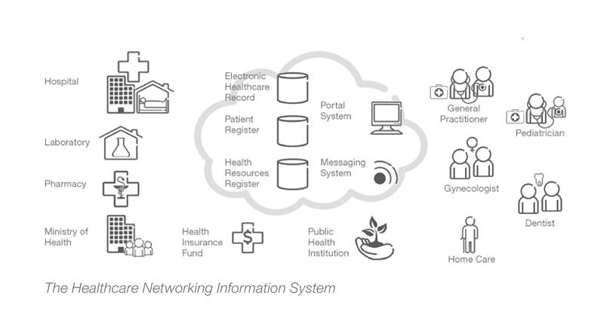
Connecting 2400 primary healthcare teams in the 20 counties and the capital, Zagreb, the Healthcare Networking Information System (Figure 14) provides electronic reporting and booking, updates patient records, and digitalizes prescriptions and referrals, so they can be sent to pharmacies, hospitals and laboratories without the need for printouts.

Figure 14 The Healthcare Networking Information System

8.5.1.1. Objective

The purpose of the study was to understand the CO2 reduction potential for adopting e-health widely across Croatia. The intended audience for the e-health delivery system from Ericsson is policy makers in Croatia. Since policy makers make long-term planning decisions on infrastructure and consider introducing policies to incentivize adoption, the scale of adoption for this study was quite large.

8.5.1.2. Scope

In this case study, the ICT system included the software and equipment required for the e-health system. The components of the system were PCs and data centers. The Business As Usual (BAU) system covered the existing healthcare system, including all associated activities and emissions. Changes to these emissions resulting from enabling effects identified the relevant BAU components. The Figure 15 summarizes all potential effects that were identified. The primary enabling effects of the e-health delivery system were reduced private vehicle use by eliminating unnecessary trips to the doctor and reduced paper use through the ability to prescribe online. Relevant components associated with these effects were private vehicles and paper. Adoption of an e-health delivery system could generate several potential secondary enabling effects. Many of them require greater time and scale of adoption to occur.
For instance, if the broader population were to reduce its use of public transportation, bus and train services could be run less frequently. Sufficiently widespread adoption could even cut public and private vehicle construction, as routes were cancelled, or families consolidated vehicle use. With fewer

vehicles on the road, the need to construct or re-pave roads might also decrease. These effects would be beyond consideration when assessing an e-health system‘s impact on a single clinic, but given the national implications, these would be all relevant effects to consider when applying this methodology. Additional effects could have been identified and included for assessment. Fewer patient visits could allow clinics to shorten their hours, reducing energy consumption. The e-health system would also help existing infrastructure to support greater numbers of patients per doctor/nurse/pharmacist, so as the Croatian population grew, a proportional expansion in number of clinics could be avoided.

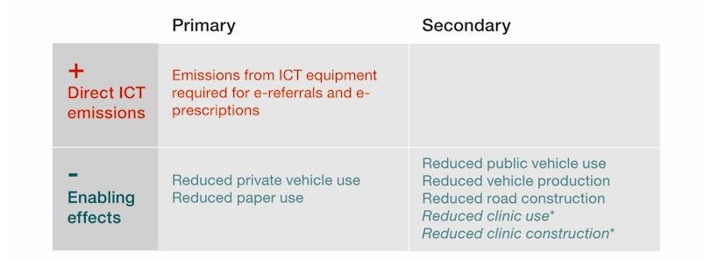
Figure 15 Potential effects of e-health delivery system implementation (Source: Evaluating the
carbon-reducing impacts of ICT, GeSI 2010) *not considered in this case study

8.5.1.3. Result

Calculations to arrive at the figures in Figure 16 used a mix of secondary and modeled data. The following assumptions were made:

• The e-referral service can reduce paper visits (approximately 12 million per year) by 50%.

• On average, patients travel 10km + 10km per visit. Twenty-five percent of patients travel by car; the other 75% by public transport.

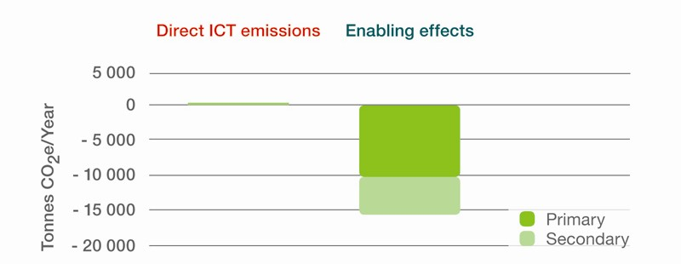
• The e-prescription service can reduce paper consumption by 50%.

Figure 16 E-referrals and e-prescriptions impact

Secondary and other data was used to determine average paper production and Croatian electricity differences from globally reported figures. Croatian demographic data was used to guide assumptions. As the e-health delivery system runs on PCs rather than a dedicated e-health device, a decision was also made to allocate emissions from the entire solution infrastructure to e-referral and e-prescription. Taken together, the e-referral and e-prescription services have the potential to reduce CO2e emissions by up to 15,000 tonnes per year while the two services only add 330 tonnes of CO2e/year from operation and manufacturing activities.
The potential reduction ratio over a 20-year period is up to 1:45, depending on whether infrastructure is included and, if so, to what extent.

8.6. Case #6: Mobile money

8.6.1. Mobile money Kenya – life cycle assessment of ICT enablement potential

In rural areas in developing markets such as Kenya, the banking infrastructure is limited. This makes it necessary to travel to the nearest town to pay for water and electricity and to refill a mobile phone prepaid account.
Making a loan repayment requires a daylong expedition to the nearest bank – 12 km away – if the money sent from relatives abroad has arrived. With the Mobile Money solution, all this can be achieved without leaving home, making it unnecessary to travel. The three main uses (Figure 17) are: money transfer, local payment and bank services.

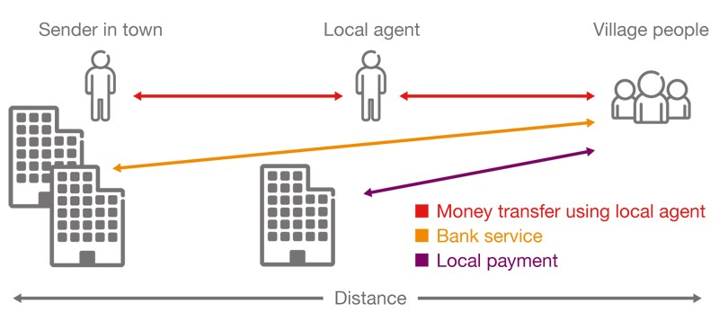
Figure 17 Mobile Money studies use cases

8.6.2. Objective

The purpose of the study is to understand the potential of the widespread use of Mobile Money throughout Kenya, one of the leading markets for this type of solution. The results demonstrate the enabling effects of solutions implemented by our industry for the intended audience: policy makers and the general public.

8.6.3. Scope

In this case study, the ICT system includes the use of the mobile network and mobile phones to perform the transactions required in the different cases. The application software is assumed to be deployed in a data center including power, cooling, building infrastructure, etc. The same applies to the back office call center.

The traditional Business As Usual (BAU) system means that individuals are forced to travel from rural areas to more central villages and bank offices in the cities in order to make payments and carry out other bank transactions. Typical transactions include remitting money, paying bills, etc.
The primary enabling effect of the Mobile Money service is less travel by bus (or by car, which is done in some cases, but is not considered in this study). Even though banking is usually a coordinated effort from the village (one individual may make the trip to handle banking errands for several other people) this results in extensive travel and security risks.
Secondary enabling effects include the potential reduction in the number of buses needed because fewer trips will be required. A related effect is also that the road system will last longer and that extensions of capacity can be limited. By spreading the use of the Mobile Money service and similar ICT solutions, the need to have cash in circulation would be drastically reduced, as would other aspects of the bank-related infrastructure like bank offices, ATMs, etc.
However, the potential secondary effects have not been included in the case because we considered an implementation in one operator network.
On a larger scale and with a longer-term perspective, they would warrant consideration. The Figure
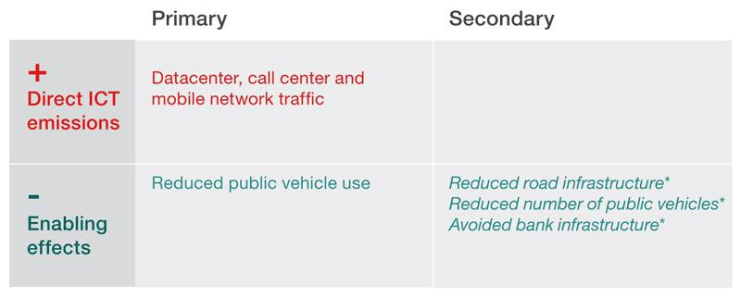
18 summarizes all potential effects that were identified.

Figure 18 Potential effects of Mobile Money implementation. (Source: Evaluating the carbon- reducing impacts of ICT, GeSI 2010). *not considered in this case study

8.6.4. Result

The result in Figure 19 is based on a mix of secondary and modeled data. The following assumptions were used:

Money transfer:

• 1-2 transactions a month per subscriber

• 1,000 agents travel to town instead of subscribers

• 1 person normally handles money for

• 5 people in BAU Local payment:
• 1 payment a month made using the mobile service (for 3-4 bills)

• Distance to local town/agent for utility/water/phone company: average 2 km each way

• Bus travel

• Normally a payment takes half a day

Bank service:

• 1 bank service every 6 months (loan payment, microfinance)

• Bank branches: one per 1,000 km2

• Average 12-km distance each way

• Bus travel

Taken together, the three cases have the potential to reduce CO2e emissions by up to 22 kg CO2 per subscriber a year while only adding 0.34 kg CO2 per subscriber a year. The absolute reduction would be about 140 tones CO2/year if adopted by 6.5 million subscribers in Kenya, while 2.1 tonnes would be added.
The potential reduction ratio over a 20-year period could be 1:65, depending on whether the infrastructure is included and, if so, to what extent.

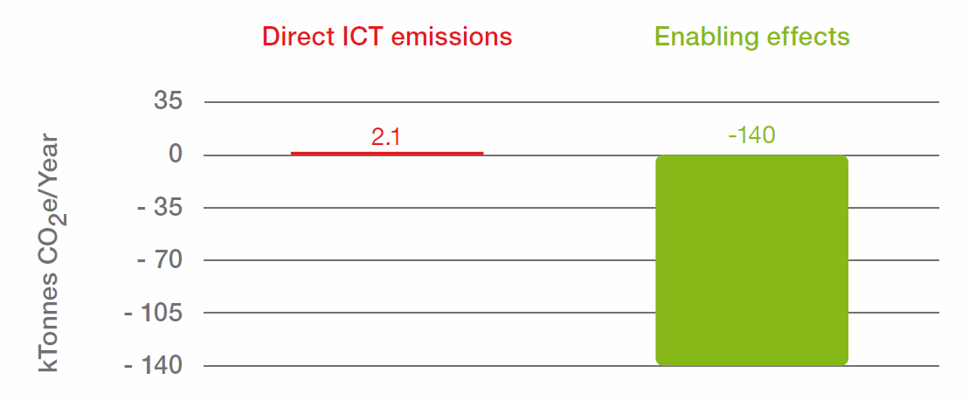
Figure 19 The impact of Mobile Money

9. Reference Documents List

[1] Samyoung Chung, KCC, ASTAP -16 ICT & Climate Change.
[2] Hyoung Jun Kim, ETRI, Green ICT international standard report in ICT Forum Korea 2010. [3] The Global eSustainability Initiative, ―SMART2020: Enabling the low carbon economy in the
information age,‖ 2008, http://www.gesi.org/ReportsPublications/tabid/60/Default.aspx

[4] WIKIPEDIA, ―Green computing,‖ http://en.wikipedia.org/wiki/Green_computing

[5] ITU Radiocommunications and Climate Change, June 2007.

[6] Alexandre Vassiliev, ITU-BR, ICTs in Climate Monitoring and Prediction and Disaster
Mitigation.

[7] RESOLUTION [COM3/6], Hyderabad, 2010. [8] ITU Report-ITU and Climate Change, 2008.

[9] TD 461(GEN/5) Working Part3/5 Report

[10] T09-TSAG-100208-TD-GEN-0147_Focus Group_Cloud Computing

[11] T09-TSAG-100208-TD-GEN-0146_Focus Group_Smart Grid

[12] Roger Forest, ISO, “ISO launches development of future standard on energy management,”
ISO News, September 2008, http://www.iso.org/iso/pressrelease.htm?refid=Ref1157

[13] Chan Kook Weng and Kevin Boehmer, ―Launching of ISO 14064 for greenhouse gas accounting and verification‖ ISO Management Systems, http://www.iso.org/iso/iso14064_ims2_06.pdf

[14] IEC, ―TC 111,‖ 2008, http://www.iec.ch/dyn/www/ftp=102:7:0::::FSP_ORG_ID:1314

[15] Jonas Sundborg, Ericsson / ETSI Board member, “ETSI Green Agenda,” The 13th Global
Standards Collaboration, July 14, 2008.

[16] ATIS, “Transmittal of ATIS Energy Efficiencies Specifications,” ITU-T FG-ICT&CC LS3, http://www.itu.int/md/T09-FG.ICT-IL-0003/en
[17] GHG Protocol Initiative, ―GHG Protocol,‖ http://www.ghgprotocol.org/ [18] OECD, “ICTs, the Environment and Climate Change,” August 2010,
http://www.oecd.org/sti/ict/green-ict

[19] OECD, “Smart Sensor Networks: Technologies and Applications for Green Growth,”
December 2009, http://www.oecd.org/dataoecd/39/62/44379113.pdf

[20] OECD, “Towards Green ICT Strategies: Assessing Policies and Programmes on ICT and the
Environment,” June 2009, http://www.oecd.org/dataoecd/3/7/44001912.pdf

[21] WWF, “Information and communication technologies (ICT),” August 2010, http://wwf.panda.org/about_our_earth/all_publications/ict/

[22] WWF, “Sustainability at the speed of light,” July 2002, http://assets.panda.org/downloads/wwf_ic_1.pdf

[23] WWF and ENTO, “Saving the Climate at the speed of light,”
http://assets.panda.org/downloads/road_map_speed_of_light_wwf_etno.pdf

[24] WWF, “Outline for the first global IT strategy for CO2 reductions,” 2009, http://assets.panda.org/downloads/global_strategy_for_the_1st billion_tonnes_with_ict by_ wwf.pdf

[25] WWF, “The potential global CO2 reductions from ICT use: Identifying and assessing the opportunities to reduce the first billion tonnes of CO2,” May 2008, http://assets.panda.org/downloads/identifying_the_1st_billion_tonnes_ict_academic_report_w wf_ecofys.pdf

[26] WWF, “Communication Solutions for Low Carbon Cities: Helping cities to reduce CO2 with existing low carbon ICT solutions,” http://assets.panda.org/downloads/communication_solutions_for_low_carbon cities.pdf

[27] WWF, “A five-step-plan for a low carbon urban development: Understanding and implementing low carbon ICT/telecom solutions that help economic development while reducing carbon emissions,” 2009, http://assets.panda.org/downloads/wwf_ericsson_5_step_plan.pdf

[28] WWF, “From Workplace to Anyplace: assessing the global opportunities to reduce greenhouse gas emissions with virtual meetings and telecommuting,” March 2009, http://assets.panda.org/downloads/wwf_from_workplace_to_anyplace_final.pdf

[29] WWF, “From fossil to future with innovative ICT solutions: increased CO2 emissions from ICT needed to save the climate,” March 2008, http://assets.panda.org/downloads/fossil2future_wwf_ict.pdf

[30] WWF, “From coal power plants to smart buildings at the speed of light: How urbanization in emerging economies could save the climate,” March 2008, http://assets.panda.org/downloads/wef_2008_ict.pdf

[31] The AIM project, “AIM architecture,” December 2008, http://www.ict-aim.eu/about-aim/aim- architecture/

[32] The AIM project, “Project information,” July 2009, http://ec.europa.eu/information_society/events/ict4ee/2009/docs/files/projects/projects/AIM/AI M-leaflet.pdf

[33] ByeongSook Bae, "Green Innovation by IT based Smart Farm," KT, Industry Workshop - ASTAP - 18.

[34] ―Indonesia‘s mobilephone operators go for ‗green‘ initiatives,‖ The Brunei Times, June 1,
2011.

[35] ―Green Office-About Green Office,‖ WWF, Indonesia.

[36] BSD Green Office Park, http://bsdgreenofficepark.bsdcity.com

Contributors to develop the white paper:

Dr. Sam Young Chung, Korea (Republic of)

Mr. Morteza Ghaffar Tabrizi, Islamic Republic of Iran

Mr. Kanhaiya Lal Gupta, Nepal

Mr. Saneh Saiwong, Thailand

Dr. Hyojin Kim, Korea (Republic of)

Mr. Yong-Woon Kim, Korea (Republic of) Dr. Kishik Park, Korea (Republic of)
Mr. Aisharuddin Bin Nuruddin, Malaysia

Mr. Mohd Nazir Osman, Malaysia Mr. Fredrik Guldbrandsson, Sweden Mr. Mochamad Hadiyana, Indonesia Mr. Koichi Fujinuma, Japan
Ms. Sri Su, Indonesia

Mr. G Alan Horne, Vanuat

Mr. Phil Philippo, Republic of the Marshall Islands

Mr. B. Otgonchimeg, Mongolia

Mr. Paula Ma'u, Kingdom of Tonga Mr. L.Ganeshamoorthy, Sri Lanka Ms. Ambika Gurung, Bhutan
Mr. Sean Weekes, Nauru

