APT GUIDELINE

ON

REFERENCING INTERNATIONAL STANDARDS IN DEVELOPING NATIONAL STANDARDS IN THE FIELD OF ICT

No. APT/ASTAP/REPT-44
Edition: June 2021

Adopted by
The 33rd APT Standardization Program Forum (ASTAP-33)
7 – 15 June 2021, Virtual/Online Meeting

(Source: ASTAP-33/OUT-11)

Guideline on Referencing International Standards in Developing National Standards in the field of ICT

Summary

The growing dependence of information society on information and communication technology (ICT) has made ICT standards an integral issue in national and global economy. Industries and governments all around the world recognized global standards as an important strategic tool in fostering economic growth and public safety. National governments employ standardization as a tool in implementing public policies to enhance quality of life by ensuring the minimum quality of products and services as well as public safety. Standards also contribute to the development of industries by encouraging innovation and rapid, efficient dissemination of information and by promoting economies of scale.
Accordingly, it is crucial for national governments to develop technical regulation and national standards to regulate and/or guide ICT equipment and facilities as well as promote the development of ICT industry.
This guideline aims to provide better understanding on standards and standardization framework as well as basic principles and cases of referencing international standards when developing national standards in order to assist developing countries in developing national standards utilizing international standards.
The main parts of this guideline are from chapter 4 to 8. Chapter 4, Introduction to Standards, deals with the definitions, purposes, benefits and procedures of standards and standardization. This chapter also helps readers acquire a comprehensive understanding of overall standards and standardization, e.g. domestic and international standards, mandatory and voluntary standards, de jure and de facto standards, standards developing organizations and IPR issue in standards.
Chapter 5, Standards Development, describes standardization framework, including legislation, policy, and systems related with standardization. It also explains general principle of developing national standards as well as operational issues in standardization process. This chapter is designed to provide comprehensive understanding the overall concept of standardization process.
Chapter 6 and Chapter 7 introduces some cases on standards development system and national standards in some countries respectively so as for readers to understand chapter 4 and chapter 5 more practically.
Finally, even though every effort has been made to check all the information in this document for accuracy, unintentional errors may have occurred while collecting, editing, and processing the information.

Keywords
International Standards, National Standards

Table of Contents
1 Scope of Guideline 1
2 References 1
3 Abbreviations and acronyms 1
4 Introduction to Standards 1
4.1 Definition of Standards 1
4.1.1 Objectives and Functions of Standards 5
4.1.2 Additional Functions of Standardization Activity 6
4.2 Types of Standards 6
4.2.1 Classification by Scope of Application 6
4.2.2 De Jure Standards, De Facto Standards, and Forum Specifications 7
4.2.3 Compulsory Standards and Voluntary Standards 9
4.3 Benefits of Standards 9
4.3.1 Benefits for Users 9
4.3.2 Benefits for Businesses 10
4.3.3 Benefits for the State 10
4.3.4 Other Benefits 10
4.3.5 Negative Effects of Standards 11
4.4 Standards Development Organizations 11
4.4.1 Standards Development Organizations (National/Regional/International Standards Bodies) 11
4.4.2 Current Status and Characteristics of Standards Development Organizations 14
4.5 Standards and Intellectual Property Rights (IPR) 15
4.5.1 Standards-Essential Patents 16
4.5.1.1 Considerations Regarding SEPs 17
4.5.2 Patent Policy of Standards Development Organizations 18
4.5.2.1 Overview of Standards Development Organizations’ Patent Policy 18
4.5.2.2 IPR Policy of Major SDOs 19
4.5.2.3 Major Standards Development Organizations’ Policy Before and After Standard Development 21
4.5.2.4 Meaning of F/RAND Conditions 22
5 Standards Development 23
5.1 Legislation Framework for Standardization 23
5.1.1 Introduction 23
5.1.2 Standards and Technical Regulation 26
5.2 National Standardization Frameworks and National Standardization Organizations 27
5.2.1 Introduction 27
5.2.2 Roles and Functions of National Standardization Organizations 27
5.2.3 Roles and Functions of Private Standardization Development Organizations 29
5.3 General Principle of developing National Standards 31
5.3.1 General Principle 31
5.3.2 Development procedure of National Standards 32
5.3.2.1 Standard Proposal and Review (Study Question Application) 33
5.3.2.2 Committee Designation and Drafting (Writing Standards) 33
5.3.2.3 Public Inquiry (Gathering Opinions) 36
5.3.2.4 Final Review and Approval 37
5.3.2.5 Publication and Distribution (Standard Notification) 37
5.3.2.6 Follow-up Management 37
5.3.2.7 Copyright Issue in Standards Development 37
6 Case Studies of Standards Development and Operation in some countries (standard development system, status, difficulties & challenges) 41
6.1 Viet Nam 41
6.2 Republic of Korea 42
6.3 Singapore 42
6.4 Japan 43
7 Case Studies of National Standards (or Technical Regulations) 44
7.1 Case of Viet Nam 44
7.1.1 Standards for QoS on the Public Land Mobile/Fixed Network 44
7.1.2 DVB-T2 terrestrial broadcasting receiver decoder 45
7.1.3 Case 46
7.2 Case of Korea 48
8 Conclusion 50

Scope of Guideline

This document is a guideline on referencing international standards in developing national standards in the field of ICT. The purpose of this document is to provide comprehensive understanding on standards and standardization, to introduce general framework and procedure of national standardization. The scope of the guideline is as follows:
- Introduction to standards (objectives and functions of standards, benefit of standards, types of standards, standards development organization, etc)
- Standards development (legislative framework, national standardization sytem, national standardization organization, general principle of standards development, etc)
- Case studies of standards development and operation
- Case studies of national standards

In addition to this guideline, ISO/IEC Guide 21 (Regional or national adoption of International Standards and other International Deliverables) providing the methods for adoption of international standards as regional or national standards is a useful document to understand national adoption of international standards. This guideline does not deal with and refer to the ISO/IEC Gudie 21.

References
APT/ASTAP/REPT-23 ICT Standardization and Conformity Assessment System in Asia-Pacific Region, 2016

Abbreviations and acronyms

IEC: International Electrotechnical Commission
ISO : International Organization for Standardization
ITU: International Telecommunication Union
OMA: Open Mobile Alliance
OMB: Office of Management and Budget (Presidential office in U.S.A)
RFC: Request for Comments
WTO: World Trade Organization

Introduction to Standards

Definition of Standards

A standard is a common criterion which is developed by a neutral organization to make sure that physical quantities or objects used for the same purposes have same effects in different users, conditions and providers. According to the International Organization for Standardization(ISO), a standard is a document established by consensus and approved by a recognized body that provides, for common and repeated use, rules, guidelines, or characteristics for activities or their results aimed at the achievement of the optimum degree of order in a given context. In other words, a standard is the documentation of an agreement established by consensus that describes common items related to transactions, production methods, or procedures that occur frequently and repeatedly.

Time, length and weight are the most fundamental standards, understood, developed and used in every civilization from the early days. As science and technology developed over time, standards for physical quantities, namely, measurement standards, have become more precise. In the industrial society, however, not only measurement standards but also technical standards became important. The mass production of products in factories called for the control of product quality at a constant level. It became necessary to maintain the same shape, functionality, and performance of products made by different makers or in different factories. As an increasing number of people started moving across borders, international standards were required to ensure using one country’s products in another country. Hence, international standardization organizations were formed.

Today, we cannot live our daily lives without being dependent not only on these measurement standards but also on standard-based products and services such as mobile phones, credit cards, TVs, electricity, and vehicles. As our society becomes an information society, the dependence on information and communications technology (ICT) intensifies. In this textbook, standards primarily refer to ICT standards, rather than measurement standards. In the field of ICT, it is necessary to have certain rules and agreements of communication, i.e., protocols, in order to ensure that all kinds of information systems that are connected by wired or wireless communication networks can provide or use various types of information and communications services. Such set of rules and agreements is referred to as ICT standards.

Since an information system can produce or use information efficiently through a process of communicating via wire or wireless communication networks, ICT standards have great importance. As ICT standards are applied to information and communications systems and services, they have different features from traditional industrial standards. While industrial standards are intended to ensure the convenience of use, ICT standards are intended for interoperability to facilitate communications among systems or terminals.

Table 1. Definitions of Standard
Category | ISO/IEC | WTO/TBT |  | EU  (EU Directive) | USA  (OMB Regulation)
Standard | - Document established by consensus and approved by a recognized body  - Provides, for common and repeated use, rules, guidelines, or characteristics for activities or their results | - Document that provides, for common and repeated use, rules, guidelines, or the characteristics of goods or relevant processes and production methods  - Document approved by a recognized body and whose compliance is not compulsory |  | - Technical specification approved by a recognized standardization body for repeated or continuous application  - Non-compulsory compliance | - Rules, conditions, instructions, and features for common and repeated use in products, relevant processes, and the course of production
International Standard | - Standard adopted by an international standardization body and available to the public |  |  |  | -
National Standard | - Standard adopted by an national standardization body and available to the public |  |  |  | -
Regional Standard | - Standard adopted by a regional standardization body (e.g., European standard organizations) and available to the public |  |  |  | -
Standards Body | - Standards body: Standards organization recognized in the national, regional, or international level whose main function is to prepare, approve, and adopt standards based on its charter  - National standards body: Nationally recognized standards body that is eligible to be a national member of the corresponding international and regional standards bodies |  |  |  | - Voluntary, consensus standards body: National and international organization to plan, develop, establish, or coordinate voluntary standards through mutually agreed processes  *Criteria to identify a standards body include openness, balance of interests, processes for objection, and consensus

Compliance with standards is not compulsory, but compliance with some standards may be required by law for safety, environmental protection, or other public purposes.

As in the case of public goods, standards are not intended for specific individuals but for all individuals. Therefore, the process of development, publication, revision, and abolition of standards should be managed by a neutral organization. Also, standards must keep up with the rapid development and changes in technology and products; otherwise, they will be turned away and deteriorate. An organization that develops and manages standards is referred to as a standards development organization (SDO).

Today, the reputation of a standards development organization depends as much on how efficiently it manages the revisions of its standards as on how good it is at establishing them. A standards development organization should be able to serve as an intermediary among stakeholders. There are many stakeholders involved in standardization, for example, manufacturers, service providers, consumers, and testing/certifying organizations, and, in many cases, their interests may collide as regards the details, although they have agreed on the outline. Coordinating stakeholders’ interests is an important role of an SDO. Hence, it is important for an SDO to ensure that the responsibilities and rights are distributed equally among stakeholders. SDOs are discussed in detail in Section 4.4.

A standard is a document that specifies the functionality, requirements, performance, testing methods, and results of a product, device, or system, while standardization is a series of processes through which interested parties negotiate and reach an agreement to establish such a standard. Standardization processes include the development and preparation of a technology, suggestions, collection of opinions and supplements, connections to other technologies, and the adoption of a standard.

Once established, depending on its classification, a standard may go through revision processes every three months or every two or three years. The emergence of a superior competing technology and standard will result in the abolition of an existing standard. Otherwise, the co-existence of products following either the old or the new standard may confuse the market, failing to accomplish the intention of standardization. Abolishing standards that are no longer used in a timely manner is also an important part of an SDO’s role.

Principles for the Development International Standards
WTO Decision/G/TBT/1/Rev.10, 9 June 2011

- Transparency: The standardization processes and details should be disclosed. Opportunities to file a written opinion should be given.
- Openness: Non-discriminatory membership to relevant organizations. Interested parties should be given an opportunity to participate.
- Impartiality and Consensus: No favor should be given to specific companies, nations, or regions. There should be a process to coordinate conflicts among interested parties.
- Effectiveness and Relevance: International standards need to be relevant and effectively respond to regulatory and market needs, as well as scientific and technological developments in various countries.
- Coherence: No duplication of, or overlap with, the work of other international standardizing bodies. In this respect, cooperation and coordination with other relevant international bodies is essential.
- Development Dimension: Tangible ways of facilitating developing countries' participation in international standards development should be sought.
Source: https://docsonline.wto.org/

Objectives and Functions of Standards

The general objectives and functions of a standard include ensuring interoperability and compatibility, guaranteeing quality, protecting consumers, and providing information. Manufacturing compatibility-specified components in automated processes allows for economies of scale. Additionally, reduced cost will be passed to consumers by lowering sales prices. At the national level, it leads to the reduction of costs incurred by the use of non-compatible or non-interoperable equipment, devices, or systems in social infrastructures. In the ICT field, communication is not feasible without predetermined protocols or procedures, i.e., standards, among devices and systems. Therefore, standards are necessary and essential in ICT.
A standard also guarantees the minimum quality of a product or a service to protect consumers. While a standard itself does not make the guarantee, it sets the minimum quality requirements for the product or the service that should be met by manufacturers and service providers. In general, consumers choose goods and services according to their own value judgments. Therefore, standards significantly help consumers make wise decisions by providing transparent and fair judgment criteria. The use of standards is also emphasized internationally as a supplementary measure to regulations in establishing consumer protection systems. For example, conformity assessment systems enforce compliance with standards and grant certifications for environmental protection, safety, and consumer protection purposes. In this regard, a government itself often participates in the development of standards required for national security, public safety, environment, and consumer protection.

A standard contains information on the corresponding technology and service, hence, helping consumers and late movers resolve information gaps. As a standard is an aggregation of the most rational and validated technical information to which various stakeholders have agreed, it can serve as more useful information than any other technical materials.

Another approach to standards emerged following the establishment of the World Trade Organization (WTO) in 1995. WTO Technical Barriers to Trade (TBT) Agreement asked the signing parties to adopt international standards for their technical regulations and conformity assessment systems in order to make regulations and standards by no means trade barriers. In effect, the TBT agreement collapsed the technical barriers and other trade and made the division between domestic and international markets faint. To gain a competitive edge in the global market, countries started to engage in fierce strategic competition with an aim to make their own technology an international standard. In ICT sector, a specific technology can monopolize the market and generate enormous royalties once it becomes a dominant standard. As such, global ICT companies are competing with each other in international standardization organizations.

Additional Functions of Standardization Activity

In a company, standardization activities may have other functions and effects in addition to their basic function of securing standards-essential patents through incorporating its technology into standards. First, since standardization is an activity based on technology, it may vitalize the company’s technical development as it should develop original technology or utilize other technology developed within the company. Second, the company can take advantage of information obtained in the course of standardization for product development as well as improve standards based on errors and shortcomings found from product development processes. Third, standardization activities result in producing teaser information on products that are to be launched in the near future, allowing for technical and strategic marketing and the development of progressive technical cooperation strategies. Standardization activities can add significant value to a company with standard-essential patents and other subsidiary effects.

Types of Standards

Classification by Scope of Application

In terms of the scope of application, standards are divided into international standards that are applicable worldwide, regional standards that are applicable to countries in a certain region (e.g., Europe, North America, and Asia), and national standards that are applicable to a specific country. This is a matter as to who establishes a standard. If a standard is established by an international, regional, or national standardization organization, it becomes an international, regional, or national standard, respectively. In European Union, the European standards are deemed identical to national standards, and there are standards established by a specific organization applicable to the members, called institute/organization standards. More recently, the expansion of the WTO scheme has led to increasing demands for the elimination of technical barriers. In particular, national standards applicable to specific countries are deemed a TBT so that countries are focusing on international standards rather than national standards. However, countries may still adopt their own standards in the fields of national defense, safety, environment, etc.

- International standards are standards adopted by international standardization organizations and available to the public. International standardization organizations include ISO, the International Telecommunication Union (ITU), and the International Electrotechnical Commission (IEC).

- Regional standards are standards adopted by regional standardization organizations that are based on a certain region where many countries are involved and available to the public in the region. Regional standardization organizations include the European Telecommunications Standards Institute (ETSI), the European Committee for Standardization (CEN), the European Committee for Electrotechnical Standardization (CENELEC) in Europe, and the Asia-Pacific Telecommunity (APT) in the Asia Pacific region.

- National standards are standards adopted by national standardization organizations and available to the public in the nation. National standardization organizations include the American National Standards Institute (ANSI) in the U.S., the British Standards Institution (BSI) in the U.K., and the Korean Agency for Technology and Standards (KATS) in Korea.

- Institute/organization standards are established by and used within a certain organization where relevant companies, research institutes, consumers, academia, and other stakeholders are involved. An institute/organization standard developed by an institute/organization in a specific country serves as a foundation for standardization, as it primarily reflects the interests of relevant industries within the nation. Standardization organizations for institute/organization standards include the Alliance for Telecommunications Industry Solutions (ATIS) and the Telecommunications Industry Association (TIA) in the U.S., the Telecommunication Technology Committee (TTC) and the Association of Radio Industries and Businesses (ARIB) in Japan, the China Communications Standards Association (CCSA), and the Telecommunications Technology Association (TTA) in Korea.

Institute/organization standards developed by global organizations (fora, consortia, etc.) where global stakeholders are involved may have the same status as international standards. Additionally, institute/organization standards developed for user protection and public purpose nationwide may be adopted as national standards. In this case, the distinction of whether the standards are institute/organization standards or national standards depends on who adopts the standards.

De Jure Standards, De Facto Standards, and Forum Specifications

De jure standards are established by recognized standardization organizations (international, regional, national, or standardization organizations for institute/organization standards) in accordance with certain processes and deliberation. They are generally recognized as the most authoritative standards. However, it takes a long time, three to six years in some cases, for an international standardization organization to establish a standard so that in many cases such standardization activities cannot keep up with market trends in the rapidly evolving technical areas such as ICT. Hence, more recently, international standardization organizations introduced accelerated processes to establish standards or adopt ones established by another forum or consortium.

Forum specifications are established by voluntary fora or consortia of multiple companies. They may be used by an alliance of late movers, who lagged behind de facto or market standards, to stand against the market leader. If there are multiple forum specifications in a market, none of which has dominant power, fora may compete with each other for the leadership in the market. In this case, the winning forum specification will be a market standard or be adopted by an official standardization organization as a de jure standard. In other words, by any means, the last surviving forum specification can ultimately be a standard.

De facto standards are established through competition in the market; hence, they are also known as market standards. Examples include the VHS format for home video tape recorders and the Windows operating system for personal computers. Winning the position of a de facto standard largely depends on business strategies, but it may also be influenced by other random, incidental factors. For example, Matsushita’s VHS format was inferior to Sony’s Betamax in terms of market entrance and technology. However, the fact that the format allowed for recording a four-hour-long football game attracted consumers. Once a de facto standard is established, it is rarely overturned without superior technology or marketing.

Table 2. Comparison: De Jure Standards, De Facto Standards and Forum Specifications
Classification | Characteristics | Examples of Organizations | Features
De Jure Standard | - Socially recognized standardization organization | - International standards body: ITU, ISO, IEC, JTC1  - Regional standards body: ETSI, APT  - Other national standards body: TTA, TTC, ARIB, ATIS, TIA | - Established through transparent, open processes  - Slow establishment
Forum Specification | - Voluntary alliance of organizations or companies for standardization in a specific technical area | - DVD Forum, Khronos Group,  - Web 3D Consortium, World  - DMB Forum, ZigBee Alliance | - Rapid and flexible standardization incorporating market demands  - Standardization competition of many organizations in the same field
De Facto Standard | - Established through competition in the market | - Windows(OS), Blu-ray (DVD) | - Standard applied to the market-winning product

Figure1. Type of Standard Classified by Various Factors
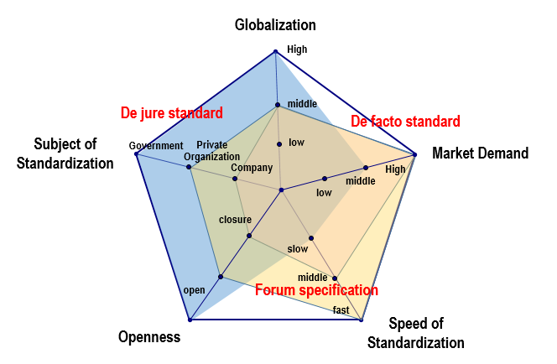
Source: Telecommunications Technology Association, 2014

Compulsory Standards and Voluntary Standards

A standard is a voluntary document and compliance is not compulsory. However, it is compulsory for devices subject to special control, for example, ones associated with human safety (short circuit, etc.) or ones that may interfere with other persons or devices (emission of electromagnetic waves, etc.), to comply with applicable standards, which are generally known as technical regulations. The annex of the WTO TBT Agreement defines a technical regulation as “a document, which lays down product characteristics or their related process and production methods, including administrative provisions, with which compliance is mandatory.” As compliance with technical regulations is mandatory and compulsory, they may serve as technical barriers to trades so that they are established according to the individual country’s needs, in general, for defense, environment, safety, and consumer protection purposes. Technical regulations form the foundation of conformity assessment systems to regulate the production, distribution, and import of relevant products based on their conformity to applicable technical regulations.

Benefits of Standards

Benefits for Users

Users, one of many players in the area of standardization, are the ones who benefit most from standards. If many product components are standardized, users can easily obtain components to repair, exchange, or upgrade them at a relatively lower cost. The comparison between the prices of standard-size batteries and non-standard mobile phone batteries clearly shows how big such a difference can be. Second, if many providers supply components that comply with the same standard, competition among them and reductions in manufacturing costs associated with the use of standardized parts result in reductions in prices, and that is another important benefit for users. Lastly, using products or services whose quality is guaranteed ensures a safe and satisfactory consumption experience.

Benefits for Businesses

Businesses can improve production efficiency and reduce production costs by producing standardized components through standard processes and procedures. This also helps maintain and improve the quality of products and services. In terms of standards-essential patents, the company that has won the battle can dominate the market and further strengthen its competitiveness by earning royalties from the patent. Late movers can take advantage of standard documents, which contain the quintessential information on the latest technology and service, to save an enormous amount of technical development costs. Standardization allows for the entry of new businesses into the market, leads to price reduction through competition, and makes it harder to differentiate from competitors. Hence, businesses that have technology, experience, and established presence in the market may not find standardization favorable. Nonetheless, market leaders actively participate in standardization activities in consideration of the positive effects of standardization on the overall industry, for example, the expansion of the market.

Benefits for the State

The benefits for the state come from the citizens as consumers and businesses as the foundation of the national economic development that benefit from standardization. First, the state can use standards to maintain and manage the quality and stability of products and services, thereby protecting health, safety, and lives of the citizens. In addition, enhanced competitiveness of businesses propelled by standards-essential patents and enhanced production efficiency help strengthen the competitiveness of the nation as a whole. The use of standards helps improve efficiency across society and significantly contributes to the state’s social development.

Other Benefits

The ICT industry is known to have the biggest network externality. In this industry, service providers, terminal manufacturers, repeater manufacturers, content producers, software developers, etc., are closely interconnected. Consumers do not decide to buy a product solely based on the provision conditions of the product (hardware), and consumer benefits vary depending on other products that are in a complementary relationship with the product (e.g., peripheral devices, software, networks, etc.). For example, in telecommunications, consumer benefits depend on the size of the network (the number of users), and the larger the network, the bigger the benefits to consumers.

The first standard for the facsimile (G1) was established by the ITU in 1968, but the market distribution started skyrocketing in 1980, when the G3 standard was adopted and facsimile modems were introduced so that facsimile devices could communicate with each other. The expansion of the market realized the economies of scale, which resulted in reductions not only in the prices of facsimile devices but also in communication fees, and this, in turn, led to the increase of facsimile users and the growth of the market.

Negative Effects of Standards

It is not that standards have only positive effects. As explained earlier, market domination by the preoccupation of standards results in monopoly, which could hinder technical innovation, deter late movers from entering the market, or limit product diversification. One can easily understand this from the cases where network externalities induce consumer inertia so that they stick to the existing product even if an innovative product emerges, which is called the “lock-in effect.”

In the network industry, it is difficult for one individual company to develop its own technology and standardize it. Rather, multiple companies interconnect their technologies and products or jointly develop them. They organize an alliance (forum or consortium) to stand against their opponents. Such an alliance of companies may lead to coordination among standards, and in some cases, they may adopt an inferior technology as a standard in order to hold a superior competitor in check, which is referred to as the “tipping effect.” Good examples of this include the VHS format for VTRs and the GSM (Global System for Mobile) standard for mobile communications. There had been several standards for mobile phones, such as the PDC (Japanese standard), the GSM (European standard), and IS-54 and IS-95 (U.S. standards) in the early 1990s.

Technically, the PDC technology was by no means inferior to the GSM technology and was actually superior in terms of its frequency characteristics. As the GSM technology was adopted as a standard in about 110 countries, the PDC technology became a domestic standard that was used exclusively in Japan. However, these negative effects are mostly seen in connection with positive effects, and they can be minimized by taking full advantage of the positive effects.

Standards Development Organizations

Standards Development Organizations (National/Regional/International Standards Bodies)

Who makes standards? A standard or specification is established by the approval of an internationally, regionally or domestically recognized standards organization in accordance with established processes. As mentioned above, standards bodies are divided into international standards bodies (ITU, ISO, etc.), regional standards bodies (ETSI, APT, etc.), and national standards bodies according to their domain of activity. They can also be classified into de jure and de facto standards bodies according to their characteristics.

Standard bodies can be institutions, organizations, committees, or meetings, but in this context, they are collectively referred to as standards development organizations (SDOs) for convenience sake. An SDO, in general, is comprised of a technical organization to develop standards, an advisory (special) organization to support standards development and provide advice, and a secretariat to run these organizations smoothly. The structure depends on the characteristics of the individual SDOs.

De jure SDOs are divided into international, regional, and national SDOs according to the domain of their activity and the scope of their standards’ effects. Examples of international SDOs include the ITU, ISO, and IEC.

ITU is an international treaty organization that has 193 countries as its members. With the foundational philosophy to streamline mutual connection of telecommunication services among the countries, ITU aims to improve telecommunications of all kinds and ensure their rational use through enhanced cooperation among the members. The main purposes of ITU include the following:

- Manage the radio frequency spectrum to ensure that all radio-based systems can operate satisfactorily together free from unacceptable interference, regionally distribute radio frequencies, register assigned radio frequencies and the locations and other characteristics of geostationary and orbiting satellites;
- Promote worldwide telecommunications standardization;
- Promote international cooperation and alliances to provide technical support for developing countries and develop and improve telecommunication equipment and networks; and
- Cooperate with member countries and organizations so that telecommunications fees are set in the minimum required level to ensure efficient communication services.

ITU is broadly comprised of three sectors: ITU-R (Radiocommunication Sector), ITU-T (Telecommunication Standardization Sector), and ITU-D (Telecommunication Development Sector). ITU-R manages satellite, broadcast, and radio resources such as wireless communication radio spectrums and satellite orbits. The main role of ITU-T is to develop international standards in the form of recommendations in the telecommunications field. ITU-D takes responsibility for the balanced development of global telecommunications and technical support for and cooperation with developing countries.

ISO is a private organization, operated by the participation of SDOs in individual countries. The organization’s mission is to streamline the international trade of products and services across industries and promote mutual cooperation. Its activities mainly focus on coordinating and unifying industrial standards among countries, promoting international exchanges of goods and services, and improving cooperation in the fields of science, knowledge, and economy. It promotes the trade of products and services and international cooperation in science, technology, and economy by establishing internationally unified standards. In 1987, ISO organized the ISO/IEC Joint Technical Committee 1 (JTC1) to prevent overlaps with the ICT standardization activities conducted by IEC. The scope of JTC1’s activities includes the following:

- Design and develop information technology (IT) system tools;
- Performance and quality of IT products and systems;
- Security of IT system information;
- Portability of applications;
- Interoperability of IT products and systems;
- Unified tools and environments;
- Harmonized IT terminology; and
- User-friendly and ergonomically designed user interfaces.

Among well-known regional SDOs, the European Telecommunication Standards Institute (ETSI) was established to develop technical standards required for ICT-related fields following the integration of the European markets, to contribute to the promotion of global ICT standards, and to proactively establish global standards. The arena of ETSI’s activities includes all ICT fields ranging from wired and wireless communications to radiocommunication, convergence, broadcasting, and Internet technology. In particular, it has been recognized in the standardization of wireless communications for its global system for mobile communication (GSM) and the 3rd Generation Partnership Project (3GPP). ETSI was established in 1988 pursuant to a resolution by the European Committee (EC), the predecessor of the European Union (EU), and the European Standards Organization (ESO), along with the European Committee for Standardization (CEN) and the European Committee for Electrotechnical Standardization (CENELEC) recognized by the EU and the European Free Trade Association (EFTA). Having 700 members from 60 countries not only in Europe but from all over the world, however, the ETSI serves as an international SDO both in name and in reality, rather than being a mere regional SDO.

Established in 1979, the Asia-Pacific Telecommunity (APT) has focused on the development and advancement of ICT, joint research and distribution of new technologies, and technical cooperation between developed and developing countries in the Asia-Pacific region, thereby creating mutual interests at the regional level. Developing regional standards is part of its activities, but it primarily pre-coordinates opinions within the region for ITU activities and makes joint responsive measures.

Domestically, many countries in the world have national SDOs to build on ICT markets, promote relevant industries, and protect consumers. National SDOs conduct downstream standardization activities to adopt international standards as their national standards and upstream standardization activities to serve as a focal point to reflect their technologies into international standards.

Standardization in the rapidly changing ICT field requires swift consent and flexibility of the outcomes of development (revisal of results). Since consent-based de jure SDOs, which follow transparent, open processes, often fail to keep pace with it, relevant industries have organized fora and consortia referred to as de facto SDOs. De facto SDOs put the feasibility of results and swiftness of process before reaching consent on the results of development. Indeed, de facto SDOs often move out of the “one nation, one vote” system that is the norm in international SDOs and give voting privileges according to the size of contributions or to organizations that have the leadership. Some de facto SDOs have closed membership systems.

De facto SDOs can be divided into fora and consortia according to their nature. Fora are organized to promote standardization in specific technical areas without preference for particular technologies, while consortia are alliances among businesses that focus on the standardization of particular technologies. There are over a hundred de facto SDOs active in the world. Examples include the Institute of Electrical and Electronics Engineers (IEEE) that is well known for its wireless local area network (LAN) technology, the Internet Engineering Task Force (IETF) that develops Internet standards, the World Wide Web Consortium (W3C), and 3GPP as a developer of mobile communications standards. Many de facto SDOs were established and active in the U.S. As international standards are becoming increasingly more important and global companies and experts are increasingly more involved in these SDOs, however, they are growing as international SDOs. De facto SDOs cooperate with de jure SDOs such as ITU and ISO and recommend their standards as de jure international standards, thereby strengthening their standards’ position globally.

Figure 3. Schematic Diagram of De Facto SDOs
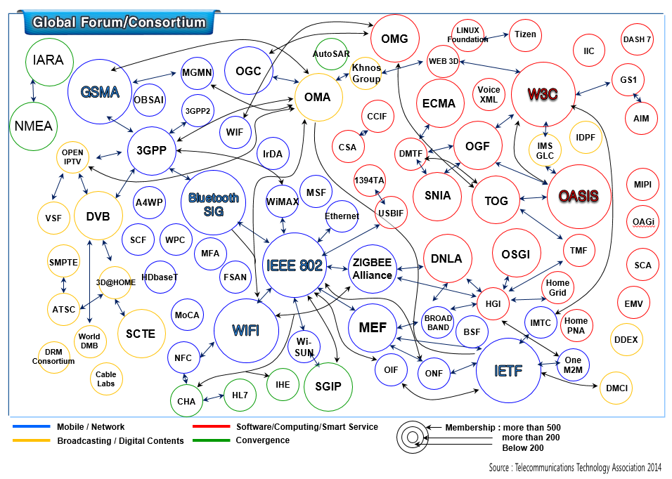

Figure 4. SDOs in Radiocommunication Field
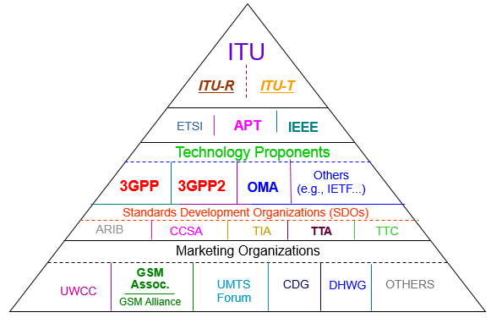
Source: Samsung Electronics Co. Ltd.

Current Status and Characteristics of Standards Development Organizations

The status and characteristics of SDOs vary by country and by organization. First, some countries have only one SDO, while others have multiple SDOs, although the unitary system is common. Typically, a national SDO corresponding to the ISO governs standardization at the national level, and other ministries and agencies take part in the activities of the SDO. In the ICT field, however, some countries have multiple SDOs and systems. This could be due to differences in government ministries responsible for ICT and other general industries, or because the nation may have recognized the necessity for a separate system to cope with the rapidly growing and heavily standard-dependent ICT industry.

Second, within the ICT field, some countries have multiple SDOs while others have a unitary system. This is associated with integrated management of similar fields. For example, the Telecommunications Technology Association (TTA) and ETSI govern wired and wireless communications and broadcasting standards in Korea and EU, respectively. TTA is even responsible for tests and certification. On the other hand, Japan has a dual system where the Association of Radio Industries and Businesses (ARIB) manages broadcasting and wireless communications standards and the Telecommunication Technology Committee (TTC) is responsible for wired communications standards. In China, the China Communications Standards Association (CCSA) governs communications standards, and a separate organization has responsibility for broadcasting stnadards. It is difficult to discuss the merits and demerits of these structures uniformly, but unitary systems may have advantages in industrial environments where technical convergence is accelerating further.

Third is the decision-making structure. As an international organization, ITU has a “one nation, one vote” system, and IEEE gives one vote to each person. In ETSI and TTA, voting rights are commensurate with the size of contribution. Each system has its own merits and demerits so that it is difficult to put one system above another. The per-nation voting system may not reflect differences in the contributions and capabilities among nations, and the per-capita voting system has no means of preventing a specific company from placing a large group of people into standardization meetings in a short period of time with an aim to advocate its technology.

Standards and Intellectual Property Rights (IPR)

Standardization aims to improve economic efficiency by sharing technologies among industry participants and promote fair competition in the market. Intellectual property rights (IPRs) aims to encourage and promote the development of technology by ensuring that the holders of exclusive rights to such technology may receive appropriate reward.

Essentially, standardization aims to distribute technology across economies and focuses on the diffusion and utilization of the developed technologies through commercialization. Standards offer equal information on new technologies to virtually all people, thereby distributing and diffusing the technologies. Patents serve as a tool to extensively distribute the benefits of new patented technology and provide patent holders with incentives. At the same time, patents prevent, for a certain period of time, others from enjoying a free ride on the benefits of the patented technology by expropriating it. Hence, there may be some conflict between goals of standardization and patents.

Figure 5. Goals of Standardization and IPR
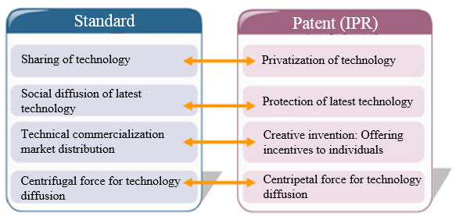

Standardization and patents may stand against each other in the course of the establishment of standards. Some focus on the efficient diffusion of technology and others on protecting patent holder’s rights. Although standardization and patents are not thought of as opposites, their relationship can be delicate and complex because the execution of patent holder’s right for implementing the standardized technology may hinder the diffusion of such a technology. In the past, a non-patented alternative technology used to be adopted as a standard so that the standard and patents did not conflict with one another. Recently, in up-to-the-minute technical fields such as ICT and biotechnology (BT), however, it has become virtually impossible to avoid using patented technologies in establishing a standard given the necessity to establish standards in an ex ante manner and the entanglement of relationships among many patents following the advancement and convergence of technologies.

Standard and patent are also in a complementary relation as they both aim at improving social and economic efficiency through technology diffusion. Due to the complementarity, patents are becoming increasingly more important in standardization.

Standards-Essential Patents

The term Essential Patents to Standards or Standards-Essential Patents (SEPs) came to be widely known to the general public thanks to the patent war between Samsung and Apple. In general, a SEP is defined as an essential patent which has been included within a specific standard and where it would be impossible to implement a certain element of the standard without infringing the patented claims
The following shows the definitions of an SEP by different standards setting organizations.

Table 3. Definitions of Standards-Essential Patents
SSOs/Pool | Terms | Explanation
ITU/ISO/IEC | Essential Patents | - Those claims contained in and identified by patents, utility models and other similar statutory rights based on invention, including applications for any of these, solely to the extent that any such claims are essential to implement a specific Recommendation/Deliverable
ETSI | Essential IPRs | - IPR which has been included within a standard and where it would be impossible to implement the standard without making use of this IPR
IEEE | Essential Patent Claim | - Any Patent Claim the use of which was necessary to create a compliant implementation of either mandatory or optional portions of the normative clauses of the [Proposed] IEEE Standard when … there was no commercially and technically feasible non-infringing alternative
MPEG-2 | Essential Patent | - Essential is defined … as:  - directly documented on MPEG-2 video standard … or;  - directly documented on MPEG-2 systems standard and the annexes

      - Considerations Regarding SEPs

Should Patents be Included in Standards?

The standardization of technology does not always guarantee only positive results. Once a specific technology is adopted as a standard, the industry may not be able to carry out a transition to other superior technology, which is named technical lock-in. Another caveat is that if there is any patent for a standard technology, the patent holder’s execution of his exclusive, monopolistic right may totally block up other competitor’ approach to the market dominated by the standard technology. Given this risk, patented technologies used to be excluded from technical standardization processes in traditional practice. Following the declaration of the American National Standards Institute (ANSI) in 1932 that a patented technology may be adopted as a standard if the patent holder is willing to restrict his right to avoid monopolistic effects, other SDOs started reflecting such a stance in their IPR policy.

Obligations of Patent Holders in Standardization Activities

ICT is the technical area with the most highly organized IPR policy. This is due to various factors including that there are distinctive network effects caused by improved compatibility; there are a large number of patents given the characteristics of products; and the speed of technical development and commercialization is very fast.
In a broad sense, the holders of patents to be adopted as standards have two obligations. First, they have an obligation of ex-ante disclosure of patents that they already have or are expecting to have in the course of standardization processes in order to allow the SDO to select the most rational technology. Second, a patent holder is required to assure that, if his technology is adopted as a standard, he or she will license the technology to potential licensees in a non-discriminatory manner in accordance with terms and conditions provided by the SDO. In such cases, one that is often included in the terms and conditions is RAND (reasonable and non-discriminatory) or FRAND (fair, reasonable and non-discriminatory) conditions. Some SDOs requires RF (royalty free) conditions for patents included in their standards.

SEPs Seen from Developing Countries’ Viewpoint

While the misuse of patent rights affects the entire global community, it places particular burden on developing countries. Large royalties may significantly affect manufacturers in developing countries. An example is interference with duty cycles of products that developing countries would have obtained from manufacturing in a standardized, mature market. As technology advances in manufacturing- and trade-oriented countries such as Brazil, Russia, India, and China, advanced countries intend to secure their profits by strengthening innovation. In such a case, they gain revenues by charging a huge amount of royalties and bear hard on developing countries to increase the value of their technology. This interferes with general duty cycles of products and deters developing countries from keeping up with them.

Patent holders often claim their rights only after the market has grown up. This deters manufacturers in developing countries from extensively engaging in industry, and they are deprived of both market opportunities and investment opportunities. In standardization, patent right abuse affect consumers in both developing and advanced countries. Consumers in advanced countries suffer from high product prices, and those in developing countries suffer even more.

It is hard to implement development goals that are dependent on ICT unless patent right abuse is well controlled in the course of standardization. In providing ICT infrastructures and social services for standards and networks, the government of a developing country may not afford to pay royalties required to provide facilities and equipment for end users. Accordingly, the construction of infrastructures may be stayed and the provision of social services such as online healthcare and education may be delayed. One cannot ensure its national information security as long as its information system is dependent on a monopolistic technology. This could be particularly dangerous to a developing country whose technology is relatively less complex. Such a country could consequently be isolated and may find it harder to exchange trade, service, and information with others. Patent misuse in standardization should not be neglected if governments and international bodies would make efforts regarding information on development projects.

Patent Policy of Standards Development Organizations

      - Overview of Standards Development Organizations’ Patent Policy

As mentioned earlier, following the ANSI declaration in 1932 that patents could be included in standards, most SDOs now have IPR policy on how to deal with patents included in their standards. In general, SDOswith ppolicy comprises of three elements, details of which can vary by SDO (see 2.2).

- Patent disclosure: SDOs request their members involved in standardization activities to submit relevant information to the SDOs if they have patents that have been or are to be included in pending or adopted standards. They urge the members to submit such patent information as soon as possible.
- Conditions for the use of SEPs: Holders of patents that have been or are to be included in a standard should assure the licensing of their patents in terms and conditions provided by the SDO. Examples of such conditions include the royalty free (RF) and fair, reasonable and non-discriminatory (FRAND) conditions.
- Noncompliance with IPR policy: If holders of patents that have been or are to be included in a standard refuse patent licensing terms and conditions provided by the SDO or reject to license their patents, pending standards will be suspended or amended to substitute alternative technologies for the patents, and adopted standards will be revised or cancelled.

SDOs do not intervene in patent-related conflicts and leave such conflicts and license negotiations with relevant parties. They usually have clauses on their limitations and indemnity as shown below.

- Non-legally-binding regulation: SDOs’ IPR policy has no legal binding force. Accordingly, it is not easy for them to designate standard technologies, allow unspecific third parties to use, in effect of general situation, patented technologies included in a standard, protect patents against infringements, and protect third parties that uses of standardized technologies against patent infringement claims. As SDOs receive patent information that their members voluntarily submit and offer it to the general public, they cannot guarantee the validity and feasibility of the patent information.

- Non-intervention in conflicts: SDOs do not intervene in conflicts related to patents included in standards. A conflict is to be solved by the directly relevant parties, i.e., the patent holder and the licensee (or user). Some of the reasons include the following:
- First, an SDO’s direct intervention in a patent conflict requires professional manpower within the organization or assistance from a lawyer or patent agent, and this will increase the operation costs of the SDO. If the case goes to court, it will incur a huge amount of costs.
- Second, apart from the matter of costs, in general SDOs are not in a position to serve as an intermediary for the settlement of patent conflicts. In the event of an IP conflict, a fair trial would require a variety of information on for example development and product costs and profits, but no patent holders will have willingness to provide the SDO with all the information related to their IPRs, as SDOs have neither administrative nor judicial authorities.
- Third, SDOs are not to verify the accuracy and validity of patents. SDOs requires even pending patents to be disclosed, as they are not sure about whether such pending patents will be granted and even if patents are registered they may be involved in subsequent patent nullity trials.

Common features of SDOs’ IPR policy

- Allow patented technologies to be included in a standard.
- Request SEP holders to license SEPs in appropriate terms and conditions provided by SSOs, such as RF, RAND or FRAND.
- A written assurance regarding SEPs are to be received before a standard is approved or published. Such an assurance includes provisions that the technology is to be licensed in appropriate terms and conditions and that SEP holder will take disadvantages if it fails to notify of any patents that it is aware of or intentionally conceal them.
- If standardization is not feasible attributable to unsolved issues relating to SEPs, the standard may be amended or withdrawn.

      - IPR Policy of Major SDOs

ITU/ISO/IEC

As international SSOs, in March 2007, the ITU-T/R, the ISO, and the IEC adopted common patent policy commonly applicable to the three organizations and joint patent guidelines necessary to implement the policy. Their patent policy and guidelines are summarized as follows:

- Obligation to notify organizations of patent rights: Parties involved in their standardization activities should, from the outset, notify the organizations of known patents and known pending patents possessed by them or other organizations (Policy Section 3). In disclosing patents they possess, the patent holders should use the Statement and Licensing Declaration Form.
- Patent holders’ licensing terms and conditions: The patent holders are to declare to negotiate licenses of their patents in either of the following conditions. They may additionally choose to apply reciprocity.
- Free of charge on a non-discriminatory basis on reasonable terms and conditions;
- Non-discriminatory basis on reasonable terms and conditions
- Patent information database: Patent information declared to the three organizations can be found in the following database:
- ITU-T : http://www.itu.int/ipr
- ITU-R : http://www.itu.int/ITU-R/ → Database & services → Patents
- ISO : http://www.iso.org/patents
- IEC : http://patents.iec.ch.

ETSI

The ETSI exerts its global standardization capabilities in the ICT field with the background of the integrated European market, and it provides relatively concrete IPR policy and guidelines. Below is the overview of the ETSIities in the I

- Obligation to notify of patent rights: Each ETSI member should use its reasonable endeavors, in particular during the development of a standard or technical regulation where it participates, to inform the ETSI of essential IPRs in timely fashion (IPR Policy Section 4). In disclosing its IPRs, the IPR holder should use the IPR Licensing Declaration Form (IPR Policy Appendix A).
- Patent holders’ licensing terms and conditions: For the following, the ETSI requires its members to grant irrevocable licenses on fair, reasonable and non-discriminatory (FRAND) terms and conditions. Patent holders are to declare to license their patents in the following conditions. They may seek licenses agree to reciprocate.
- MANUFACTURE, including the right to make or have made customized components and sub-systems to the licensee's own design for use in MANUFACTURE;
- sell, lease, or otherwise dispose of EQUIPMENT so MANUFACTURED;
- repair, use, or operate EQUIPMENT; and
- use METHODS.
- Patent information database: Patent information declared to the ETSI can be found on http://ipr.etsi.org.

IEEE-SA

As an SDO based in the US, the IEEE-SA is a global SDO in the field of electrics and electronics. The following are the IPR policy of the IEEE-SA.

- Obligation to notify of patent rights: Individuals participating in the standards development process (a) shall inform the IEEE (or cause the IEEE to be informed) of the holder of any potential Essential Patent Claims of which they are personally aware and that are not already the subject of an existing Letter of Assurance, owned or controlled by the participant or the entity the participant is from, employed by, or otherwise represents, and (b) should inform the IEEE (or cause the IEEE to be informed) of any other holders of such potential Essential Patent Claims that are not already the subject of an existing Letter of Assurance. (Section 6.2). Those disclosing Essential Patent Claims are to submit a Letter of Assurance (LOA).
- Patent holders’ licensing terms and conditions: Those submitting an LOA to the IEEE should confirm either of the following:
- A general disclaimer : the Submitter without conditions will not enforce any present or future Essential Patent Claims against any person or entity making, using, selling, offering to sell, importing, distributing, or implementing a compliant implementation of the standard; or
- A license to an unrestricted number of applicants on a worldwide basis without compensation or under reasonable rates, with reasonable terms and conditions that are demonstrably free of any unfair discrimination. At its sole option, the Submitter may provide with its assurance any of the following: (a) a not-to-exceed license fee or rate commitment, (b) a sample license agreement, or (c) one or more material licensing terms.
- Patent information database: Patent information declared to the IEEE-SA can be found on http://standards.ieee.org/about/sasb/patcom/patents.html.

      - Major Standards Development Organizations’ Policy Before and After Standard Development

Before Standard Development

SDOs, in principle, should exclude the technology in the standard making process or develop subsequent measures that should include retrieval of other technologies as reasonable alternatives, in cases in which:

- a patent holder involved in standardization violated the SDOs’ patent disclosure obligation provided in SDO’s patent policy and/or guidelines;
- a SEP holder avoided the obligation to submit a written assurance provided in the SDOs patent policy and/or guidelines by concealing the fact that he/she possessed SEPs; or
- SEP holders rejected to submit a written assurance provided in the SDOs patent policy and/or guidelines after disclosing its SEPs information to SDOs, etc.

When SDO has adopted a technology as a standard without just cause even though the written assurance provided in the policy and/or guidelines on SEPs was rejected, the access to the potential standards-essential technology was not secured. In this case, the competition authority should investigate whether the patent holder could abuse the exclusive and market dominant power relating to the standards-essential technology after SEP has been adopted as a standard and may restrain competition against competitors for the said standards-essential technology.

After Standard Development

If it is revealed, after publishing the standard, that there is any IPR holder that possesses SEP relating to the published standards, SDOs should develop subsequent measures as follows:

- SDO requests the known SEP holder to submit the written assurance provided in SDO patent policy and/or guidelines.
- If the SEP holder does not respond to the above request from the SDO, the SDO should, if practically feasible, develop processes to revise the published standard to exclude the patented technology from the standard in order not to infringe the patented claim of SEP.
- If the SEP holder does not respond to the above request from the SSO, the SSO should, if practically impossible, develop processes to withdraw the published standard to exclude the patented technology from the standard in order not to infringe the patented claim of SEP.

      - Meaning of F/RAND Conditions

In order to allow the potential licensee to use of patented technologies in implementing the standard, SDOs request the patent holder to provide the written assurance of the terms and conditions for future licensing of the technology to third parties on a fair, reasonable and non-discriminatory (F/RAND) basis. However, most SDOs’ patent policy does not include a definition as to what is fair, reasonable and non-discriminatory and there have been no agreements on such a matter outside of the patent policy.

As for what is fair, fairness is a matter of knowledge and procedures and can be deemed to correspond to what jurists often refer to due process (of law), which is construed as a guarantee that there is a process to reach a result of licensing negotiation, such a process fully and equally consider both parties, and both parties will be given notice of the process before it is started.

As for what is reasonable, reasonability focuses not on the process but on the result of the licensing negotiation. It is construed as that both parties will find the final result acceptable and they will be able to live by the result. Accordingly, being reasonable means not making undue profits from royalties or corresponding benefits. As for what is non-discriminatory, non-discrimination is construed as that neither party will be disadvantaged compared to similar terms and conditions that the party has negotiated with a third party.

As it is unclear as to what are F/RAND conditions, there may be disputes on F/RAND conditions where the patent holder insists that its licensing terms and conditions are fair, reasonable and non-discriminatory whereas the other party claims they are not.

In general, F/RAND conditions mean that the benefits of the license are fair, reasonable, and non-exploitative, and non-discriminatory conditions mean that licensees and patent holders in similar situations are allowed to fairly compete with each other under the same conditions. However, various theories to determine justification in the royalty level have limitations in reality. Hence the court’s judgment on the justification of the amount of royalty intrinsically has limitations. Accordingly the court hesitates to determine royalties by itself and generally encourages the parties to reach an agreement.
Internationally, despite recent rapid increases in lawsuit cases, there have not been a sufficient number of precedents. However, the amount of reasonable and non-discriminatory royalties should be no more than the maximum amount of royalties that the patent holders could collect before the technology was adopted as the standard or the sum of such an amount and the value added by the technology’s serving as the standard, otherwise they may be deemed as excess royalties following patent threats.

Such ambiguity of F/RAND conditions is somewhat unavoidable. It is impossible to clearly demarcate the benefits of a future license despite uncertainties in the market, and excessively detailed restrictions in the course of standardization may deter patent holders from participating in the standard or may serve as centrifugal force to exclude them from the standard, thereby dissipating standardization. However, no restrictions mean the absence of safeguards to prevent the patent holder’s dominancy once its technology is adopted as the standard. F/RAND conditions serve as a kind of compromise to SSOs.

Standards Development

Legislation Framework for Standardization

Introduction

Many countries have national standardization frameworks for their citizens’ safety and welfare, and economic development of their industry and state. While traditional industrial standards have a history that goes back to currency and weights and measurements, the history of ICT standards started in the late 1980s when the state-owned or monopolized communications markets were liberalized. Therefore, countries have different national frameworks for industrial standards and ICT standards.

Some countries have integrated frameworks where ICT standards are included in the industrial standard frameworks and others have separate frameworks for industrial standards and ICT standards. Some have so-called convergent frameworks where standardization is carried out without differentiation between industrial and ICT standards, and the responsibility for management and coordination of the standards is taken by a single organization. Accordingly, countries have different legislations for national standardization, depending on their standardization frameworks. Standardization legislation can vary according to whether the national standardization organization is a public or a private organization.

The U.S. has a convergent national standardization framework and a private organization (American National Standards Institute, ANSI) as the national standardization organization, but has no legislation on national standardization. Relevant laws only emphasize voluntary standardization activities in the private sector and encourage the government to support such private standardization activities to vitalize cooperative research and development (R&D) among enterprises, to be involved in the private standardization activities, and to use private standards.

The National Cooperative Research Act (NCR) of 1984 emphasized voluntary standardization activities in the private sector and admitted them as exceptions from antimonopoly in order to vitalize standardization activities as cooperative R&D among enterprises. The Act was amended as the National Cooperative Research and Production Act (NCRPA) of 1993, and the Standard Development Organization Advancement Act (SDOAA) of 2004. The National Technology Transfer Advancement Act (NTTAA) of 1995 provided that the federal administration should use standards adopted by voluntary consensus standards bodies and encouraged government organizations, e.g., the National Institute of Standards and Technology (NIST), to participate in voluntary standardization activities. The SDOAA of 2004 provided that standardization activities by voluntary consensus standards bodies could be exempted from responsibilities under the nation’s strict antimonopoly laws.

The European Union has separate frameworks, but each member country has an integrated framework. In most cases, the national standardization organization is a private organization, and there is no legislation on national standardization frameworks. However, there is EU-wide legislation that provides legal grounds and supportive measures for the standardization activities of the three European standardization organizations, i.e., the European Committee for Standardization (CEN), the European Committee for Electrotechnical Standardization (CENELEC), and the European Telecommunications Standards Institute (ETSI).

Following the economic integration within the EU, Europe announced a resolution titled A New Approach to Technical Harmonization and Standards in 1985, which served as the first European regulation on standardization. Afterwards, the ETSI was established as the European standardization organization responsible for the ICT standards, and the first decision on ICT standardization in Europe, Standardization in the Field of Information Technology and Telecommunications, was announced in 1987. The decision provided that an international-standard-based cooperation system should be established to develop a technical standard within the European Economic Community in the field of information technology and communications and that the ETSI was responsible for the standardization of communications within Europe. In 2012, the EU improved the European standardization system and developed new legislation on standardization, the Regulation of European Standardization, in 2012 in recognition of the roles of standardization organizations. Legislation on standardization in Europe includes the following:

- Council Resolution on A New Approach to Technical Harmonization and Standards, May 1985;
- Green Paper on the Development of the Common Market for Telecommunications Services and Equipment, June 1987;
- Council Decision on Standardization in the Field of Information Technology and Telecommunications, December 1986;
- Directive 98/34/EC (98/48/EC) of the European Parliament and of the Council Directive laying down a procedure for the provision of information in the fields of technical standards and regulations, June 1998; and
- Regulation on European Standardization, December 2012

In Asia, Korea (Republic of), China, and Japan have national standardization organizations as government authorities, and their national standardization frameworks are provided by legislation, which is different from the American and European schemes. Also, the national standardization frameworks of Korea, China, and Japan are different from one another.

Japanese Industrial Standards Act

Article 11. If a minister intends to establish an industrial standard, the minister shall have the proposal approved by the JISC.

Article 12. Interested parties may ask the responsible minister to establish an industrial standard by submitting a proposal pursuant to applicable ministerial orders. If a minister receives a request in accordance with Paragraph above and the minister recognizes the necessity for the proposed industrial standard, the minister shall bring the proposal to the JISC. If the minister finds no necessity for the proposed industrial standard, the minister shall notify the applicant of its intention to reject to proposal and reasons.

Article 13. The JISC shall deliberate industrial standard proposals in accordance with fair procedures provided by responsible ministries and notify responsible ministers of the results. If the responsible minister recognizes that the proposed industrial standard that has been approved by the JISC incorporates the intentions of all interested parties and its application may cause no unreasonable disadvantage against parties under various conditions, the minister shall establish it as an industrial standard.

Japan’s national standardization frameworks are integrated into a single industrial standard framework, but in reality, the nation has separate frameworks in that the heads of the respective administrative authorities recommend and announce national standards. The national standardization body is a government committee, and the Industrial Standards Act serves as the single legislation on national standards. Japan’s national standards are deliberated by the Japanese Industrial Standards Committee (JISC) under the Ministry of Economy, Trade and Industry but heads of seven ministries have the authority to suggest and announce national standards.

China’s national standardization is twofold: On the one hand, administrative authorities establish business standards for each field and register them with the Standardization Administration of China (SAC) (then they become a Chinese national standard), which means that China has a distributed national standardization framework. As in the case of Japan and Korea, China’s national standardization organization is a government organization, and there is legislation to manage national standards.

- The Agricultural and Industrial Products and Process Construction Technology Management Rule was established in 1962 as the first technical standards-related legislation.
- The State Council established the People’s Republic of China Standardization Management Ordinance in 1979 to classify standards into national, business, and enterprise standards.
- The People’s Republic of China Standardization Act was established in 1989, finalizing the current national standardization framework.

The Republic of Korea has distributed a standardization framework for ICT and general industry. Similar to Japan and China, government authorities take responsibility for these national standards. However, the difference is that the legislation on national standardization is comprised of separate laws rather than one integrated law. Standardization for general industry is governed the Industrial Standardization Act, While ICT standardization is governed by individual laws related to ICT.

Table 4. ICT Standardization Laws in Korea (as of March 2014)
Act | Subject of Standardization
Framework Act for the Development of Broadcast and Communication | Broadcasting and communication
Radio Waves Act | Radio-using technology
Act on Internet Address Resources | Internet address resources
Act on Protection and Use, Etc. of Location Information | Technology for the collection, use, or provision of positional information
Act on Promotion of Information and Communication Networks Utilization and Information Protection | Information networks
Software Industry Promotion Act | Software
Contents Industry Promotion Act | Content (*Regarding content digitalization)
Framework Act on Electronic Documents and Electronic Transactions | Standardization of electronic documents and transactions
Framework Act on National Informatization | Knowledge information resources
Information and Communications Industry Promotion Act | Information and communication technology, products, networks, and relevant services
Special Act on ICT Promotion and Convergence Activation | Standardization of ICT and information and communication convergent technologies and services

Standards and Technical Regulation

In general, standards are divided into technical regulations that have binding force and voluntary standards that have no binding force. When it come to national standards, they used to be interpreted technical regulation in some countries, however, in principle, they are voluntary standards to which complicance is not mandatory even though they are established by government agencies.

Table 5. Technical Regulations vs. Voluntary Standards
Classification | Technical Regulations | Voluntary Standards
Authority | Government | SDOs (government or non-government)
Objectives | Setting Minimum (or essential) requirements for ICT equipment or devices | Setting General and detailed requirements for interoperability among equipment, facilities, and networks
Considerations | Protecting equipment, facilities, and networks from any harm  Protecting public interest and fair competition by network operators  Maintenance of equipment, facilities, and network | Securing interoperability among equipment, facilities, and networks
Compliance | Mandatory | Voluntary

National Standardization Frameworks and National Standardization Organizations

Introduction

Who develops standards generally depends on the level of the nation’s standard development. In non-industrialized countries or countries at an early-stage of industrialization, the government itself often develops standards or has the national standardization organization take the role as a government agency. Also, in highly industrialized countries, the government or national standardization organization may develop and manage national standards. However, such roles are mostly left to private SDOs where industry, research institutes, academia, and other interested parties jointly develop (voluntary) standards. Private SDOs can vary in terms of their nature and domains according to their foundational objectives and backgrounds. As standardization has become an important factor for industrial and economic development, private SDOs that are led by industry sometimes play similar roles as national standardization organizations such as supporting standardization policies within the country, developing national standardization infrastructures, and promoting international standardization.

National standardization organizations govern national standards. A national standardization organization can be an independent organization or an umbrella organization under a government ministry. Some standardization organizations develop and manage all national standards across all government ministries and others are diversified according to their expertise. Some countries have multiple national standardization organizations that correspond to the ISO, IEC, and ITU system of international standardization.

This section examines the roles, functions, and operational modes of national standardization organizations using case studies.

Roles and Functions of National Standardization Organizations

The important roles and functions of national standardization organizations include the following:

- Development and management of national standards;
- Response to and support for international standardization;
- Distribution of standards and provision of information;
- Support for domestic standardization activities; and
- Support for government in implementing national standardization policies.

In most countries, the primary objective of national standardization organizations is developing and managing national standards. In few countries such as the U.S. and Canada, however, the national standardization organization recognizes standards developed by SDOs as national standards and manages them.

In general, national standardization organizations set up and operate internal groups to develop national standards or recognize standards developed by SDOs as national standards. Most of these groups take the form of committees classified by technical areas. Experts from various stakeholders (e.g., industry, institute, academia, user, etc.) participate as members. The primary role of these committees is to develop and review national standards. Also, they provide advice on issues related to national standardization policies and strategies.

A typical committee is comprised of committees classified by technical area, e.g., technical committees, special committees, review committees, etc., and the superior organization that has the authority to make the final approval of standards developed by such committees, e.g., an assembly or a council. If such committees need to be further specialized, each committee may have subgroups, working groups, or subcommittees. Each committee and its subgroups consider whether to develop a standard when a proposal is received and develop drafts as necessary. The final decision on the development and approval of the standard is made by the superior organization.

In organizing and operating such a committee, national standardization organizations provide support for the operation of the committee and develop regulations and instructions for its operation and the development of national standards. Also required are the secretary’s roles, for example, providing advice for the methods and processes of national standard development, establishing and managing overall processes for the development of national standards, and providing relevant information.

Regarding the secondary role of responding to and supporting international standards, national standardization organizations should first play the role as a contact point with corresponding international standardization organizations. This includes receiving, reviewing, and processing documents notified or circulated by international standardization organizations and drafting the nation’s opinions and decisions to be submitted to such organizations. In addition, they organize national delegates to international standard meetings and present the nation’s position on agenda items. Second, they establish organizations, e.g., committees. corresponding to international standardization organizations. Many countries do so to make sure that their national standardization organizations can effectively serve as the contact point with international standardization organizations. Otherwise, the organization that develops national standards can take the contact point role.

Another role of national standardization organizations is to distribute standards. National standardization organizations should establish efficient standard information distribution systems to allow interested parties to acquire and use national and international standards in a timely manner. Standard information refers to general information on standardization, including how to apply standards, how to obtain international standards, how to develop standards, how to participate in the development of standards, as well as the standards themselves. Therefore, national standardization organizations are responsible for operating educational programs on standards, standard technologies, and international standardization.

Most standards are available at cost because developing standards requires a huge amount of time and money. However, some standardization organizations provide their standards for free in the interest of the public. The revenues from the sales of standards are usually allocated to developing quality standards or to standard education and promotion programs.

Roles and Functions of Private Standardization Development Organizations

This section examines the roles of private SDOs in the national standardization framework. As mentioned in Chapter 1, following the trends of market liberalization and deregulation, many countries started to implement standardization policies that encourage the development and use of voluntary private standards rather than technical regulations. In the ICT field, private SDOs emerged in advanced countries in the late 1980s, when the liberalization and privatization began to take place in the communications services market.

Table 6. Private SDOs of Major Countries
Country | Organization | Areas of standardization | Website
Europe | European Telecommunication Standard Institute (ETSI) | Security, Satellite, Broadcast, Human Factors, Testing & Protocols, Intelligent Transport, Power-Line Telecoms, e-Health, Smart Cards, Emergency Communications, GRID & Clouds, Aeronautical, etc. | www.etsi.org
China | China Communications Standards Association (CCSA) | IP & Multimedia, Mobile Communication, Transport &Access Network, Security, Electromagnetic Environment &Protection, etc. | www.ccsa.org.cn
Japan | Association of Radio Industries and Businesses (ARIB) | Digital Broadcasting System, Mobile Telecom System | www.arib.or.jp
 | Telecommunication Technology Committee (TTC) | Network, Security, IPTV, Mobile Network, M2M, etc. | www.ttc.or.jp
Korea | Telecommunications Technology Association (TTA) | All ICT Areas including Network, Radiocommunication, Broadcasting, Security, ICT Application, Software, etc. | www.tta.or.kr
USA | Alliance for Telecommunications Industry Solutions (ATIS) | Network, Emergency Service, IPTV, Home Network, Optical Network, etc. | www.atis.org
 | Telecommunications Industry Association (TIA) | Mobile Telecommunications, Multimedia, M2M, Smart Network, Satellite Communications, etc. | www.tiaonline.org

Private SDOs are usually organizations that have industrial players as their members, but the standardization committees they operate to develop standards are open to various stakeholders including members, research institutes, academia, and the government, and are operated in a transparent manner. These SDOs often support the implementation of national standardization policies through close cooperation with the government and/or national standardization organization. Some countries designate an SDO as a specialized standard organization and entrust the government’s standardization tasks to that SDO in order to strengthen the competitiveness of the nation’s industry and standards.

Such practice is for the promotion of consistency, sustainability, and professionalism in standardization activities at the national level. Therefore, these SDOs not only support the development of local ICT standards and the international standardization of local technologies but also promote cooperation with private SDOs in other countries as the nation’s representative, or conduct aid and support projects for developing countries as a national project or collaborative project with international organizations.

As described above, private SDOs are industry-oriented organizations, in which relevant stakeholders participate, and this is why they are usually seen in industrially advanced countries that have strong base of local manufacturers. In other words, in countries whose markets and industries are so liberalized and advanced that voluntary private standards are needed and whose level of maturity in technology is high enough to support the development of such standards, most standards are developed by private SDOs. Among these voluntary standards, the government or national standardization organization may select ones that the entire national industry needs to adopt or that are associated with public safety and consumer protection as national standards.

Table 7. Standardization Areas of Major International Standardization Organizations
Standardization Areas of De Jure International Standardization Organizations |  | De Facto International Standardization Organizations
ITU-T | BcN, LAN/MAN, Internet | IEEE802, IETF, ICANN, IPv6 Forum, Ethernet Alliance, TM Forum, OIF, SIP Forum
 | Security | PKI Forum, LAP, SCA, VoIPSA, DMTF
 | Green ICT | Ecma International
ITU-R | Mobile Communication | 3GPP, 3GPP2, GSMA, WiMAX Forum, IEEE802
 | Wireless Communication | IEEE, WiFi Alliance, Bluetooth SIG, ZigBee Alliance, NFC Forum, EPC Global
 | Broadcasting | CableLabs, ATSC, World DMB Forum, SCTE, TV-Anytime Forum, DRM Consortium, FLO Forum
ISO/IEC JTC1 | MPEG, Computer Graphics | MPEG Industry Forum, DMP, Khronos Group, DVD Forum
 | E-Learning, Metadata, E-Commerce | IMG Global Learning Consortium, OASIS, RosettaNet Consortium, IDF/MPF, WfMC
 | Web | W3C, Web3D Consortium, Voice XML Forum
 | S/W Component, Open S/W | SA Forum, Linux Foundation
 | Biometrics | Bio API Consortium
 | Green ICT, Smart Grid, Cloud Computing, etc. | CSA, OCC, OGF, IEEE
Others | Mobile Platform | MIPI Alliance, OMTP, Tizen Association
 | SDR, CR | Wireless Innovation Forum, IEEE802.22, Ecma International
 | Intelligent Robot | IEEE RAS, IFR
 | Next Generation PC, GRID | 1394TA, PCI-SIG, PCMCIA, PICMG, Ecma International, OGF
 | Telematics | OGC, MOST Cooperation, Auto-SAR
 | Home Network | PLC Forum, UPnP, OSGi Alliance, HGI, CEA, IrDA, DLNA, HAVi, HomePNA, Broadband Forum

General Principle of developing National Standards

General Principle

While industry standards are driven by industry on the basis of their needs, national standards are more close to public area. It means that national standards need certain critea to be distinguished from industry standards. In principle, interests of public, satety, protection of user/consumer, environment, quality of service are important factor in determining national standards.

Criteria for national standards and technical regulation in Viet Nam

- Widely accepted international standards which are primary grounds for standards formulation;
- Ensure the harmonization, uniformity of Viet Nam’s standard system. It means that a new developed standard will not duplicate or conflict with current standards;
- Technical specifications should be feasible for implementing measurement and assessment by specified measurement methods considering limited resource and capacity of local testing laboratories to ensure its applicability for conformity assessment;
- Referencing to similar, widely accepted international standards by whole or partly selected parts;
- In some specific circumstances, regional standards, especially from the region, which have high degree of similarity with Viet Nam’s technical and technological characteristics could be referenced with justified modification;
- Avoid (if possible) direct referencing to international standards if there are any national/domestic standards; Avoid to reference to restricted access standards

Criteria for National Standards of Korea

      - Validity of the Candidate of a National Broadcasting and Communication Standard
  - Compatibility and fair competition among broadcasters and communication providers
  - Big ripple effects on other industries and across the nation
  - Improvement of the quality of broadcasting and communication systems and services, the safety of users, and user environments
  - Provision of the benefits of broadcast and communication to the aged, the disabled, and other socially disadvantaged classes
  - Association with communications in emergency and disaster conditions
  - Association with the development or introduction of new technologies, early creation of markets, and other industrial promotion

      - Appropriateness of the Standard Development Processes
  - Openness, fairness, and equity of the development processes
  - Appropriateness of participants in the development of the standard
  - Appropriateness of the opinion collection and the treatment of objections

There is no exact procedure to develop national standards, however, generally, government develop national standards to ensure its policy and regulative objectives. Namely, government can drive standardization activity by setting its policy and regulation. For example, Korea has set 5 years rolling plan for national standardization. The vision of the 4th rolling plan is ‘Advancing the economy by upgrading national standard system’ and one of 4 objectives of the plan is ‘achieving happiness of the people by pleasant and safe life’. The Ministry of Science and ICT of Korea has set an implementation plan to fulfill the objective which emphasizes ‘standardization for convenient and healthy life’ and ‘standardization for secured life’. Accordingly, the Korean government has endeavored to develop national standards in filed of accessibility/usability, EMC/EMF, information security, privacy, etc.
When a government develops natioanal standards, it should firstly define equipment/service which national standards should comply with and research various information on int’l and regional standards as much as possible. Then the government can adopt the most appropriate international standards as national standards without modification and also modify the international standards to develop national sandards within national context because even internationl standards may not be applicable to every county.
In other words, it can be said that some modifications are given for localization while introducing international standards. For example, the frequency range of transmission equipment for Internet service is basically set in international standards. Since service interference must be avoided in actual use in each country, standards are created by limiting the frequency range that can be used according to the characteristics of the domestic product market.
In summary, since national standards or technical standards are fundamentally regulations within their own environment, they must be developed in accordance with the characteristics of the country's environment. At this time, if the required standard already exists in international standards, etc., before development, it is introduced through a filtering process to conform to the environmental characteristics.

Development procedure of National Standards

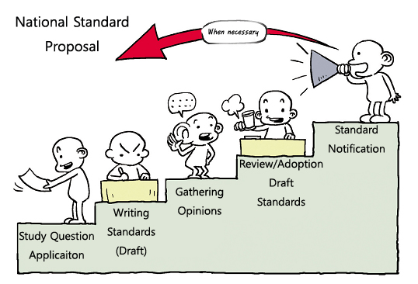
A national standard is developed through the processes of standard proposal and review, committee designation and drafting, public inquiry, final review and approval, and publication. Below are the detailed processes and methods.

Figure 6 – Standard Development Process
      - Standard Proposal and Review (Study Question Application)

The development of a standard begins when a proposal is received. Any interested party, for example, companies, organizations, or individuals can suggest a standard, and the government itself can be a proposer. In general, when a proposer submits an application and the descriptions of the suggested standard to the national standardization organization, it is assigned to a committee, which reviews the appropriateness of the proposal and determines whether to develop a standard. The review process mainly focuses on the reasonability of the proposed standard. That is, the process determines whether the proposed standard can be used across industry, have big ripple effects, be associated with the quality of systems or services or user protection, communications in emergency and disaster conditions, and the socially disadvantaged or the public. If deemed appropriate, the organization determines the scope of the standard and sets a timeline. If deemed unnecessary or inappropriate, the organization notifies the proposer of its conclusion and the reasons for the conclusion.

      - Committee Designation and Drafting (Writing Standards)

After reviewing the proposed standard, the national standardization organization assigns the duty to develop the standard to an appropriate committee, which, in this context, is referred to as the technical committee. The technical committee may encourage interested parties other than the committee members to take part in the development of the standard, sometimes by making public notices.
In general, the standard is developed based on the base document which the proposer submits. Most standards organizations have standard development guidelines including required templates and forms. National standards are prepared in accordance with forms that the national standardization organization provides. Below is an example of a Korean national standard developed in accordance with the national standard development form.

Reference

National Standard for Assistive Broadcasting Services for the Vision and Hearing Impaired

Preface

          - Purpose of Standard

This standard is intended to provide Closed Captioning, Video Description and Sign Language to promote the welfare and education of Hearing-impaired and Visually impaired users. This standard is applicable to domestic digital TV broadcast specifications including terrestrial, cable, satellite, and Internet Protocol Television (IPTV).

- Summary of Contents

This standard covers the transmission of Closed Captioning, Video Description, and Sign Language in the digital TV broadcasting service. It defines Closed Caption character sets, the format of Closed Caption data carried in the video stream and its transmission in digital TV signal. It also includes the transmission of Video Description and identification method of its audio data, and the specification on Sign Language.

- Applicable Fields of Industry and its Effect

This standard is to provide Closed Caption, Video Description and Sign Language in all digital broadcasting media such as terrestrial, cable, satellite, and IPTV which will improve accessibility of broadcasting media for the person with visual and auditory handicaps and will lead to enhance public welfare.

- Reference Standards (Recommendations)

- International Standards (Recommendations)
CEA-708-D, Digital Television (DTV) Closed Captioning, August 2008.
- Domestic Standards
None

- Comparison between Reference Standards (Recommendations) and this Standard

  - Relevance of this Standard with Reference Standards (Recommendations)
Closed Captioning specifications in this standard are based on CEA-708-D with additional requirements and mandatory items for Korea digital broadcasting environment. Closed Captioning services shall comply with CEA-708-D for the parts that are not mentioned in this standard. Transmission of Caption data via MPEG-2 and AVC/H.264 video codec conforms to ATSC A/53 and ATSC A/72 respectively.

A Comparative Table of Reference Standard (Recommendation) and this Standard
KSX-07.0093 | CEA-708-D | Remarks
- Introduction
- Scope and Structure
- Terms and Definitions
- Closed Captioning
4.1. Caption Channel Layered Protocol | 3. Caption Channel Layered Protocol | Same
4.2. Transport Layer | 4. DTVCC Transport Layer modified | Modified
4.3. Packet Layer | 5. DTVCC Packet Layer | Same
4.4. Service Layer | 6. DTVCC Service Layer | Same
4.5. Coding Layer | 7. DTVCC Coding Layer | Added
4.6. Interpretation Layer | 8. DTVCC Interpretation Layer | Modified
4.7. Mandatory Requirements for Caption Decoders and Receivers | 9. DTVCC Decoder Manufacturer  Requirements and Recommendations | Modified
- Video Description |  | Added
- Sign Language |  | Added
Annex A. Signaling of Closed Captioning |  | Added
Annex B. Handling of Terrestrial Closed  Captioning in the Absence of Caption  Service Descriptor |  | Added

- Statement of Intellectual Property Rights

Written Confirmation of Intellectual Property Rights for this standard can be referenced to the website of the National Radio Research Agency. Those using this standard must confirm that whether intellectual property rights are included in this standard. Other intellectual property rights may exist in relation to written confirmation received for this standard.

- Statement of Testing and Certification

- Object of Testing and Certification
None
- Standards of Testing and Certification
None

- Detailed History of Standard

Contents

1. Introduction
2. Constitution and Scope
3. Terms Definitions and Abbreviations
4. Closed Captioning
4.1. Caption Channel Layer Protocol
4.2. Transport Layer
4.3. Packet Layer
4.4. Service Layer
4.5. Coding Layer
4.6. Interpretation Layer
4.7. Mandatory Requirements for Caption Decoders and Receivers
5. Video Description
5.1. Method for Providing Audio Service of Video Description
5.2. Audio Identification of Video Description
5.3. Implementation Details of Receiver for Video Description
6. Sign Language
6.1. Method for Providing Sign Language
Annex A. Signaling of Closed Captioning
Annex B. Handling of Terrestrial Closed Captioning in the Absence of Caption Service Descriptor
Annex C. Placement of Video Description Audio ES Information
Annex D. Priority between Video Description and Preferred Language
Appendix I. Related Documents

When the standard above was developed, it was necessary to research local digital TV broadcast transmission and reception specifications, requirements of the vision and hearing impaired for broadcast, the Consumer Electronics Association Standards as the reference standard, and relevant local and international standards. A national standardization organization often asks national R&D institutes to conduct relevant studies and promote national standardization based on the results of such studies. In particular, when adopting an international standard, a regional standard or a foreign standard as a national standard, such a standard is developed based on the reference standard and reflects the nation’s policy and technical environments and characteristics.
Once the draft of a standard is completed, the national standardization organization reviews the draft to see if it conforms to the technical regulation, if it conflicts with any established national standard, and if the terms and forms follows applicable national standard guidelines.

      - Public Inquiry (Gathering Opinions)

After reviewing the standard proposal, the national standardization organization makes a public notice on the establishment, amendment, or abolition of a national standard in order to collect opinions from interested parties. Such a notice should include the title and number of the standard, main contents, and the reasons for establishment, amendment, or abolition.

      - Final Review and Approval

After the public inquiry, the standard is brought to the higher-ranking committee (hereinafter, such a committee is referred to as a council, for convenience sake) for review and final approval as a national standard. A typical council is comprised of heads of technical committees and officials from relevant government authorities, and they decide whether to approve the standard based on the opinions collected and specific criteria. Such criteria may vary country by country, but the general criterion is the appropriateness and validity of the standard’s objectives and development processes.

      - Publication and Distribution (Standard Notification)

Once approved by the council, the national standardization organization edits the standard without revising its contents, does a final review, and officially publishes it. During publication, the title, number, and other information on the standard should be notified in like manner as the opinion collection process. To promote the use of the standard, the national standardization organization conducts distribution activities, including publicizing through education, advice, and media promotions.

      - Follow-up Management

Once established, national standards may be amended on a regular basis or abolished in consideration of technical and environmental changes. An amendment of a standard follows the same process as the establishment of a standard. When abolishing a standard, the technical committee reviews the necessity to abolish the standard and makes a recommendation for abolition, and the council deliberates the suggestion and decides whether to abolish the standard.

      - Copyright Issue in Standards Development

When developing national standards by referencing int’l standards, the first thing to be confirmed is the copyright policy of the int’l standards organization that owns the international standards. A copyright is one of intellectual property rights and, accordingly, can be legally punished in case of violation. While some SDOs encourage to use their standards for free for the purpose of promotion of their standards, others protect their copyright strictly. Therefore, when an organization plans to develop national standards by referencing int’l standards, it is essential to check the copyright policy of the SDOs in advance. It is also recommended to contact the SDOs for inquiry about reference and use of the standards of the SDOs.
Generally, there are two ways of referencing of int’l standards, making reference to an entire document and reference to a specific section(s). In case of making reference to an entire document, there are ways of adopting int’l standards without translation into national standards, or adopting int’l standards as it is or adopting int’l standards after modifying a part of content to suit domestic environments and conditions. In the case of partial reference, there are methods to cite the phrase as it is, or to specify the source in which the phrase is specified instead of citing the phrase within the standard. If the content is not referenced in a specific international standard, but only for reference when developing a standard, the source of the relevant international standard can be specified as a bibliology.
It is important to check out carefully in advance whether or not a patent has been declared on the int’l standards to be referred because costs may be incurred or unexpected problem may be occured when domestic industry implement the standards.

Table 8. Copyright Policy of major SDOs

SDO | Related Regulation | PRICE | Main contents
ITU | ITU-T  Recommendation  A.Sup5 | Free | 11.2 The subject of modifications to texts and arrangements for royalty-free copyright licences, including the right to sub-license, for texts accepted by either ITU-T or by the organization and their publishers and others, is a matter to be agreed upon between TSB and the particular organization. However, the originating organization retains the copyright for its texts.
 | ITU-T  Recommendation  A.25 |  | 7.3 Copyright arrangements  The subject of modifications to texts and arrangements for royalty-free copyright licences, including the right to sub-license, for texts accepted by qualified organizations and their publishers and others, is a matter to be agreed upon between TSB and the particular organization. However, the ITU retains the copyright and change control for its texts, unless explicitly relinquished.
ISO | Directives, Part 1 | Charged | Attention is drawn to the fact that the respective members of ISO and IEC have the right to adopt and re-publish any respective ISO and/or IEC standard as their national standard. (2.13)
 | ISO POCOSA ISO Policies and Procedures for Copyright, Copyright Exploitation Rights and Sales of ISO |  | 3.4 The inclusion of the text of ISO standards in full or in part in national standards by ISO members, is allowed free of charge. Therefore, the Central Secretariat supplies ISO standards to members for the purpose of adoption and publication as national standards in revisable or non-revisable formats, when available.  7.1 Translation of ISO standards into the national language of a member is not subject to payment of a copyright fee if this is part of the member’s process for implementing an ISO standard as a national standard or if such a translation is necessary in the normal context of discussions leading to the development of a new or revised ISO standard.  7.2 Translation of ISO standards into the national language of a member for sales purposes (not in the form of a national standard) is subject to the payment of a copyright fee
ETSI | ETSI Directives  Annex 6  & Homepage | Free | 9.1 The ownership of the copyright in STANDARDS and TECHNICAL SPECIFICATIONS documentation and reports created by ETSI or any of its COMMITTEES shall vest in ETSI but due acknowledgement shall be given to copyrights owned by third parties that are identifiable in ETSI copyrighted works.  * ETSI standards are publicly available for consultation on the ETSI website.  The ownership of the copyright in standards created by ETSI or any of its committees shall vest in ETSI.  ETSI is responsible for the copyright management having all rights reserved.  The reproduction of parts of ETSI standards may be allowed provided a request is made using the ETSI Copyright Licence request.  The copyright authorization shall never imply a license on any potential SEP.
IEEE | IEEE Policies  6.3 General policies | Charged in principle | - IEEE Copyright Policies  2) All technical, educational and professional publications of the IEEE, except newsletters, but including Society and Technical Council Newsletters, are required to be copyrighted by the IEEE.  5) Third-Party Rights to Reuse IEEE-Copyrighted Material. Licenses and permissions to use IEEE copyrighted material (abstracts, full text, etc.) for commercial or other non-IEEE related purposes may be granted under terms approved by the IEEE Publication Services and Products Board.
IETF | IETF TRUST Legal Provisions Relating to IETF Documents | Free | c. Licenses For Use Outside the IETF Standards Process. In addition to the rights granted with respect to Code Components described in Section 4 below, the IETF Trust hereby grants to each person who wishes to exercise such rights, to the greatest extent that it is permitted to do so, a non-exclusive, royalty-free, worldwide right and license under all copyrights and rights of authors:  i. to copy, publish, display and distribute IETF Contributions and IETF Documents in full and without modification,  ii. to translate IETF Contributions and IETF Documents into languages other than English, and to copy, publish, display and distribute such translated IETF Contributions and IETF Documents in full and without modification,  iii. to copy, publish, display and distribute unmodified portions of IETF Contributions and IETF Documents and translations
W3C | W3C Document License | Free | Permission to copy, and distribute the contents of this document, or the W3C document from which this statement is linked, in any medium for any purpose and without fee or royalty is hereby granted, provided that you include the following on ALL copies of the document, or portions thereof, that you use:  - A link or URL to the original W3C document.  - The pre-existing copyright notice of the original author, or if it doesn't exist, a notice (hypertext is preferred, but a textual representation is permitted) of the form: "Copyright © [$date-of-document] World Wide Web Consortium, (MIT, ERCIM, Keio, Beihang). http://www.w3.org/Consortium/Legal/2015/doc-license"  - If it exists, the STATUS of the W3C document.
3GPP | 3GPP Working Procedures | Free | - Article 46: Copyright and ownership  The Organizational Partners will have joint ownership (including copyright) of the Technical Specifications and Technical Reports produced by 3GPP.

Case Studies of Standards Development and Operation in some countries (standard development system, status, difficulties & challenges)

Viet Nam

ICT standards in Viet Nam includes voluntary and mandatory standards which are classified into: international/ national/ organizational Standards and national/ municipal Technical Regulations respectively. Ministry of Information and Communications (MIC) is responsible for ICT standardization activities in Viet Nam. The process of developing standards and responsibility of involved entities is depicted in the following diagram.The terms of standards can be used for government regulations, in that case, companies and individuals must follow them as a matter of law. In usual cases, MIC initiates and participates in standards development, so the standards can be included in legislation. In other cases, MIC finds that an existing standard, which may be an international standard, can be used to deal out a public policy problem and includes it in new legislation.

Figure 7. Standardization Framework of Viet Nam
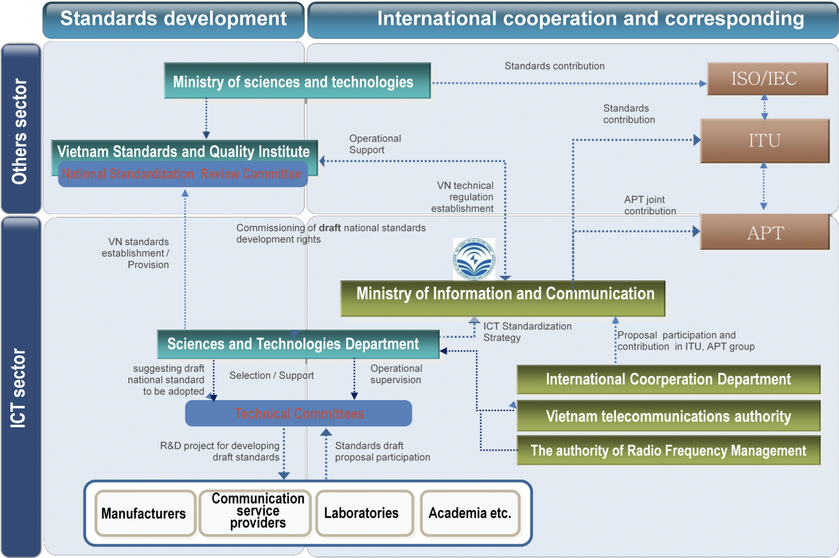

With more than 100 national technical regulations and nearly 100 national standards, ICT standards establish a wide range of requirements on performance specifications, characteristics, compatibility and interoperability of ICT products, requirements on Quality of Services, regulation on Electro-magnetic exposure of radio sites, requirements on information security, requirements on IPv6 nodes, etc.
The primary objectives of Viet Nam ICT standards are:

- Protection of human safety and environment with regards to the frequency interference when installing, deploying or employing of ICT products;
- Protection of ICT products from interference;
- Ensuring the interoperability between ICT devices;
- Protection of consumer’s right with regards to the quality of service

Republic of Korea

Korea has a dual sided framework under a structure to correspond to the world’s three major standard organizations, i.e., the ITU, ISO, and IEC. The Korean Agency for Technology and Standards (KATS), as the national standardization organization, governs the national standard system, KS, and serves as the national body to correspond to ISO and IEC. The Korean Standards Association (KSA) entrusted by KATS takes responsibility for the distribution and diffusion of national standards, standard education, and KS certification. In the ICT field (left side, Figure 14), the Ministry of Science and ICT (MSIT) corresponds to the ITU, and the National Radio Research Agency (RRA), which is a subsidiary organization of MSIT, governs the Korea Communications Standard (KCS). RRA runs the National IT Standard Commission to review and deliberate the development of the KCS.

TTA is a private SDO in the ICT field, where stakeholders from industries, academia, and research institutes develop voluntary TTA standards and, if necessary, suggests selected standards as a KS/KCS national standard. During the TTA’s standardization activities, anyone can suggest a basic document of a standard. The research results of national research institutes such as ETRI, KISA, and NIA are often used to develop draft standards. Designated by the MSIP as the standardization organization, TTA takes the responsibility for planning national standardization plans, establishing national standard infrastructures, responding to international standardization, fostering standard experts, and supporting developing countries’ standardization activities.

Figure 8. Standardization Framework of Korea

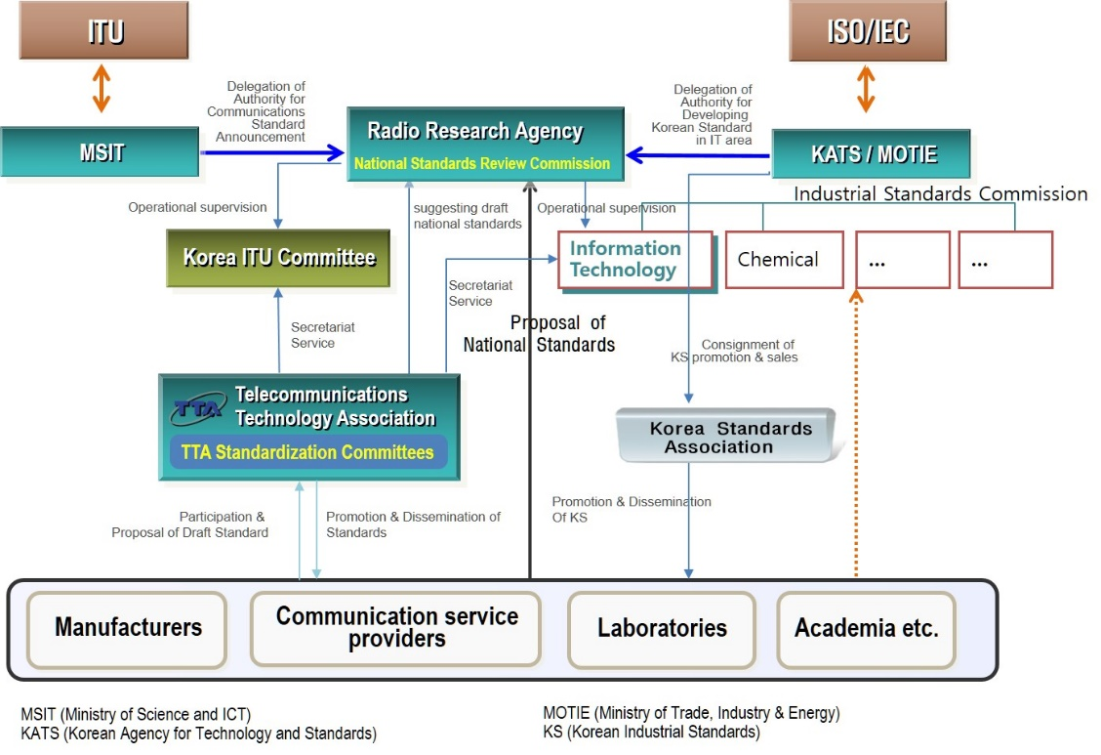

Singapore

Being an advanced economy, Singapore does not have substantial foundations of manufacturing. Developing countries may find more implications from the Singaporean model, where institutions and regulations are highly advanced without industrial foundations, rather than those of countries underpinned by strong manufacturing.

Figure 9. Standardization Framework of Singapore
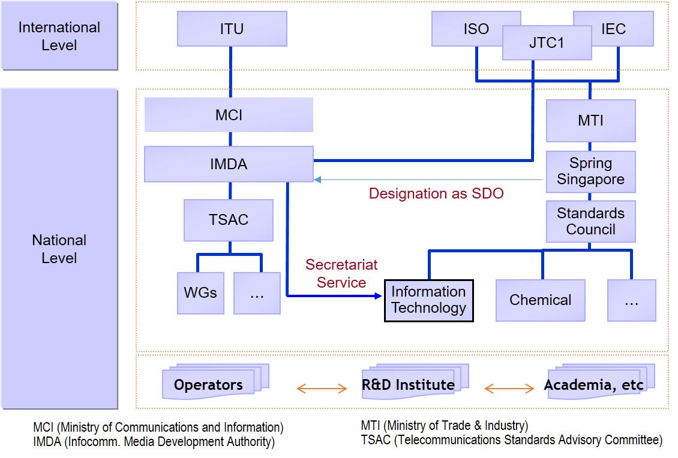

MCI is responsible for ICT in Singapore, and the ministry designated IMDA as an independent organization to develop and regulate ICT technologies and services. The overall national standards are governed by the national standardization organization under MTI, which is SPRING Singapore, and its Standards Council develops national standards. The Standards Council also responds to relevant international standardization activities.
IMDA serves as the secretariat for the Information Technology Standards Council (ITSC), the IT-relevant committee under the Standard Council of SPRING Singapore, and provides administrative support for the development of IT standards. It is also a SDO designated by SPRING Singapore that develops ICT standards by itself. In practice, TSAC under IMDA takes the responsibility for the development of IMDA standards.
TSAC is comprised of experts from network operators, service providers, manufacturers, academia and research. Its roles include developing and establishing ICT standards and providing advice to IMDA. In summary, government organization, IMDA, plays the national standardization organization’s role in the ICT field and develops standards through councils comprised of various stakeholders with expertise.

Japan

Standardization system in Japan is divided into the government sector corresponding to the international standardization organizations such as ITU, ISO, IEC and the private sector promoting the actual standardization work. The ICT Council under the Ministry of Internal Affairs and Communications and the Japanese Industrial Standards Association (JISC) under the Ministry of Economy, Trade and Industry are correspong to ITU and ISO/IEC respectively.
ICT Council investigate and deliberate important matters concerning the use of radio waves, postal services, national policy in telecommunication fields such as telecommunication, broadcasting, and radiocommunication. JISC is an organization that directly establishes the Japanese Industrial Standard (JIS) in industrial sector including information technology.
While JIS is developoed by the JISC, but development and notifications of the JISC in specific areas are carried out by individual government ministries. Standardization in ICT is promoted by Ministry of Internal Affairs and Communications and, in private sector, the TTC (Telecommunication Technology Committee) and the ARIB (Association of Radio Industries and Business) are developing voluntanry standards in telecommunications and radiocommunications field respectively.

Figure 10. Standardization Framework of Japan

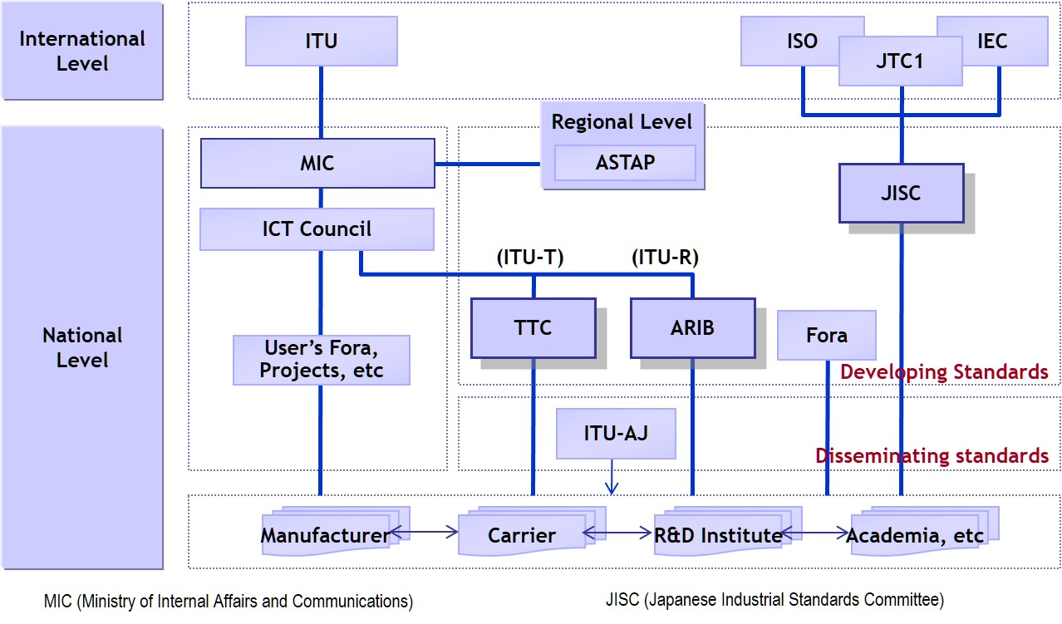

Case Studies of National Standards (or Technical Regulations)

Case of Viet Nam

Standards for QoS on the Public Land Mobile/Fixed Network

The unprecedented growth in Viet Nam’s telecommunications market has derived from the increase of the variety of services and providers available to booming consumers. The market is becoming intensely competitive for service providers. Competition has brought not only lower prices but also improved quality of service. However, improving the quality of service, which means considerable investment in infrastructure, is never an easy option for operators. To ensure the minimum quality of service for user and maintain a competition between operators, Ministry of Information and Communications Viet Nam has promulgated several technical regulations for quality of basic services on public land mobile/fixed network, including:
National standards TCVN 11302:2016 “Streaming video service on the IMT-2000 Public Land Mobile Network - Quality of service requirements”;
Technical regulations:
QCVN 82:2014/BTTTT “National technical regulation on quality of Short Message Service (SMS) on the Public Land Mobile Network”;
QCVN 81:2014/BTTTT “National technical regulation on Quality of Internet access service on the Public Land Mobile Network IMT-2000”; This technical regulation is being amended to cover 4G LTE/LTE-A Internet access service;
QCVN 36:2015/BTTTT “National technical regulation on Quality of telephone service on the Public Land Mobile Network”;
QCVN 35:2011/BTTTT “National technical regulation on quality of telephone service on the Fixed Public Telecommunications Network”;
QCVN 34:2014/BTTTT “National technical regulation on quality of fixed land broadband Internet Access Service”.
These standards provide technical criteria, each comprise of: (1) Definition of parameter; (2) threshold level and (3) measurement method. Sharing similar principle of assessing mobile communication quality of service based on end-to-end perspective or viewpoint the user, all the technical regulations (for mobile service) refer to the ITU-T Recommendation E.804 definition with whole adoption without modification. The selected criteria are considered to have main influence on the user's satisfaction with regard to the service. For the mobile Internet access service, the parameters are: Radio network availability; Successful data transmission ratio; Set-up time; Mean data rate; Session drop ratio; For the mobile telephony service, the parameters are: Radio network availability; Successfully connected call ratio; Dropped call ratio; and Voice quality.

DVB-T2 terrestrial broadcasting receiver decoder

Since 2012, Viet Nam started to deploy nationwide analogue to digital migration plan which will see the country’s television stations broadcasting completely in digital by 2020. The DVB-T2 terrestrial broadcasting standard has been chosen to implement the migration. To facilitate the analogue switch off plan, user receiver/decoder technical specifications has been established with the aim to ensure that equipment in the market will satisfy a common set of minimum requirements, independent from operators/service providers. The technical regulation for DVB-T2 digital receiver used in digital terrestrial television broadcasting, namely QCVN 63:2012/BTTTT was developed by referencing NorDig and Digi.TV standard thanks to its similarity of technological characteristics between Viet Nam and Nordic and South East Europe region.
The parameters in QCVN 63:2012/BTTTT are:
Reference to NorDig specifications includes: General requirements for audio/video decoder signal, power supply, and software update mechanism; Functional requirements such as remote control, signal level and signal quality indicator; Interface requirement for to high-definition multimedia interface (HMDI), radio frequency (RF) interface, audio interface;
Reference to IEC standards for EMC requirements (refer to CISPR 13);
Reference to Digi.TV specifications for processing of program specific information/Service Information (PSI/SI) table, electronic programming guide (EPG) functionality which required for signaling processing in receiver/decoder.

Case

- QCVN 81:2014/BTTTT technical regulation on Quality of Internet access service on the Public Land Mobile Network IMT-2000
Parameter | Reference standards | Modified adoption & Reason
Radio network availability (%) | ITU -T E.804 | Difference:  - Minimum level for KPIs;  - Measurement methodology for KPIs;  - Service provider is required to make a map of the coverage area publicly available. There are further data needs on broadband communications services, for example upload and download rates of data transmission provided to end-users.  Reason:  - Suitability for network technology and policy of Viet Nam;  - To ensure the minimum quality of service for all telecommunication user and maintain a competition between operators;  - To ensure technical specifications are measured by specified measurement method.
Successful data transmission ratio (%)
Set-up time (s)
Mean data rate (kbit/s)
Session drop ratio (%)
- QCVN 36:2015/BTTTT technical regulation on quality of telephone service on the Public Land Mobile Network”
Radio network availability (%) | ITU -T E.804 | Difference:  - Minimum level for KPIs;  - Measurement methodology for KPIs;  - Service provider is required to make a map of the coverage area publicly available. There is further information about Rx level.  Reason:  - Suitability for network technology and policy of Viet Nam;  - To ensure the minimum quality of service for all telecommunication user and maintain a competition between operators;  - To ensure technical specifications are measured by specified measurement method.
Successfully connected call ratio (%)

Dropped call ratio (%)
Voice quality
- QCVN 63:2012/BTTTT technical regulation on digital receiver used in DVB-T2 digital terrestrial television broadcasting
Reference to NorDig and Digi.TV standards by partly adoption.
Reference to IEC standards for EMC requirements
Parameter |  | Reference Standard
1. General requirement
Electromagnetic compatibility |  | IEC/CISPR 13:2009
System software upgrade |  | Digi.TV Regional receiver specification
Remote control
Signal level and signal quality indicator
2. Service information requirements
Processing of PSI/SI tables.
Real time clock
EPG functionality for EIT actual and EIT other
Subtitles
Logical channel number descriptor |  | NorDig Unified Requirements
3. Interface requirement
RF interface input
RF interface output
HDMI interface
RCA analogue video output
RCA analogue audio output
Interfaces for conditional access
4. RF requirements
Signal bandwidths
RF modes
Multiple PLPs
Multiple PLPs and common PLP
Normal mode
Changes in modulation parameters
RF bypass
C/N performance on Gaussian channel
C/N performance on 0dB echo channel
Minimum receiver signal input levels on Gaussian channel
Minimum IRD signal input levels on 0dB echo channel
Noise figure on Gaussian channel
Maximum receiver signal input levels
Immunity to digital signals in other channels
Immunity to analogue signals in other channels
Immunity to co-channel interference from analogue TV signals
C/(N+I) performance in single frequency networks inside the guard interval
C/(N+I) performance in single frequency networks outside the guard interval
5. Audio/video decoder requirements |  | Digi.TV Regional receiver specification
MPEG2 de-multiplexer
Video decoder
Audio decoder

Case of Korea

Following is a basic components of technical requirement for Internet Multimedia Broadcasting Equipment of Korea.
 |  | Reference
Carriers Facilities | Power Line Facilities | Technical Requirement on Broadcasting & Telecommunication Equipment
 | Protector & Grounding | Technical Requirement on Broadcasting & Telecommunication Equipment
 | Voice Codec | ISO/IEC 13818-7 AAC
 | Video Codec | ITU-T H.264 or ISO/IEC 14496-10 AVC
 | Transmit Stream Multiplexing | ISO/IEC 13818-1 MPEG-2 TS
 | Retransmission of terrestrial broadcasting | Service & System : PSIP (Program Specific Information Protocol)
User Equipment | Physical Network Connection | IEEE 802.3/802.3u Ethernet(10/100M)
 | Multicast Channel Transit | IETF RFC 2236 IGMP (join/leave)
 | Voice Decoding | ISO/IEC 13818-7 AAC
 | Video Decoding | ITU-T H.264 or ISO/IEC 14996-10 AVC
 | TS Demultiplexing | ISO/IEC 13818-1 MPEG-2 TS
QoS | QoS of Network | 1. Packet Delay ≤ 100ms  2. Packet lose ≤ 10⁻³  3. Packet lose variation ≤ 50ms

As the table shows, technical requirement stipulates essential requirements for Internet Multimedia Broadcasting service such as equipment of service provider, user equipment and quality of service, and, in principle, follows international standards. However, some components which are related with national matter of a country such as power line facility, protector and grounding, refers to national technical regulation.

The table below shows some requirements for surge protector in technical regulation of Korea.

Performance Item |  |  | Korean Technical Regulation | Reference Int’l Standard  (ITU-T K.12)
overvoltage | DC. discharge |  | 184V~280V | DC 184V~280V
 | Impulse | 100V/μs | 180V~600V | below 600V
 |  | 1,000V/μs | 180V~700V | below 700V
 | capacitance |  | - | below 20pF
overcurrent | current limiting |  | AC 110V 250Ma -1min  AC 110V 1A – 2 secs | -
 | Safe values of let-go current |  | DC 150mA - 3 hrs | -
Ignition protection | Ignition withstand |  | 60Hz 5A – 15 mins | -
 | withstand voltage test |  | AC 220V 3A – 15mins | -

As shown the table above, the overvoltage performance as a major factor in surge protector performance shows that the range of DC discharge is aligned with the range given in ITU-T K.12. The range of impulse is set to the highest level but no criteria for the lowest level in ITU-T K.12. However, the Korean technical regulation suggests the lowest level to offer clarity.
In the case of capacitance, there is a criteria in ITU-T recommendation, but the Korean technical regulation does not have the performance item because it is agreed that capacitance has no meaning practically in the field. Although there are no figures presented in ITU-T recommendation for over-current performance and ignition protection performance, the Korean regulation stipulates the figures for over-current and ignition protection performance which reflects a result of the research which service providers has conducted for their business needs.

Conclusion

ICT is an essential component for both developed and developing countries in achieving sustainable economic development. Standard is a fundamental factor in developing ICT. The overall capability of a country in standardization can be measured by various factors, such as legislation, national policy, institutional system, human resources, technological capability, etc. Compared with developed countries, most developing countries lack resources and systems, which leave so-called a standardization gap between the developed countries and developing countries.

Harmonious and balanced development of the worldwide ICT is of mutual benefit to developing and developed countries. In this regard, international standardization organizations and some developed countries have been providing various programs to developing countries for enhancement of their standardization capabilities.

Despite those efforts to reduce the standardization gap, major disparities in knowledge and management of standards remain between developing and developed countries. Moreover, recently, the benefits of standardization are being focused on market dominance by standards, which make developed countries lead global standardization.

Standardization would be particularly meaningful to developing countries. By utilizing standards, developing countries can minimize trials and errors in ICT development. They also can benefit from standardization in implementing ICT infrastructure and services in a cost-effective way, as well as promoting the welfare of the people.

In this regard, the guideline focused on what should be considered in referencing international standards when developing national standards as well as how standardization systems operate because standards is not a simple technology but a product of intergrated system. accordingly, it is expected that this guideline would motivate policy makers to introduce standardization system or enhance current standardization capabilities in their countries so as to benefit further from ICT standardization.

ISO/IEC Guide2:1996
Protocol: A set of standard rules for data representation, signaling, authentication, and error detection required to send information over a communications channel. By using the same communication protocol, different computers can communicate with each other, and unifying the meaning of data among computers allows for the operability of programs running in different computers. The word “protocol” comes from diplomatic terms and refers to a set of rules to be observed among nations. If a protocol is violated, a crisis among nations may occur. In this sense, the observance of protocol is considered mandatory. When any communications protocol is violated, there will be severe problems, such as communication interruption. Accordingly, communications protocols must be maintained. Examples of communications protocols: a radio dispatcher talking to mobile stations, X-series recommendations published by ITU-T, and TCP/IP, which is used for Internet communication.
An organization that develops and manages standards is referred to as standards body, standardization organization, standards setting organization (SSO), or standards development organization (SDO), etc.
Network externality: Direct network externalities are an increase in individual users’ benefits from a product following an increase in the number of users (e.g., telephone, communication networks, railroads, etc.). Indirect network externalities exist when an increase in the number of users of a product and/or its compatibles expands the demands for its complementary products (for example, the distribution of VHS players resulted in increases in demands for cassette tapes, movies, and other content).
Rudi Bekkers & Andrew Updegrove, 「A study of IPR policies and practices of a representative group of Standards Setting Organizations worldwide」, National Academies of Science, 17 September 2012.
Source : IPR Policy or Guidelines of ITU/ISO/IEC, ETSI, IEEE-SA and the license program agreement of MPEG-2
OECD, "Innovation and Growth: Rationale for an Innovation Strategy", 2007, refer to : http://www.oecd.org/dataoecd/44/50/40908171.pdf.
ITU/UNCTAD, "World Information Society Report 2007: Beyond WSIS", June 2007, refer to : http://www.itu.int/osg/spu/publications/worldinformationsociety/2007/report.html
Xuan Li and Baisheng An, “IPR MISUSE: THE CORE ISSUE IN STANDARDS AND PATENTS”, SOUTH CENTRE(JUNE 2009); George S. Cary et al., Antitrust Implications of Abuse of Standard-Setting, 15 GEO. MASON L. REV.1241, 1242 (2008), p.24
As mentioned before, in standardization activities the patent issues are most important, so this chapter will describe only the Patent Policy.
RAND and FRAND are generally considered to constitute the same meaning. They are rereinafter referred to as “F/RAND.”
Refer to : Common Patent Policy for ITU-T/ITU-R/ISO/IEC.
Refer to : Guidelines for implementation of the Common Patent Policy for ITU-T/ITU-R/ ISO/IEC.
‘Reciprocity’ means that the Patent Holder shall only be required to license any prospective licensee if such prospective licensee will commit to license its Patent(s) for implementation of the same above document Free of Charge or under reasonable terms and conditions.
Refer to : ETSI Rules of Procedure, Annex 6 ETSI Intellectual Property Rights Policy
The ETSI IPR policy includes provisions on rights bestowed under the positive law, for example trademark rights and patents, but this text will focus on the patent part.
Refer to : IEEE-SA Standards Board Bylaws, Section 6 Patents.
Rudi Bekkers & Andrew Updegrove, op. cit., p. 103. Similarly, Daniel G. Swanson & William J. Baumol, “Reasonable and Nondiscriminatory (RAND) Royalties, Standards Selection, and Control of Market Power”, 73 Antitrust Law Journal 1 (2005), p. 5; Anne Layne-Farrar et al., “Pricing Patents for Licensing in Standard-Setting Organizations: Making Sense of Frand Commitments”, 74 Antitrust Law Journal 671 (2007), p. 671
Larry M. Goldstein& Brain N. Kearsey,Technology Patent Licensing, p27
See Commission Decision No. 2001/165/EC, O.J. L 59/18 (2001) ("IMS Health"),suspended sub nom, IMS Health Inc. v. Commission, Case T‐184/01, [2002] 4C.M.L.R. 2, suspension confirmed sub nom, NDC Health Corp. v. IMS Health Inc. and Commission, Case C‐481/01, [2002] 5 C.M.L.R. 1, prelim. hr'g sub nom, IMS Health Inc. v. NDC Health Corp., Case C‐418/01 (ECJ May 1, 2002).
EC Council Resolution (85/C136/01), A New Approach to Technical Harmonization and Standards, 1985. 5.
EC Council Decision (87/95/EEC), Standardization in the Field of Information Technology and Telecommunications, 1987.
Regulation (EU) No. 2025/2012 of the European Parliament and of the Council, Regulation on European Standardization, Amending Council Directives 89/686/EEC and 93/15/EEC and Directives 94/9/EC, 94/25/EC, 95/16/EC, 97/23/EC, 98/34/EC, 2004/22/EC, 2007/23/EC, 2009/23/EC, and 2009/105/EC of the European Parliament and of the Council and Reporting Council Decision 87/95/EEC and Decision No. 1673/2006/EC of the European Parliament and of the Council, 2012.10. 25.
https://nordig.org/about/
http://www.southeast-europe.net

