APT REPORT

on

EMF information platform

APT/ASTAP/REPT-41
Edition: June 2019

Adopted by
31st APT Standardization Program Forum (ASTAP-31)
11 - 15 June 2019, Tokyo, Japan

(Source: ASTAP-31/OUT-23)

Contents
1. Scope 3
2. Abbreviations and acronyms 3
3. Concept of EMF information platform 3
4. Information types for the EMF information platform 4
5. System configuration for EMF information platform 9
6. Reference 11

Scope

This report informs the concept of EMF information platform which makes better awareness of EMF exposure management activities and result of EMF assessment for the general public. This informative platform is aim to the risk communication with the people who concerned about EMF exposure. The report includes EMF assessment activities that are In-situ measurement, compliance assessment, long-term and area monitoring of EMF exposure.

Abbreviations and acronyms

AF Antenna Factor (dB/m)
DB Database
DBMS Database Management System
ELF-EMF Extremely Low Frequency Electromagnetic Field
GIS Geographic Information System
RBS Radio Base Station
RBW Resolution Band Width
RF-EMF Radio Frequency Electromagnetic Field
TER Total Exposure Ratio

Concept of EMF information platform

The concept of EMF information platform for the general public and experts is expressed in Figure 3.1.

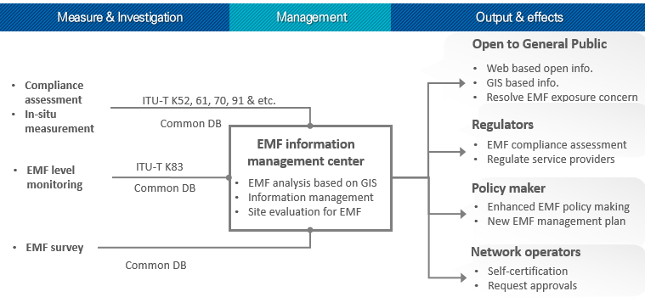
Figure 3.1 Concept of EMF information platform

All EMF related information collected and delivered to the information platform can be opened to various people. The concept of the EMF information platform provides user interface based on GIS for easy understanding and convenient access by general public, industry, researcher and policy makers. All measured and collected data need to be common database format to handle them by the open platform. The platform has two types of data handling that are the evaluated result and measured raw data which can be accessible from the professional people with open API.
The detail platform architecture consists of Data collection, Data classification, Standard database, Interactive system and data transaction with user interface part. To overcome some difficult access to the platform server directly, local DB can be used for changing common DB and sending server in platform system. General public can access the system using App or Web based UI and dedicated UI for Professional.
Many countries effort to manage EMF radiation from the radio transmitters to reduce the general public concerning under EMF exposure environment. And they regulate radiation sources according to ICNIRP limit and doing in-situ measurement and long-term measurement activities using ITU-T K.52, K.61, K83, K70, EM50400, 50492, 50383, 50554 and etc. guide lines.
The EMF management activity can be classified as Pre-analysis with calculation, Compliance assessment (Put into service), In-situ measurement and long-term measurement (Long-term EMF monitoring and EMF area scanning).
But another important thing is risk communication with general public who concern about the exposure from EMF radiation in vicinity of radio stations. The one of effective method will be the information delivering for better awareness of EMF well managed to general public. All EMF related information collected and delivered platform is useful for the general public understanding.

Information types for the EMF information platform

EMF information contains various assessment types and methods according to purpose and environment. Figure 4.1 shows the overall process of EMF assessment.
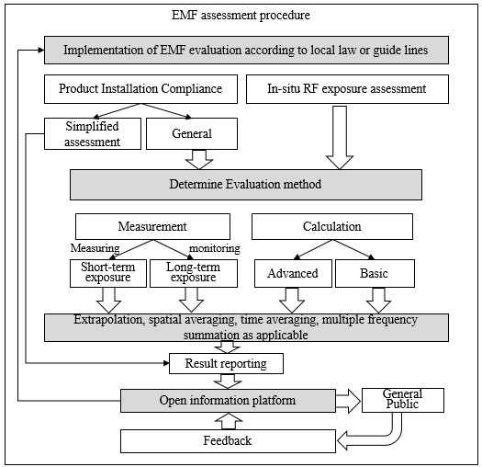
Figure 4.1 Evaluation process based on EMF information platform

EMF assessment procedure is
This sequence involves determining the evaluation purpose, method(s) of evaluation, as well as extrapolation, spatial averaging, time averaging and multiple frequency summation. The uncertainty and reporting stages complete the evaluation process.

  - Compliance EMF assessment

EMF information platform includes the procedure of calculation, measurement and information delivering to all related segments refer to Figure4.1.
According to international standards like IEC62232, ITU-T K.52, ITU-T K.61, there are three categories for EMF assessment that are Product compliance, Installation compliance and In-situ exposure assessment. the platform covers Installation compliance and In-situ RF exposure assessment. They also be classified three sections for assessment that are Pre-analysis, In-situ measurement and EMF monitoring.
The basic concept of the EMF information platform provides all the results of them with standard expression and classified location based information for easy understanding and accessible by general public, industry, academy and related organization like government and policy maker of EMF.

  - EMF assessment
This standard defines the methods that shall be used to determine, or overestimate, the total exposure ratio in relevant area where the general public has access. i.e. in the domain of investigation. For this assessment, alternative routes (Figure 7.1) can be used and any completed rout is valid.
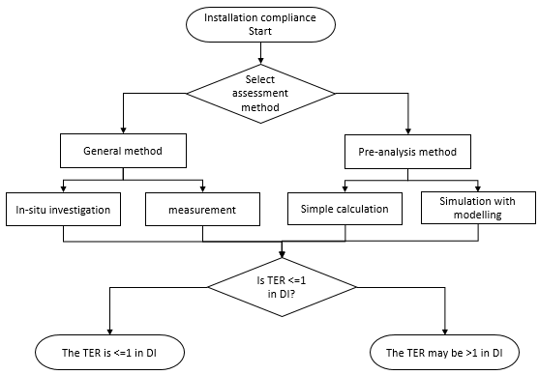
Figure 4.2 Installation compliance process to determine the total exposure ratio where the general public has access

For sources with time-varying power, the value of the average emitted power at the maximum power setting of equipment shall be used.
In general, EMF exposure assessment in vicinity of radio station carry on to assess the whole body human exposure. The field-averaging protocol is required. The spatially averaged field value shall be established using the following equation for broadband and frequency selective measurement basically.
$${\left(E or H\right)}_{spatial averaging}=\left[\sqrt{\frac{\sum_{i=1}^{N}{{\left(E or H\right)}^{2}}}{N}}\right] with \left\{\begin{aligned}E_{i}=\sqrt{E_{i_{x}}^{2}+E_{i_{y}}^{2}+E_{i_{z}}^{2}} \\ H_{i}=\sqrt{H_{i_{x}}^{2}+H_{i_{y}}^{2}+H_{i_{z}}^{2}}\end{aligned}\right\}$$
For frequency selective measurement, the above equation shall be evaluated separately for each frequency band.
Steady and continuous signal radiated from the fixed radio stations can be used the concept as :
$$P_{avg}=\frac{1}{t_{2}-t_{1}}\int_{t_{1}}^{t_{2}}{P\left(t\right)}dt$$
Where$t_{1}$ and $t_{2}$are the start and stop time of the measurement. The period$t_{2}$ - $t_{1}$ is the exposure duration time.

The basic general procedure to measure electric field of CW signal at a given frequency with a generic spectrum analyzer in a selected point of space can be described as follows.
- fix the antenna with the radome in the point selected and set the spectrum analyzer the spectral band of interest;
- set the spectrum analyzer parameters (Start and Stop Frequency, RBW, detector type, etc.);
- measure in sequence the amplitude of the three components $E_{x}, E_{y}, E_{z}$ using the manual or automatic axis selection or selecting them directly on the spectrum and compute the total electric field , i.e. $E_{tot}=\sqrt{\left(E_{x}^{2}+E_{y}^{2}+E_{z}^{2}\right)}$ .
The point of the above procedure involves these further computations to be done for each component of electric field:
  - take the reading R_{dBm} in dBm unit on the spectrum analyzer;
  - convert the reading in dBμV : R_{dBμV} = R_{dBm}+ 107dB (50 ohm instruments impedance);
  - add cable attenuation and antenna factor at the given frequency to get the value of the component of electric field under measurement : E_{dBuV/m} = R_{dBμV}+ AF_{dB} + Att_{dB} ;
  - convert the result in V/m : $E_{v/m}={10}^{\left(\frac{E_{dBuV/m}}{20}-6\right)}$

  - Monitoring EMF levels for long-term measurement
One useful approach to give reassure citizen worried whether RF EMF levels are under control is EMF area monitoring. There are two considerations to monitor that is long-term RF EMF measurement and RF EMF area scanning method for the distribution of filed strength concerned area.

RF EMF monitoring for long-term exposure
To take into account the temporal variability of the emission of the radio stations within 24 hours, the power deduction factor can be considered. Each electromagnetic field emission from the radio stations for the measurement need to be corresponded with all service types in a certain frequency band. Each service band has $P_{i}$ which is average power in the i-th time interval. the coefficient relative to "SIGNAL" is defined as the maximum value on a yearly basis of the daily coefficient a defined as:
$$α_{24h}^{day}=\frac{1}{m}\sum_{i=1}^{m}{\frac{P_{i}}{P_{max}}}$$

Where $P_{max}$ is the value of the maximum power that can be supplied to the antenna terminals of radio station. And m is equal to the number of time intervals with a duration of 60 minutes or defined interval according to local policy for one day, i.e. 24 hours.
In particular, the average value over the 24 hours of the electric field, $E_{24h}$, will be given by the following relation :
$$E_{24h}=E_{max}\sqrt{α_{24h}}$$
Where $E_{max}$ is the maximum electric field value.

Long-term RF EMF measurement system monitors the exposure levels of the general public in specific locations. The results of continuous measurement of the exposure level in the whole spectrum used in radio communication are registered by the automatic system in order to show the exposure as a function of time. The results of measurements may be presented for the general public by a user-friendly tool accessible via Internet.

RF EMF area scanning with GIS based for EMF distribution analysis
Long-term EMF measurement can deliver the understanding the variability of electric field strength along with time and assessment of long-term based exposure. But It is limited measurement number in some given time and not sufficient to general public who concern his or her place to live or site of interest. To deliver more well managed under control with guideline, EMF strength distribution based on GIS will be more efficient method for this kind of concerning.

    - Broadband EMF monitoring
The easiest way to long-term measurement is broadband EMF monitoring. Because the value measured by Broadband EMF monitoring does not exceed the most restrictive exposure limit in the whole frequency band. In general, broadband EMF monitor is made by diode sensing or thermocouple sensing with short dipoles. This method has some advantages that are more accurate than other and economical approach to assess for EMF emitters.
Exposure to a single frequency is an ideal case. The most general case is that of exposure to various sources or to a single source with various frequencies. Considering this general case, it can, however, be easily proved mathematically that if the value measured by the equipment does not exceed the most restrictive exposure limit in the frequency band to be measured, then the contributions at different frequencies will also be below said limit, since:

All possible information about how the measurements are taken should be provided:
  - Measurement location (by its geographical positioning on a map).
  - Description of the measurement site.
  - Date and time.
  - Description of the measurement method: broadband, frequency selective, average time, position of the probe, etc.
  - Identify the measurement equipment,
  - Record calibration details for any instrumentation used,
  - Identify who has done the assessment,
  - Record when and where the assessment was performed,
  - Record the Relevant Sources considered and associated parameters,
  - Include the value of parameters used in the assessment and any assumptions made, record the results of Total Exposure Ratio measurements.

    - Frequency selective EMF monitoring
EMF monitoring with frequency selective is the most useful method to assess each service frequency bands and analysis the dominant contributor. And it also gives many valuable information to general public.
For each frequency band the measurement should be done using detector according to the national regulations. If there are no national regulation, it can be referred to the ICNIRP guideline. The measurement time for each band is chosen according to the typical time behavior of the emitters.
The measurement equipment consists of the following parts:
- Measurement probe
- Frequency selective measuring instrument, which processes the signal from the probe and indicates the value of the EM field quantity
- Measurement automation
As additional information date, time, actual measurement position, ambient temperature and humidity and system status and warnings are added to the measurement result.
This result is stored internally (offline evaluation) or transmitted automatically via data link to a server (online evaluation).

  - EMF area monitoring with mobile scanning
For the EMF mobile measurement, all measuring parts can be installed in the roof box on the vehicle to protect outside environmental impact like dust, rain and vibration. The measurement and scanning control shall monitor the system status and measuring status with auto script which be made in scanning scenario automatically. The measured data shall be saved to the internal memory with every 1 second GPS interval. The process of EMF scanning system shows as Figure 4.3 for example.
The first process is that EMF area scanning procedure starts with the measurement set-up and scenario which included scanning area and frequency subranges.
And the second, scanning targeted area along with all roads as possible. The measured spectrum and electric field strength data is recorded at each coordinate and mapping on the commercial map. Collected electromagnetic field strength results using drive measurement will provide the information of the field strength and power density distribution along with geographical based.
Each measured pixel is a small square area which can be decided with vehicle moving speed and GPS data update rate. Therefore, 1 degree of coordinate is the basic resolution unit of the scanning data. The size of the pixel is 24.6m for longitude and 30.8m for the latitude in grid mapping.
Finally, all measured results with targeted service frequency bands shall be recorded and collected data converted database with GI based. The measured results expressed with color dots that show electric field intensity.
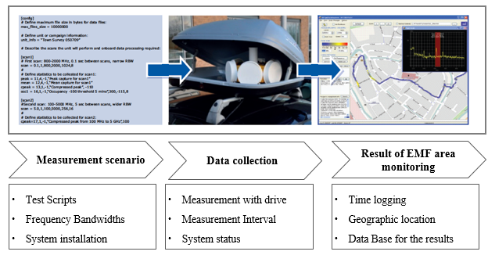
Figure 4.3 EMF scanning process of GIS based

Mapping data shows the high point of electric filed strength or power density. The colored results can be expressed with interpolation of strength intensity.

System configuration for EMF information platform
The architecture of EMF information platform could be considered server based system as described in Figure 5.1. All type of measurement results in the filed can be delivered via public internet or private communication methods to the DB servers via DB transformation system. All data base can be transacted in GIS based interactive system for the general public access or related organizations and party.
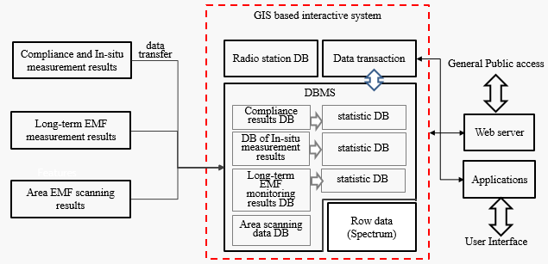
Figure 5.1 EMF information platform architecture

The detail platform architecture consists of Data collection, Data classification, Standard database, GIS server and data transaction for interactive user interface.

Web based information
All possible information about how the measurements are taken is provided:
  - measurement location (by its geographical positioning on a map).
  - description of the measurement site.
  - date and time.
  - description of the measurement method: broadband, frequency selective, average time, position of the probe, etc.
  - identify the measurement equipment,
  - record calibration details for any instrumentation used,
  - identify who has done the assessment,
  - record when and where the assessment was performed,
  - record the Relevant Sources considered and associated parameters,

GIS based interface method
The current measuring device shows all information related system and result of EMF strength values in interested area. Measured points are also shown with various chart which includes daily, weekly, monthly, yearly based result statistics.

Statistics analysis
The results are provided as the time chart, bar chart, each frequency subranges chart for better understanding to general public

Reference

[T-REC-K.91] | Guidance for assessment, evaluation and monitoring of human exposure to radio frequency electromagnetic fields
[ITU-T K.52] | Recommendation ITU-T K.52 (2004), Guidance on complying with limits for human exposure to electromagnetic fields.
[ITU-T K.61] | Recommendation ITU-T K.61 (2003), Guidance to measurement and numerical prediction of electromagnetic fields for compliance with human exposure limits for telecommunication installations.
[ITU-T K.70] | Recommendation ITU-T K.70 (2007), Mitigation techniques to limit human  exposure to EMFs in the vicinity of radio communication stations.
[ITU-T K.83] | Recommendation ITU-T K.83 (2010), Monitoring of electromagnetic field levels.
[ICNIRP] | ICNIRP (1998), ICNIRP Guidelines for Limiting Exposure to Time-Varying Electric, Magnetic and Electromagnetic Fields (up to 300 GHz), Health Physics, Vol. 74, No. 4; pp. 494-522.  http://www.icnirp.de/documents/emfgdl.pdf

Appendix Ⅰ RF EMF monitoring for long-term measurement

- Objectives

This technical system level recommendation gives guidance to provide the EMF exposure level information of the selected areas that are under public concern in order to show that EMF are under control and the under the limits for the general public. This purpose of system information is to provide clear and easily available data concerning electromagnetic field levels in terms of area and long-term measurement. EMF area monitoring platform that consist of GIS based or time variation based, and broadband or frequency selective based could help to make general public intrinsic understand and increased awareness for the EMF information which can be well managed

- Broadband EMF area monitoring procedure

General process
This Recommendation defines the methods that shall be used to determine the Total Exposure Ratio TER over a certain period to perform a time dependent evaluation of EMF exposure.
The broadband measuring method is based on [2, 3]. It allows obtaining the total radiation level in the form of electric field strength (E) in the frequency band of interest, averaged over a certain period of time.
This method is applicable in those cases where the total summation of the emissions of a said frequency band is required to be measured. It allows obtaining a rapid measure of the total emission level of the band with a low cost.

Measurement method
The measurement is continuously and automatically carried out over the targeted frequency range. The frequency range is from 100 kHz to 3GHz. Installation shall be above 1.5m from the floor level.
The equipment should operate autonomously once it is put into operation. The same equipment will manage the taking of the measurements and its automation, so that the measurements will be continuous and uninterrupted.
Field measurements should be an average of duration to be defined by national regulations or 6 min should be used according to the ICNIRP guideline. The reassured data shall be transferred to designated server or PC via wireless modem every day or defined time interval.

Measurement equipment, general requirements
In order to take the broadband measurement, the instrument to be used consists of equipment which has a broadband probe and measures the electromagnetic field. This equipment will consist of:
- Broadband probe.
- Measurement instrument, which processes the signal from the probe and provides the measurement of the field strength.
- Protection.
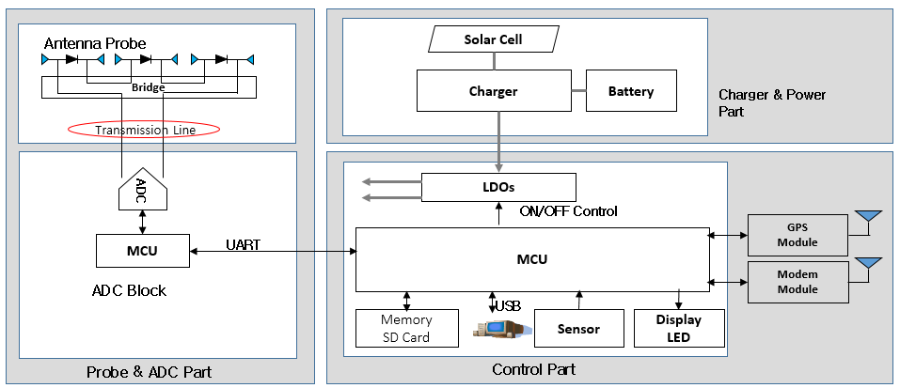
Figure 2. Broadband EMF area monitor block diagram

It is essential that the measuring equipment provides the RMS (root mean square) value of the electric field strength in order to compare the levels measured with the exposure limits.
This probe must be isotropic and the isotropic deviation must be less than 2.5 dB for frequencies up to 3 GHz, and less than 3.5 dB for higher frequencies. The deviation of the measurement due to the variation of response of the probe with the frequency must be less than ±3 dB for the interest frequency band.
A sampling rate of at least 1 second is recommended and the average period should be 6 minutes, as specified by ICNIRP, and it should be continuous or “sliding” over time, in order to avoid losing data, as specified by IEEE Std C95.3. It should have an adequate storage capacity for measurements, which in any case should exceed one month.
The measuring equipment should be adapted to environmental conditions (temperature, humidity, rainfall, wind, etc.) that can be expected in the location point. To this end, we will employ a properly conditioned mechanical protection.

Result evaluation
All various sources are measured with the broadband area monitor, but not identify each source frequency. It is designed with Schottky diode detector generally. The result of broadband monitoring is the electric filed strength variation along with time.
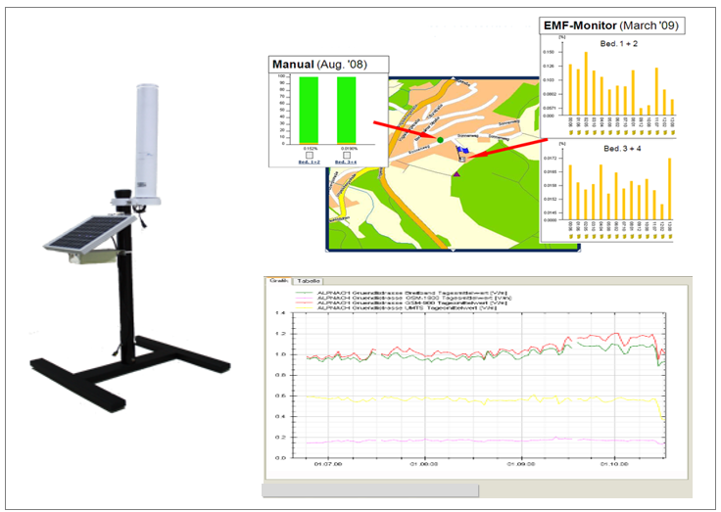
Figure 3. Result of broadband EMF monitoring
The result can be shown with location based EMF long-term monitored based on time domain.
The daily, weekly, monthly and yearly based statistic results shows on the web or app on the smart phone.

4. Frequency selective EMF area monitoring procedure

Overview
The limits for general public exposure specified in the national regulations or if they do not exist the ICNIRP limits as well as conditions for simultaneous exposure to multiple frequency fields shall apply for the purpose of this Recommendation.
From such derived field strengths E_{i} the TER for the complete frequency range is derived:
In the case of ICNIRP guidelines the total exposure ratio TER criteria referred to electrical stimulation effects (a = 87 V/m; El is the frequency depended limit):
Total exposure criteria referred to thermal effect circumstances (c = 87/f^{1/2} V/m, El is the frequency depended limit):
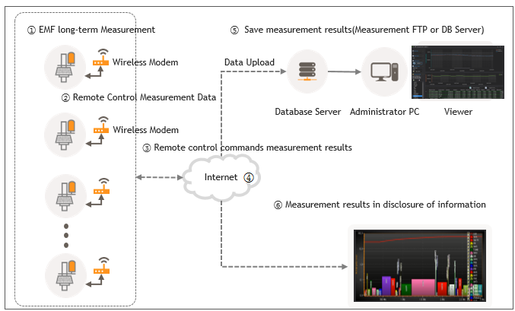
Figure 4. Frequency selective EMF area monitoring architecture system

The frequency selective EMF area monitoring can be distributed at local interested sites and measuring EMF strength continuously and sending data to center server via wireless modem. The result shows each EMF strength value and percentage of limit for all frequency subranges in the chart with graphic result and level variation along with time (1, 2, 6, 15 min interval) for daily, weekly, monthly, yearly variation results.

Measurement method
Incident field can be measured with the tri-axial isotropic antenna for three components $E_{x}, E_{y, } E_{z}$ switched measured. Repeated fulfil the criteria of 3.1 for the continuous measurement with 1, 2, 6, 15 minute RMS average interval for all frequency subranges simultaneously.
Data ending interval is required hourly, daily. Added after RMS averaging measurement interval would be possible.

Measurement equipment, general requirements
The measurement equipment consists of the following parts:
- Measurement probe
- Frequency selective measuring instrument, which processes the signal from the probe and indicates the value of the EM field quantity
- Measurement automation
- Mechanical and protective housing
The system parameters as defined in this section are valid for the completely assembled unit as installed on site.
The frequency subrange is the frequency bandwidth list or table in the instrument. The frequency ranges are listed as FM, TV, TRS, GSM, CDMA, WCDMA, LTE, WiFi and etc, as an example.
For mobile communication service is recommended identify each service type.
The parameters (e.g. attenuation, preamplifier) for each sub range are adopted automatically during each cycle to achieve best possible sensitivity without signal distortion due to overload (e.g. in preamplifiers, mixers) from other emitters in the same or other sub bands.
For the frequency selective measurement, the tri-axial isotropic antenna also be recommended and it need to have less than 2.5 dB isotropic error in the frequency range up to 3 GHz and less than 3,5 dB for 3 to 6 GHz.
The built-in spectrum analyzer is required frequency range from 100 kHz to 6 GHz at least. For the weak and strong signal detection, it is required to have high dynamic range over 120 dB and wide measurement range over 60 dB. The instrument shall have GPS for the location information, wireless modem for the data transmission to server and alarms for security, system status and over limit.
The measuring equipment shall be appropriate to the environmental conditions (e.g. temperature, humidity, wind speed, vibration) to be expected during the monitoring period at the measurement site.

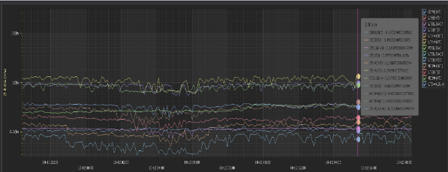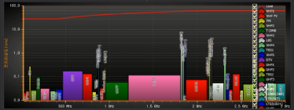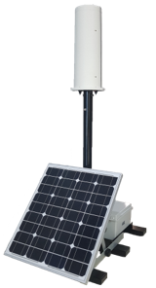
Figure 5. Frequency selective EMF area monitor and graphic results

Result evaluation
Measurement result consists of values achieved according measurement method and frequency subranges that fulfil the criteria of 5.1 stored as relevant emissions and used for the TER calculation.
As additional information date, time, actual measurement position, ambient temperature and system status and warnings are added to the measurement result.
This result is stored internally (offline evaluation) or transmitted automatically via data link to a server (online evaluation).

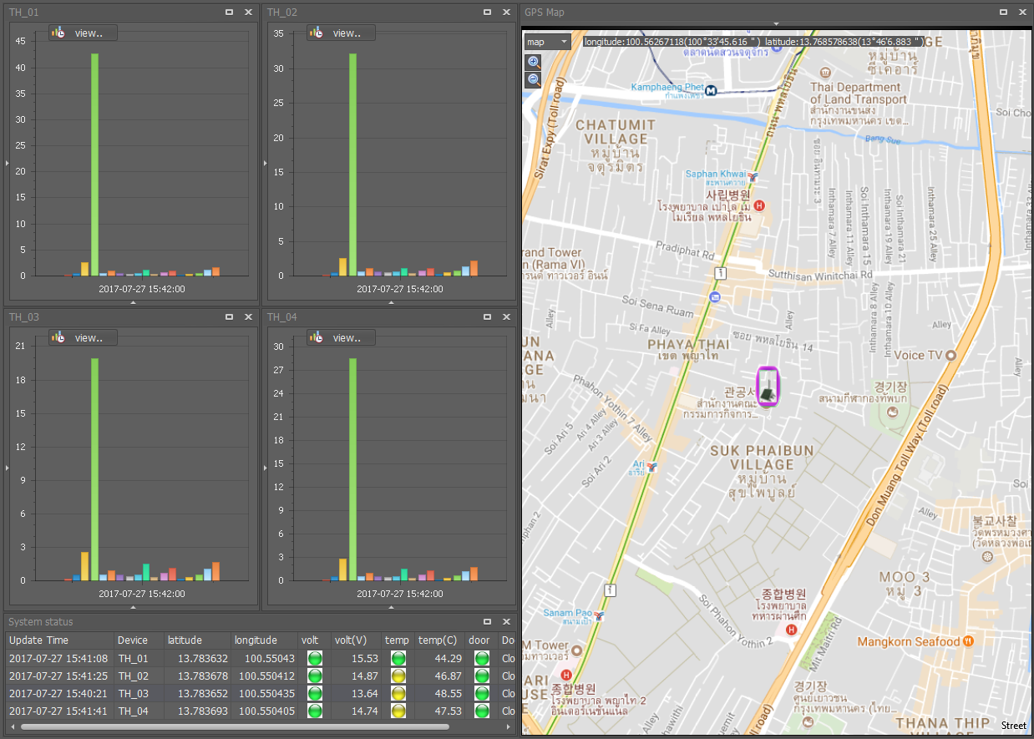
Figure 6. System management and control view

GIS based interface method
The current measuring device shows all information related system and result of EMF strength values in interested area. Measured points are also shown with various chart which includes daily, weekly, monthly, yearly based result statistics.

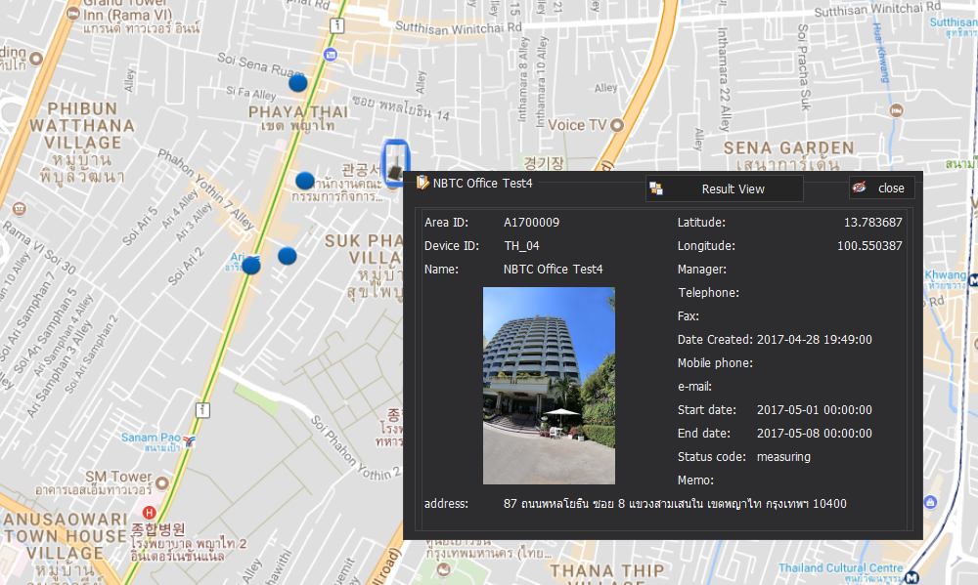
Figure 7. Web based general public access view

Statistics analysis
The results are provided as the time chart, bar chart, each frequency subranges chart for better understanding to general public.
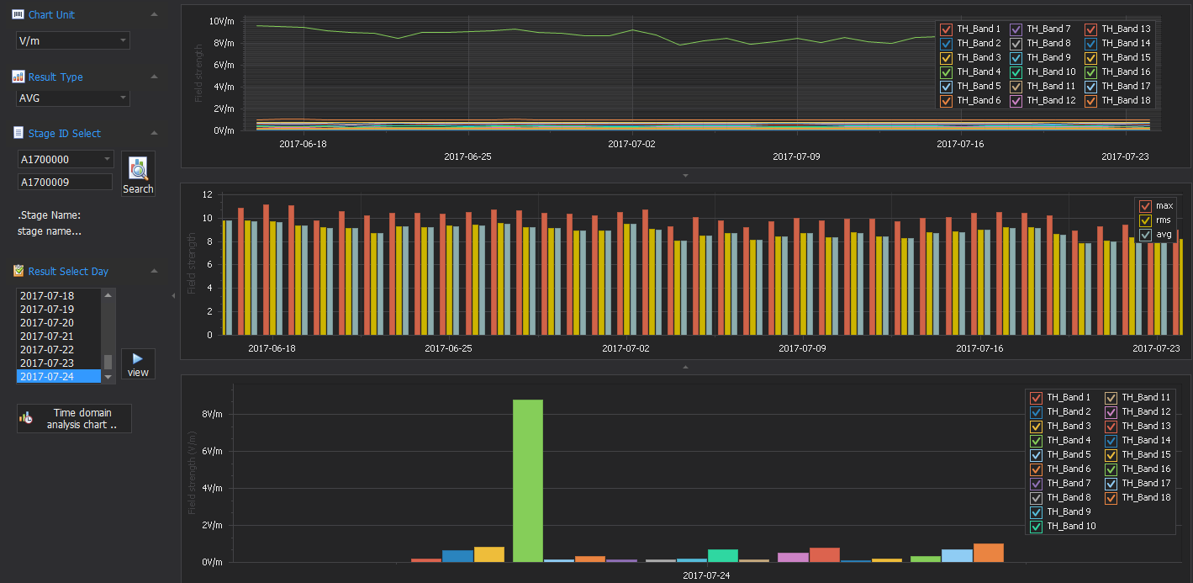
Figure 8. Result analysis view

Appendix Ⅱ RF EMF area monitoring analysis

- Measurement Procedure & method

Typical frequency subranges for EMF area scanning can be considered as;

- FM Broadcasting
- VHF
- DMB
- DVB-T
- TRS or Tetra
- UHF (TV or DTV)
- LTE800
- GSM850
- GSM900
- GSM1800
- GSM1900
- UMTS (WCDMA)
- LTE other bands
- WiFi
- LTE2600
- WiMax
- 5G below 6GHz

EMF area scanning procedure starts with the measurement set-up and scenario which included scanning area and frequency subranges. And scanning targeted area along with all loads as possible. The measured spectrum and electric field strength data is recorded at each coordinate and mapping on the commercial map. The measured results expressed with color dots that show electric field intensity.

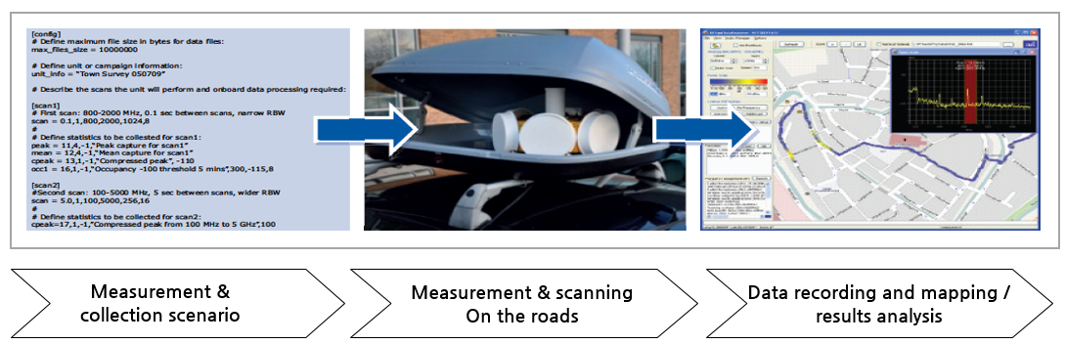
Figure 1. EMF area scanning process

For each sub-band the maximum detectable level is at least the limit value. The minimum detectable level is required in case no emissions above the threshold value are present. It can be achieved with adopted settings of e.g. attenuation, bandwidth. An instantaneous dynamic range of 60 dB must be achieved for each level setting. Another signal present in any other subrange and bigger than 25% or at least 3 MHz off the measurement frequency, must cause no overload or measurement error, if its field strength is below the exposure limit.
If there are no national regulation then r.m.s. level should be used according to the ICNIRP guideline.

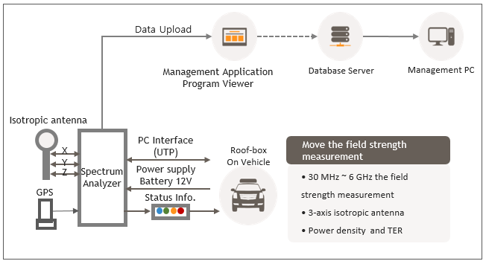
Figure 2. EMF area scanning system overview

Scanned and measured data need to upload to DB server for area analysis with huge amount of data size. It is need to be built database for the measured electric field strength to generate analysis of exposure ratio, power density based on geographic information.

- Measurement equipment, general requirements

The measurement equipment consists of the following parts:
- Measurement probe
- Frequency selective measuring instrument, which processes the signal from the probe and indicates the value of the EM field quantity
- Measurement automation
- Mechanical and protective housing

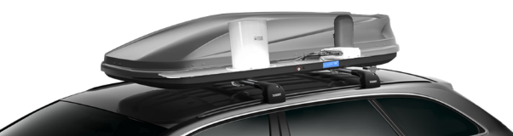
Figure 3. EMF area scanning example using vehicle mounted

For the EMF mobile measurement, all measuring parts need to be installed in the roof box on the vehicle to protect outside environmental impact like dust, rain and vibration.

Isotropic measurement shall be used to determine the field value used to assess the human exposure. The isotropy shall be analyzed according to EN50383 and the isotropy deviation shall be less than 2.5 dB in the frequency range up to 3 GHz and less than 3,5 dB for 3 to 6 GHz. In the extended frequency range 3 to 6 GHz and above the isotropy may increase to 3.5 dB.
The size of each probe should be smaller than 150 mm. Interaction between the probes, radome and the measurement equipment shall be taken into account for isotropy, sensitivity and measurement uncertainty evaluation.
The measurement instrument is need to get high speed scan for whole frequency range. It depends on vehicle speed and receiver sweep speed. It is recommended FFT based spectrum analyzer over 6 GHz frequency range. The sensitivity should be sufficient to determine the lowest level to be measured within the accuracy at that level as stated by the instrument’s manufacturer.
The measurement and scanning control shall monitor the system status and measuring status with auto script which be made in scanning scenario automatically. The measured data shall be saved to the internal memory with every 1 second GPS interval.
The measuring equipment shall be appropriate to the environmental conditions (e.g. temperature, humidity, wind speed, vibration) to be expected during the monitoring period at the measurement site.

- Result evaluation

Each measured pixel is a small square area which can be decided with vehicle moving speed and GPS data update rate. So, 1 degree of coordinate is the basic resolution unit of the scanning data.
It is 24.6m for longitude and 30.8m for the latitude.
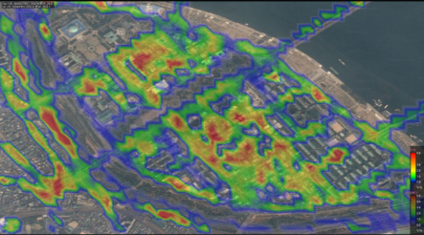
Figure 4. Measurement results mapping and analysis

Mapping data shows the high point of electric filed strength or power density. And with this information, standard EMF in-situ measurement or long-term EMF monitoring could be decided.
And it gives the information that the mobile communication mast need to be move to other site or reduced radiating power by telecom operator.

Appendix Ⅲ ELF (ExtremELY Low frequency) EMF measurement & information system FOR PROVIDing the relief about general public

Background

Although electric power facilities and communication base stations play an important role in providing stable electric and communication services through the national backbone network, there is a public anxiety about electromagnetic waves generated from those facilities. In particular, the influence on the human body of EMF(Electro-Magnetic Field) is not clarified, and the anxiety about EMF harmfulness is not completely solved. In some cases, it is used as a reason for opposing the construction of those facilities. One of the reasons for this is that there is no objective data on the amount of electromagnetic radiation generated by the power facility or communication base station in which the public reside and there is no method to confirm this. Therefore, it is necessary to identify the current EMF status of those facilities located in major civil or sensitive areas, and to measure the EMF exposure generated by the facilities in accordance with location, distance, and time. And, it is also necessary to prepare a plan to provide EMF information to the civilian and the local people in real time. As a result, we could resolve civil complaints based on objective facts, such as measuring the electromagnetic wave exposure to EMF facilities, acquiring EMF information and providing the public. We would like to introduce measurement and information systems that can measure and manage these EMF exposures.

EMF Measurement and Information System by IFRE in Korea

Figure 1 shows the overall configuration of the EMF measurement system developed by IFRE in Korea. The operator measures the EMF strength around the points where the public concerned and analyzes it to construct the EMF database. Once this database is built, the public can easily see the EMF measurements in the area of ​​interest and whether its level is safe using a personal computer or smart phone. Through this EMF information service, the public is clearly aware of the level of EMF risk in the area in which they live, and what the meaning of the value is, which can eliminate vague anxiety about EMF risk. Furthermore, building a database provides opportunities to discover and take action when EMF measurements go beyond safe levels.

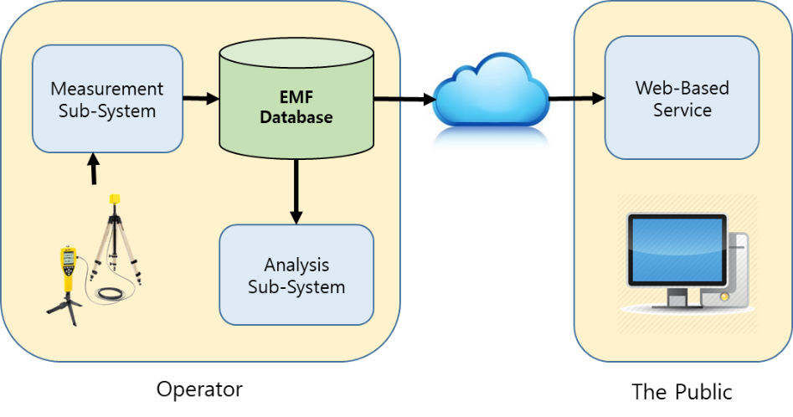
Figure 1. EMF Measurement and Information System

EMF Measurement Sub-System

Figure 2 shows the concept of the measurement sub-system in the IFRE EMF system. The areas of public interest are very broad and require a lot of measurements. Therefore, the efficiency of the measurement system is an important factor in building the EMF database. Our measurement system is very automated and efficient, so the measurement engineer can easily build an EMF database with little effort.

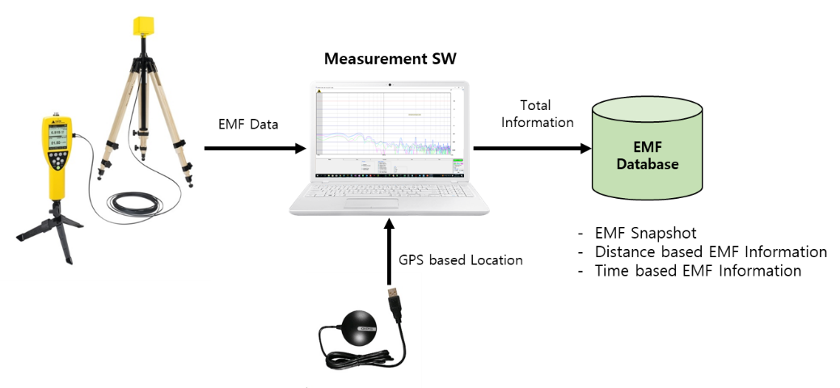
Figure 2. EMF Measurement sub-system

Figure 3 shows the software for the measurement. Using the GPS receiver and open map, temperature, humidity and weather are recorded automatically, as well as the current measurement location and address. Based on the map, all information such as the facility, EMF measurement value, location, weather, and measurement time are built in the EMF database.

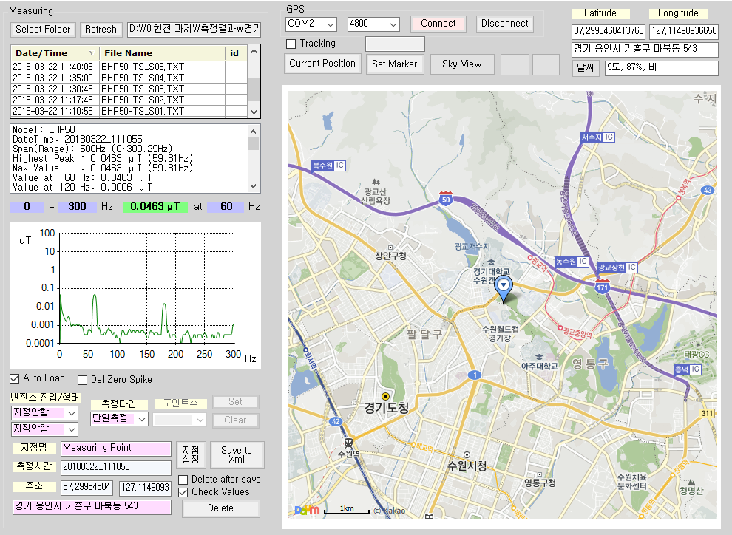

Figure 3. Measuring software

When analyzing the effect of distance from EMF source such as power equipment or communication base station, if measurement engineer specifies a start position and an end position, the software automatically locates the positions to be measured and he uses real time position tracking function using GPS receiver. And then he can easily locate the positions where measurement is required.

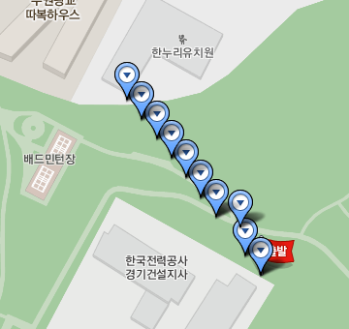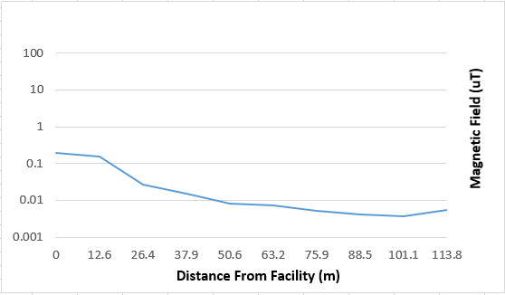
Ground
Start
Kindergarten
Substation of KEPCO
Figure 4. Automated distance based measuring

EMF Monitoring Sub-System

Residents living near a strong EMF source will not be satisfied with a single measurement result. In this case, the method of communicating with the residents more positively is providing the real-time monitoring. Figure 5 shows the real-time EMF measurement sub-system developed by IFRE. It shows the current EMF measurements and their level relative to the average, which can greatly alleviate concerns about the public's EMF risk.

Information of Real Time EMF Values

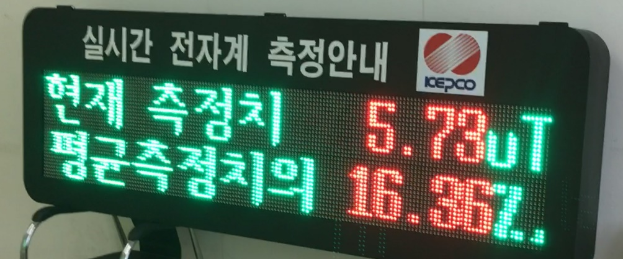
16.36% of average measurement value
Current measurement value 5.73uT

Figure 5. Real-time measurement

EMF Analysis Sub-System

The EMF database collected by the method described above can be checked and analyzed for details through the EMF Analysis Sub-System software. The left graph in Fig. 6 shows the measured total spectrum at a specific point, and the right graph shows the EMF measurement values ​​by the distance from the strong EMF source point to the sensitive facility (kindergarten in the figure).

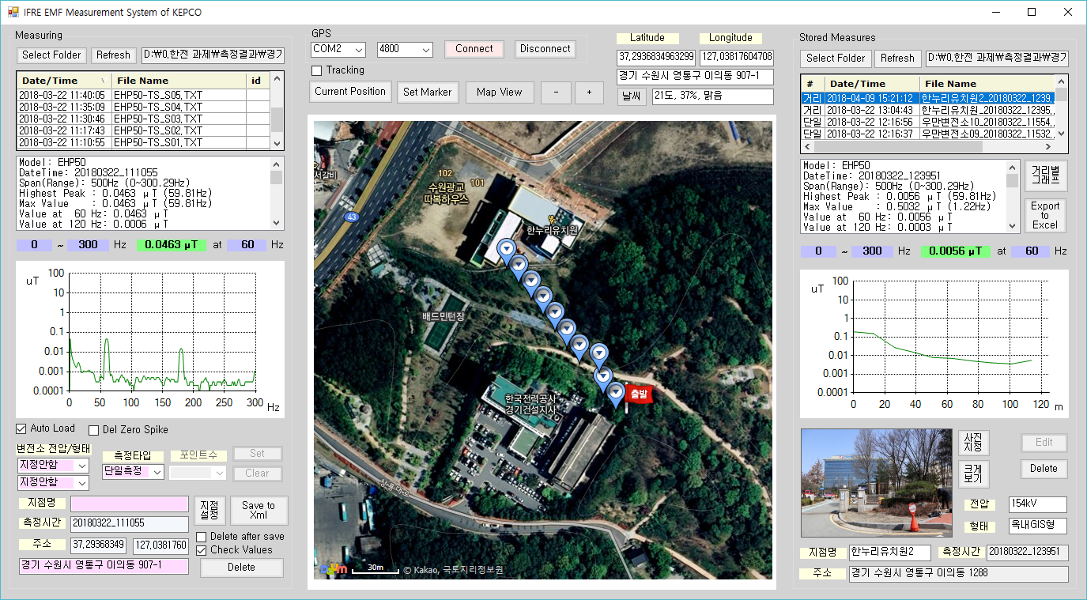
Figure 6. EMF Analysis Software

It is difficult to quantitatively and clearly define the harmfulness of electromagnetic waves to human body. However, each country or organization has its own standards, and table 1 shows the electromagnetic strength standards for the general public notified by the Korean government.

Table 1. Electromagnetic Strength Reference for the General Public in Korea
Frequency Range(f) | Unit | Electric Field  Strength  (V/m) | Magnetic Field  Strength  (A/m) | Magnetic Flux Density  (μT) | Power  Density  (μT)
0 ~ 1 | Hz | - | 3.2x10⁴ | 4x10⁴ | -
1 ~ 8 | Hz | 10,000 | 3.2x10⁴/f² | 4x10⁴/f² | -
8 ~ 25 | Hz | 10,000 | 4,000/f | 5,000/f | -
0.025 ～ 0.8 | kHz | 250/f | 4/f | 5/f | -
0.8 ～ 3 | kHz | 250/f | 5 | 6.25 | -
3 ～ 150 | kHz | 87 | 5 | 6.25 | -
0.15 ～ 1 | MHz | 87 | 0.73/f | 0.92/f | -
1 ～ 10 | MHz | 87/f^{1/2} | 0.73/f | 0.92/f | -
10 ～ 400 | MHz | 28 | 0.073 | 0.092 | 2
400 ～ 2,000 | MHz | 1.375f^{1/2} | 0.0037f^{1/2} | 0.0046f^{1/2} | f/200
2 ～ 300 | GHz | 61 | 0.16 | 0.2 | 10

Communication with The Public

The EMF database built with above IFRE system can be accessed by the public in an easy way through a web server and a web browser. Using a desktop, laptop, and smart phone, the general public can easily search and see EMF measurement values ​​and safety of their residence area or area of ​​interest. This systematic and easy-to-use system enables active communication and allows the public to know about EMF risk correctly and eliminate unnecessary anxiety.

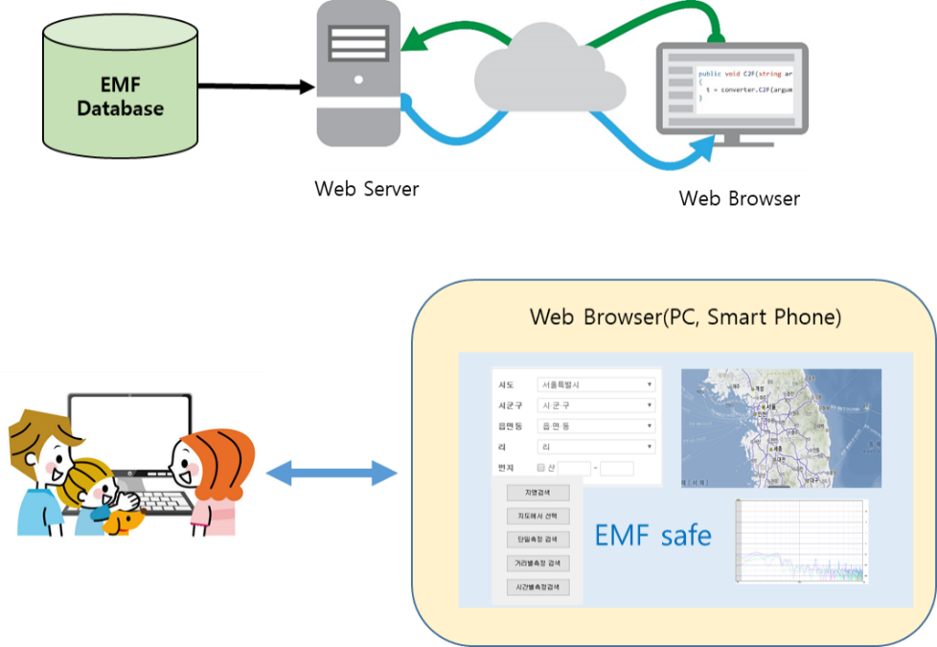
Figure 7. Web services for the public

