APT REPORT

ON

POWER OVER FIBER SYSTEM FOR RADIO OVER FIBER NETWORK

APT/ASTAP/REPT-37
Edition: June 2019

Adopted by

31st APT Standardization Program Forum (ASTAP-31)
11 – 15 June 2019, Tokyo, Japan

(Source Document: ASTAP-31/OUT-09)

Contents

1. Introduction 3
2. Scope 3
3. References 3
4. Abbreviations and acronyms 3
5. System Architecture 4
6. System demonstration and discussion 6
7. Conclusion 8

Introduction
The aim of this contribution is to propose Power over Fiber (PoF) component evaluation, system requirement and application for use in Radio over Fiber (RoF) network.

Scope
This Report provides technical guidance and requirement of optical power delivery using PoF for RoF network, which is part of the wired and wireless seamless access communication systems. PoF components, configurations, applications, key parameters and specifications are also addressed as examples.

References
[APT/ASTAP/REPT-03(Rev.4)]: APT Report (2015), Characteristics and requirement of optical and electrical components for millimeter-wave Radio on Fiber systems
[APT/ASTAP/REPT-04]: APT Report (2011), Technology trends of telecommunications above 100 GHz
[APT/ASTAP/REPT-11]: APT Report (2013), Wired and wireless seamless connections using millimeter-wave Radio over Fiber technology for resilient access networks
[APT/ASTAP/REPT-19]: APT Report (2015), Integration of Radio over Fiber with WDM PON for seamless access communication system
[APT/ASTAP/REPT-20]: APT Report (2015), RoF relay link for indoor communication systems
[APT/ASTAP/REPT-25]: APT Report (2017) Fronthaul/backhaul using millimeter-wave radio over fiber technologies
[APT/ASTAP/REPT-26]: APT Report (2017) Multiservice signal transmission using radio over fiber technology
[ITU-T G. Suppl.55]: ITU-T G-series Supplement RoF on Radio-over-fiber (RoF) technologies and their applications
[ITU-T G.RoF] : Draft new Recommendation ITU-T G.RoF, Radio over fiber systems.

Abbreviations and acronyms
This Report uses the following abbreviations and acronyms:

CS Central station
DP Distribution point
E/O Electrical-to-optical converter
LD Laser diode
MCF Multi core fiber
MMF Multi-mode optical fiber
MUX Multiplexer
ODN Optical distribution network
O/E Optical-to-electrical converter
PD Photodiode
PHEMT p-type high-electron-mobility transistor
PoF Power over fiber
PPC Photovoltaic power converter
PPM Photonic power module
RAU Remote antenna unit
RoF Radio over fiber
SMF Single-mode optical fiber
WDM Wavelength division multiplexing

System Architecture
5.1 Overview
Optical power delivery is unique compared to other power delivery methods mainly due to its stability and immunity from RF and EMI attenuations, resilient to corrosion and moisture, as well as being able to operate over long distances. In 1978, DeLoach reported his work on the activation of a remote sound alerter through optical fibers [1] and this has generated numerous studies related to photonic power delivery. For example, the first optically powered video-link with bitrates above 100 Mbit/s was demonstrated by Bottger et. all [2]. In 2008, Werthen discusses photovoltaic power converters (PPC) with electrical output powers over 1 W. The optimum light for a GaAs PPC lies in the wavelength range of 790 nm to 850 nm where various pump lasers with power levels as high as 5 W are available. For higher light levels above 10 W, InGaAs pump lasers in the range of 915 nm to 980 nm are most practical. Other recent works on various applications [4-7] were also derived from this technology.

In power over fiber (POF) technology, there are 3 main components that contribute to the performance and output of the overall optical power delivery system as shown in Figure 1, namely transmitter unit (or known as photonic power module, PPM), optical fiber and receiver unit (also known as photovoltaic power converter, PPC).

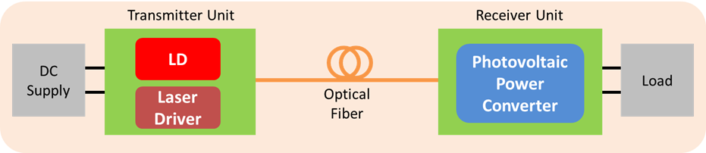

Figure 1: Optical power delivery system components

In the context of POF, high power laser simply means a laser that generates significantly higher output power than other lasers based on the same technology, and at the same time its output power is capable and safe to be transmitted over ordinary single mode or multimode fiber. For example, JDSU’s PoF solution consists GaAs modules operating in the 780 nm to 980 nm range, and are generally powered by laser diodes (LD) emitting up to 5 watts of optical power into 62.5 μm multimode optical fiber.

A PPC is essentially a photovoltaic receiver cell, whereby a pn-junction photodiode operates in photovoltaic mode. In its power generating mode, incoming incident light causes an electron-hole pair to be generated which produces photocurrents. The photocurrent is proportional to the generation rate and therefore the incident optical power. Figure 2 shows typical I-V characteristics of a photovoltaic receiver. The short circuit current Isc occurs when the load, and therefore the voltage, equals zero. The open circuit voltage Voc occurs when the resistive load is considered infinite producing no net current. The maximum power, Pmax, produced is the point on the I-V curve where the current multiplied by the voltage is at a maximum.

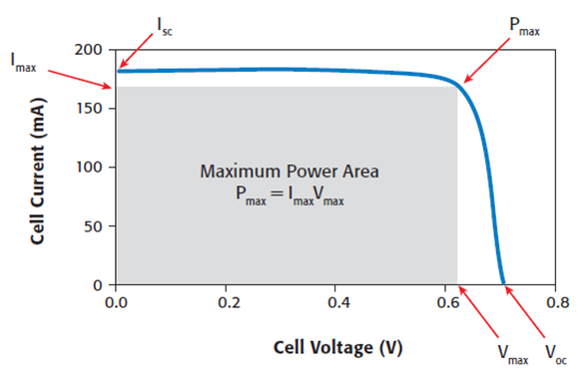

Figure 2: Typical forward bias I-V characteristics of a PV cell

The PPC as shown in Figure 3 is a multi-segmented photovoltaic device made typically from GaAs material. Each segments of the device equates to roughly around one volt, so in this case it is six volts series-connected PPC. The maximum electrical power output from a PPC is 500mW based on the optical input power, load resistance and choice of PPC.

Figure 3: Physical view of a six-segmented photovoltaic power converter.

For GaAs PPC, the optimum wavelength range is between 790nm to 850nm whereby various pump lasers are available with power levels going as high as 5W. For higher power output, pump lasers in the range of 915 to 980nm are used which are made from InGaAs material and can reach power levels above 10W. Correspondingly, InGaAs PPCs are needed to receive these transmitted powers.

5.2 Concept of Power over Fiber for RoF Network

In RoF system based on single service or multiservice radio transmission over RoF technology, FTTH is converted into a wired and wireless solution, as shown in Figure 4. This solution combines centralized signal processing at the CS which are the transported over to remote antenna unit (RAU) as its distributed point (DP) at the customer side, for wireless last mile access. The use of PoF is especially suitable for deployment of RAU in hard-to-reach areas such as tunnels or terrain-challenged areas where grid power line connection is limited. Typically, the RAU requires minimal power as most of the signal processing are done at the CS for most RoF network deployment.

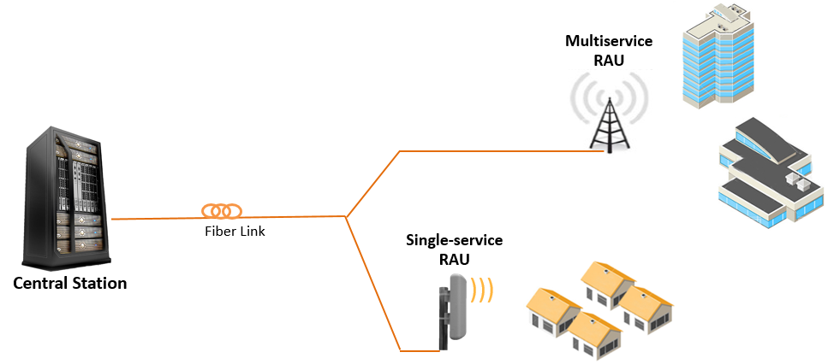

Figure 4: RoF network deployment senarios

As shown in Figure 5, in the deployment of single service or multiservice RoF network, POF solution through PPMs and PPCs can be utilized to allow remote powering of biasing circuits or low-power electronics components of the RAU. In low power condition, this can be the primary source of power to the components. Alternatively, for heavy duty power usage at the RAU, PoF can be a supplemental power solution in addition to the grid power.

The delivery of PoF typically uses a separate fiber for concurrent delivery with the main data signal transmission. Depending on the PPM and PPC type, the more common type is using Multi-mode fiber (MMF) power transmission for shorter distances while using Single-mode fiber (SMF) for longer distances.

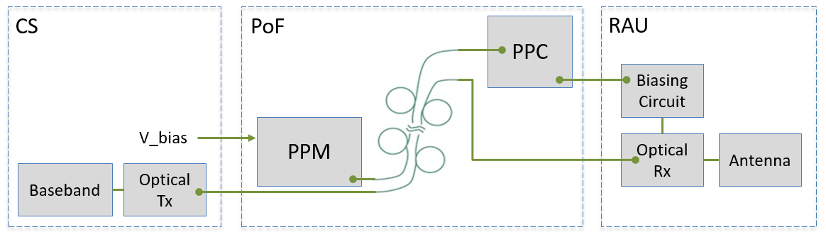

Figure 5: Block diagram of optically powered RAU in RoF network

System demonstration and discussion

6.1 Configuration of PoF system application in RoF network
6.1.1 Radio and power simultaneous generation in millimeter-wave band by integrated photoreceiver module
An integrated photoreceiver is composed of a high-speed photodetector (PD) and a p-type high-electron-mobility transistor (PHEMT) amplifier, to enhance the responsivity and output power. In general, a millimeter-wave amplifier was employed with the PHEMT process, and then a positive drain bias and a negative gate bias would be required as well as a positive PD bias. The minimum number of bias lines in a photoreceiver integrated with a PHEMT amplifier would become three. Equally, three cores in PoF transmission and one core in data transmission, bundled fibers or multi-core fibers, would be required for RoF networks.

In contrast, a bias-free operational high-speed photodetector can play a dual role for high-speed signal detection and small electric power generation simultaneously, because of the bias-free design [7]. The generated electric power on the energy harvesting high-speed PD would be good enough to drive the gate bias in the PHEMT amplifier. When an enhancement-type transistor working under a positive bias is realized in the PHEMT process, positive photonic power supply on the high-speed PD can be applied to the gate bias. The required cores for power transmission would then be reduced from three to a single core. A power and radio over fiber transmission from each single core will be constructed as shown in Fig. 6.

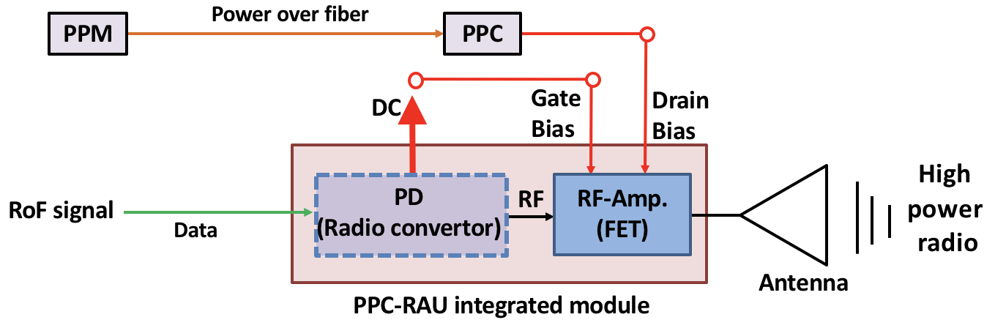
Figure 6: Block diagram of PoF-RoF integrated system
Another key part configured for the integrated photoreceiver module in addition to the PD and the amplifier, is a bias-tee circuit, which is located between the PD and the PHEMT amplifier. In the photonic power generation process, the generated RF current in microwave and millimeter-wave bands from the bias-free operational high-speed PD would be filtered by a low pass filter owing to the inductance in the bias tee, and only DC current from a source with RoF average optical power could be passed through it. The DC electric power level could be controlled with a variable resistor and applied to the gate bias. The RF current would be fed to an input stage in the amplifier.

6.2 Discussion on PoF system application in RoF network
Figure 7 shows the typical generated electric voltage-current and the O/E conversion efficiency characteristics of the high-speed PD by changing the variable resistance, where the optical input power and its wavelength are] +10 dBm and 1.55 μm, respectively. A maximum generated electric power and conversion efficiency of 0.8 mW and 8% can be expected from the measurement result respectively, even though high-speed PD is adapted. The small generated power is fully satisfied with driving gate bias, because the gate bias requires extreme low power consumption, due to high impedance device structure.

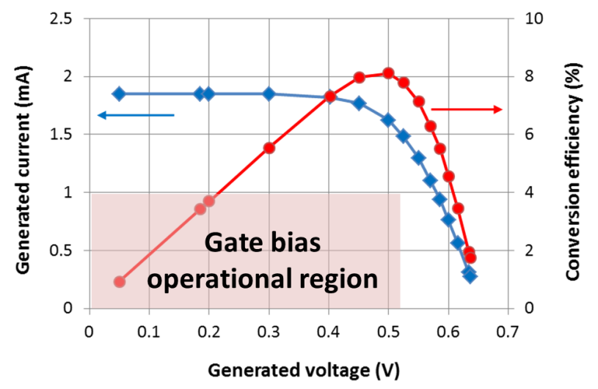
Figure 7: Generated electric voltage-current and the O/E conversion efficiency characteristics of the high-speed PD
In the frequency response for the developed integrated photoreceiver module with radio and power simultaneous generation in the frequency range 80–120 GHz, the large 3-dB bandwidth from the peak gain frequency is estimated approximately 20 GHz. By increasing the photocurrent, a 97 GHz RF output was measured as shown in Fig. 3. At a 1mA photocurrent, an output of −16.2 dBm for a single PD and a 21.2 dB higher output (+5 dBm) with an amplifier (integrated photoreceiver) can be obtained. The output saturation begins at +4 dBm, and a maximum output of +6 dBm can be achieved. Therefore, the integrated photoreceiver module is capable to use the RoF system integrated with the PoF system by effective reduction of a number of fiber cables and power consumption.

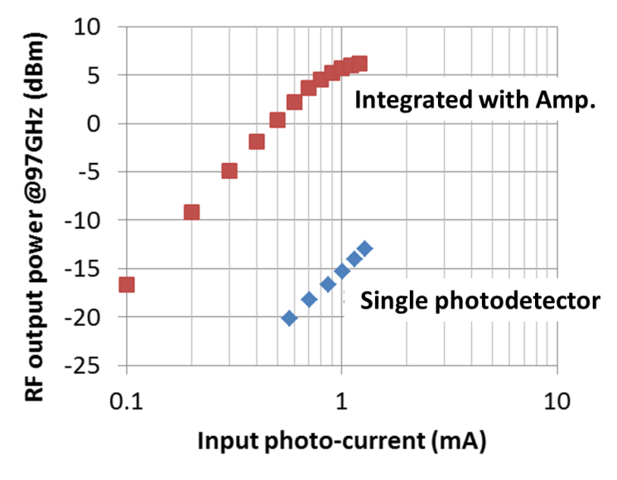
Figure 8: Input photo-current versus RF output characteristics for the single PD and integrated photoreceiver in radio and power simultaneous generation

Conclusion
The component requirements, configurations and proof-of-concept demonstration of PoF for RoF network is presented. PoF has the capability to carry power over optical fiber network using single core or combination of multiple cores, and subsequently provide sufficient power needed for RoF network functionality. This report has shown the technical guidance and experimentation works of PoF technology, which have been successfully proven with stability and free from RF/EMI fluctuations, thus a viable solution for optical power delivery such as powering of integrated photoreceiver module in RoF network.

Bibliography:
[1] B. C. Deloach, R. C. Miller, S. Kaufman, “Sound alerter powered over an optical fiber.” Bell Syst. Tech. Journal, Vol. 57, pages 3303-3316, 1978.
[2] G. Böttger, M. Dreschmann, C. Klamouris, M. Hübner, M. Röger, A. W. Bett, T. Kueng, J. Becker, W. Freude, and J. Leuthold, “An Optically Powered Video Camera Link,” IEEE Photon. Technol. Lett., vol. 20, pp. 39–41, January 1, 2008.
[3] J. G. Werthen, “Powering next generation networks by laserlight over fiber,” in Proc.
Optical Fiber Communication Conference / National Fiber Optic Engineers Conference, 2008. OFC/NFOEC 2008, San Diego, CA, USA, Feb. 24–28, 2008.
[4] V. Sittakul, L. R. Clare, S. G. Burrow, X. C. Li, and M. J. Cryan, “Power-over-Fibre for Wireless Applications,” Microwave and Optical Technology Letters, Vol. 53, No. 5, pp. 1027-1032, May 2011.
[5] J. Turan, L. Ovsenik, M. Turan, “Atmosphere Quality Monitoring System with Optical Powering” 13th International Carpathian Control Conference (ICCC), pp. 748 - 751 28-31 May 2012.
[6] Perhirin, S., F. Audo, M. Guegan, V. Perennou, L. Ghisa, S. De Blasi, Y. Auffret, “A Power-Over-Fiber System and Its Low Consumption Remote Equipment for Submarine Applications,” in OCEANS 2013 MTS/IEEE, Bergen, June 10-13, 2013.
[7] T. Umezawa, K. Kashima, A. Kanno, A. Matsumoto, K. Akahane, N. Yamamoto, T. Kawanishi, “100-GHz Fiber-Fed Optical-to-Radio Converter for Radio- and Power-Over-Fiber Transmission,” IEEE Journal of Selected Topics in Quantum Electronics, vol. 23, no. 3, 3800508, September 20, 2016.

ANNEX

POF COMPONENT CHARACTERIZATION

I. Photonic Power Module:

To evaluate the photonic power module (PPM) performance, supply currents are varied while at the same time the output optical power of the PPM module are measured.

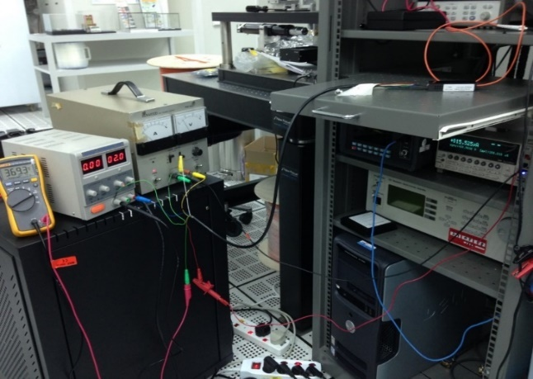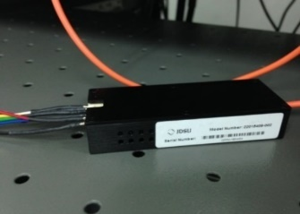

Figure A1: PPM characterization setup

The PPM is basically a laser source with output up to 2W optical power, showing good linearity.

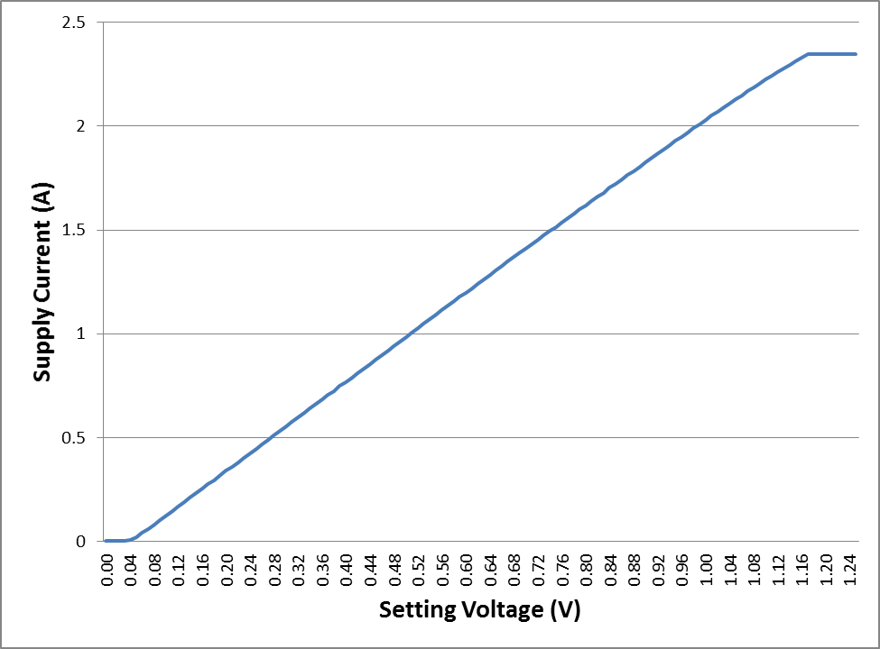
Figure A2: PPM laser characterization curve

II. Photovoltaic Power Converter:

To evaluate the PPC performance, variable resistive loads in combination with voltmeter/ammeter are applied to vary and monitor the load across the PPC as shown in Figure A3.

The PPC is sourced with a fixed optical input power while incrementally vary the electrical load resistance. The load potential and load power is then recorded. The measurement is repeated by varying the optical input power to the PPC.

Figure A3: PPC testing setup

The following shows the load potential and load current of each optical supply power from 0.35W to 2.1W.

Figure A4: PPC load current vs load potential

The following graph shows its corresponding maximum output power possible for each supplied optical power.

Figure A5: PPC load current vs load power experimental result

III. PPM efficiency (E/O power conversion efficiency):

The following indicates the electrical to optical power conversion efficiency of the laser source. The efficiency of the laser driver increases from 9% at 0.5A to a maximum of 15.2% at 2.3A supply current. The efficiency for the PPM at Laser Driver current of 2.3A (equivalent to maximum power output of 2.1W) is 15.2%.

Figure A6: Laser electrical to optical power conversion efficiency

IV. PPC Efficiency (E/O power conversion efficiency):

PPC efficiency with respect to differing laser driver supply currents and PPC loads:

Figure A7: PPC optical to electrical power conversion efficiency

V. Overall system efficiency and system capacity:

The system efficiency of the PoF link is defined as:

ɳ = P_{out} / P_{in} where;

P_{in} = laser driver supply voltage X laser driver supply current
P_{out} = PPC load potential X PPC load current

Figure A8: Overall POF system efficiency

The system capacity (maximum power output capacity) is the maximum power output at variable laser driver supply current and load current.

Figure A9: Load power capacity

