

**APT REPORT**

**on**

**REQUIREMENTS OF INFORMATION AND COMMUNICATION SYSTEM USING VEHICLE DURING DISASTER**

No. **APT/ASTAP/REPT-21**

Edition: September 2015

Source Document: ASTAP-26/OUT-23

**Adopted by**

**The 26th APT Standardization Program Forum (ASTAP-26)**

**9 – 12 September 2015, Bangkok, Thailand**

| **CONTENTS** |
| --- |
| Page |
| [1. Scope 1](#_Toc429825588)  [2. Terms and definition 3](#_Toc429825589)  [3. Framework of disaster information/communication system using vehicle 3](#_Toc429825590)  [i Necessary approaches for acute phase in response stage 4](#_Toc429825591)  [ii Architecture of the role mode 8](#_Toc429825592)  [iii Use cases requirements 10](#_Toc429825593)  [iv Operational scenarios 16](#_Toc429825594)  [4. Applications models 17](#_Toc429825595)  [i Gathering victim survival and accessibility to disaster area information in acute phase and Delivering information to professional team 17](#_Toc429825596)  [5. Network interface requirements 18](#_Toc429825597)  [i Kind of network interfaces 18](#_Toc429825598)  [ii Communication Interface in Network 19](#_Toc429825599)  [iii Beacon interface in Network 20](#_Toc429825600)  [iv Others interfaces 20](#_Toc429825601)  [6. Application interface requirements 21](#_Toc429825602)  [7. Architecture of V-HUB system 21](#_Toc429825603)  [ANNEX I Disaster System Use case in Japan 22](#_Toc429825604)  [1. Deliver messages to the evacuation site 22](#_Toc429825605)  [2. Share messages among evacuation sites 26](#_Toc429825606)  [3. Upload messages to the internet 26](#_Toc429825607)  [ANNEX II Use cases of Information and Communications System using Vehicle during Disaster 27](#_Toc429825608)  [ANNEX III List of Suggestion by Use cases of V-HUB 31](#_Toc429825609)  [APPENDIX I 34](#_Toc429825610)  [APPENDIX II 35](#_Toc429825611) |

Requirements of Information and Communication System   
using Vehicle during Disaster

# 1. Scope

Disaster management involves government departments and agencies at every level, from the national government to local communities, or from local police to fire, health, and social services. It is very important for the disaster management that each of these bodies has clearly defined authority and responsibility.

The disaster management process is defined by four closely integrated stages; Mitigation, Preparedness, Response, and Recovery. These four stages of the process has some overlapping activities with other stages. (Fig. 1-1) Identification of the actions taken at each stage of disaster management can help to choose and deploy the applications of ICTs.

Fig_1-1

Although these are overlapping activities among four stages, most needed stages for development and deployment of ICT applications are the three stages, i.e. Preparedness, Response and Recovery. Table 1-1 below summarizes the actions taken at each stage of disaster management process.

Table 1-1. Action taken in disaster management (Reference 1)

|  |  |  |
| --- | --- | --- |
| Preparedness stage | Response stage | Recovery stage |
| - Analysis of data from previous disaster cases  - Raising public awareness  - Monitoring of potential risks  - Early disaster predictions  - Structural strengthening of buildings and infrastructure  - Possible damage assessments  - Reviewing and updating strategies, tools and resources  - Training of stakeholders  - Establishment of communication and collaboration systems  - Response and recovery planning with collaborators  - Establishment of disaster warning systems | - Notification of stakeholders  - Transportation of response personnel (police, fire-fighters, rescue teams, health personnel, etc.)  - Transportation of resources (food, medicine, etc.)  - Communication of rapidly changing disaster data  - Collaboration with stakeholders  - Management of available resources  - Warnings for a possible consequent disaster/crisis/ chaos | - Sharing disaster specific information  - Damage assessments  - Archiving of resources and information  - Registration of claims for disaster relief funds  - Repair of infrastructures and buildings  - Reconstruction of infrastructures and buildings |

However, even though there is a huge variety of ICT tools that can be used for information and collaboration in disaster management, there is a possibility that most of or almost all of the ICT tools and power generators cannot operate in certain area and certain period of time after the outbreak of the disaster. This implies the existence of blackout or imperfect period in applying ICT to disaster management. It turned out that communication was literally vital in a matter of life and death, and the electric power drove that communication. Vehicles would have gas, dynamo (electric generator) and battery.

This standard deals with the requirement to construct provisional communication network at the Response stage of disaster management under the circumstances of the imperfect communication capability of the devastated area.

After the outbreak of disaster, the most important mission of the Response stage is to save the lives of people and to know the safety status of people at the devastated area at the very early phase of the Response stage, i.e. immediately after the outbreak of disaster, which is called the acute phase.

This standard is focused on the introduction and applications of temporary mobile communication means at the acute phase after the outbreak of disaster. As in the case of the other standards of ITU-T developed for resilient networks, this standard shall be implemented in the Preparedness stage of disaster management for the uses in the acute phase of the Response stage.

Since this standard is dealing with the temporary means of communications immediately after the outbreak of disaster, whenever and wherever the network recovers at the recovery stage, most of the contents and volume of communications will be transfer to the various communications systems operating at this stage.

However, the activities related to saving the lives of people and knowing the safety of people are usually still needed after the acute phase. Therefore, not only the smooth transfer of communications means but also smooth transfer of necessary databases and software which are used in local police stations, fire stations and hospitals are needed.

The standards related to the technologies developed for the uses in the latter part of the Response stage and the Recovery stage are published by ITU-T. Moreover, various standards related to construct resilient networks at the Preparedness stage such as the infrastructure design to ensure availability of radio communication station, installation of the tentative portable radio communication station units and adoption of multilayered communication network to realize delay tolerance network, are also published by ITU-T. (Reference 2)

References;

1) Advanced ICTs for Disaster Management and Threat Detection (Collaborative and Distributed Frameworks) Eleana Asimakopoulou (Loughborough University, UK), Nike Bessis (University of Bedfordshire, UK) published by Information Science Reference, Hershey, Mew York, 2010

2) ITU-T Focus Group on Disaster Relief Systems, Network Resilience and Recovery; Overview of Disaster Relief Systems, Network Resilience and Recovery, Promising technologies and use cases – Part I, II and III, Promising technologies and use cases – Part IV and V, Gap Analysis of Disaster Relief Systems, Network Resilience and Recovery, Terms and definitions for disaster relief systems, network resilience and recovery, Requirements for Disaster Relief System Focus Group, Requirements for Network Resilience and Recovery, Requirements on the improvement of network resilience and recovery with movable and deployable ICT resource units, Technical Report on Telecommunications and Disaster Mitigation

# 2. Terms and definition

This document defines the following terms;

・V-HUB:

This system is the information and communication system using vehicle during disaster.

・Preparedness stage:

This stage is preparedness work for disaster in normal.

・Response stage :

This stage is response work from outbreak of disaster to recovery work.

・Recovery stage :

This stage is recovery work from response stage to normal life.

・Acute phase :

This stage is rescue and recovery work less than seventy-too hours from outbreak of disaster, in the preparedness stage.

# 3. Framework of disaster information/communication system using vehicle

The disaster information/communication system using vehicle (the System) shall play an important role in disaster cases as the social activity in disaster state fully depend upon the System as the ordinal information/communication systems are heavily damaged and/or do not provide normal functions. In the acute phase of response stage particularly, rescue activity is urgently needed and for that activity, the System is the most important element. The System can also be provided by the emergency power supply to the disaster area as such systems are usually mounted on mobile vehicle and backup power supply sources. As the Response stage progresses, the System becomes more important for the various social activities such as information sharing among civilians and professional teams for rescue and logistic activities. This section provides basic framework description of that system together with architecture of the role model, use cases requirements, and operational scenarios.

Although, the official organizational structure of emergency rescue responsibility varies country to country or city to city, the basic requirement of that system shall be in common. When designing and implementing such System, it is important to understand that there are various types of needs form various actors and their needs vary between each types. In the acute phase ad-hoc type of each independent system shall play an major role but as the Response stage becomes terminated, the ad-hoc system shall gradually connected each other to form large scale or switched back to recovered public networks. In other words, ad-hoc communication systems and the related locally distributed ad-hoc data bases will be integrated into the originally designated network platform form.

There are several key issues concerning the System when implementing, namely;

- The System in normal state shall be used for other purposes effectively

- The device for civilians shall be simple to use as possible

- User interface shall be simple and positive expression shall be used in messaging

- Pre disaster data base preparation work is important for effective response and recovery operations

- Pre disaster drills in Preparedness stage are important for efficient response works

- Training to professional team and civilians in normal state are important

Therefore, defining the System, which is commonly acceptable internationally, is indispensable for both of advanced and emerging countries, where the System implementations are needed. This is the purpose of this standard.

The System architecture and required standards needed varies country to country and therefore, this standard provide basic framework guide lines which shall be referred when such System is implemented.

## i Necessary approaches for acute phase in response stage

At the Great East Japan Earthquake of March 11, 2011, the large-scale disaster lifesaving corps DMAT (Disaster Medical Assistance Team) was able to gather in Tohoku disaster site immediately after the earthquake. However, due to huge tsunami, severe damages caused total infrastructure service black out including communication, and as a result, there were no means for them to gather information required for search and rescue activities, from the fact that there were no physical movement of people possible in that region. As a result, DMAT arrived in such area fell into a situation that they had to find victims by walking around by their own feet. And there was a case that there was a place where no rescue and search activities performed and where both of DMAT and Self-Defense Forces Medical Officer rushed in and surplus of medical staffs occurred.

To minimize the number of deaths due to large-scale disaster immediately after the disaster, the duration of the acute phase (within 72 hours) is known to be important. Furthermore, with the reference to the report of the life-saving performance, for the realization of the search-and-rescue within 72 hours (search and rescue), the start of the rescue activity within "24 hours" from the large-scale disaster is important. As shown in the figure-3-1 below, the peak of the victims rescued by DMAT in the Great East Japan Earthquake occurred where survival percentage drops to 20-30%.

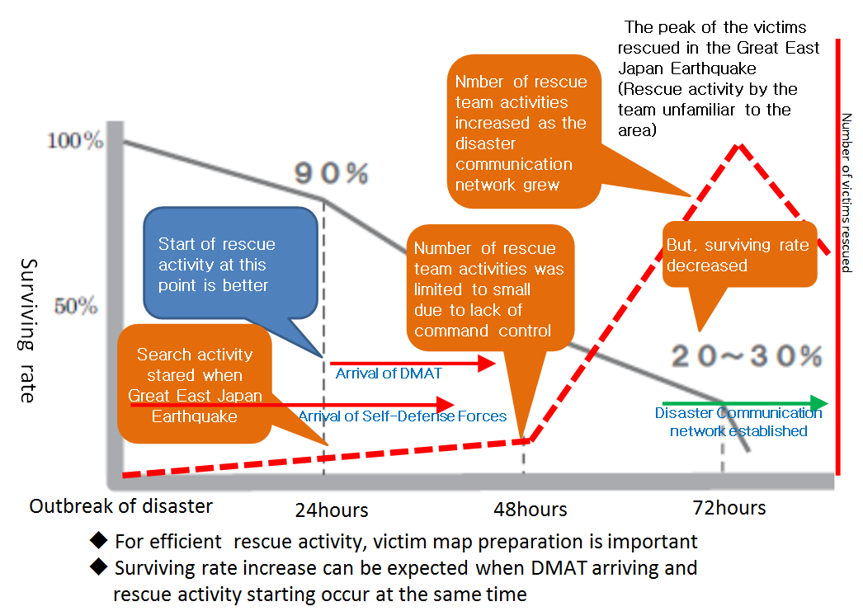

Fig. 3-1 Surviving rate and number of victims rescued by DMAT   
after the Great East Earthquake   
(The surviving rate is referred from Reference 1)

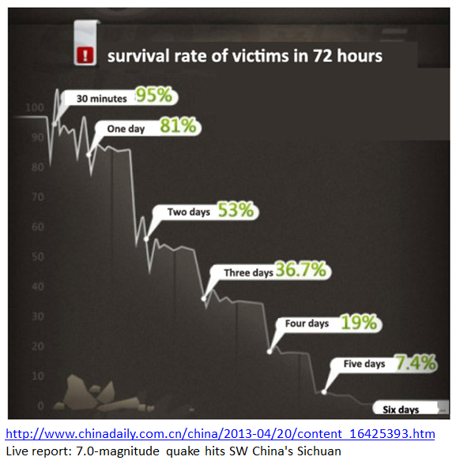

Figure-3-2 Surviving rate in the China Sichuan Earthquake

What is most needed for life-saving rescue team in the event of a disaster, to obtain accurate information required for rescue activity (such as location, symptoms and the number of victims).

This standard for the System is necessary for the implementation of such system for the activities such as rescue emergency work and is for the mobile communication system using air interface such as wireless LAN and ITS communication service such as DSRC (Dedicated Short Range Communication) and etc. Those system shall be used in general purpose in normal stage and shall be shifted to emergency mode when disaster outbreaks, and shall be used for the search and rescue activity for the victims in acute phase of the response stage.

As shown in figure 3-3 and figure 3-4 below, the necessary approaches for response stage and recovery stage are different in conjunction with availability of communication network and System shall be designed based upon this circumstances.

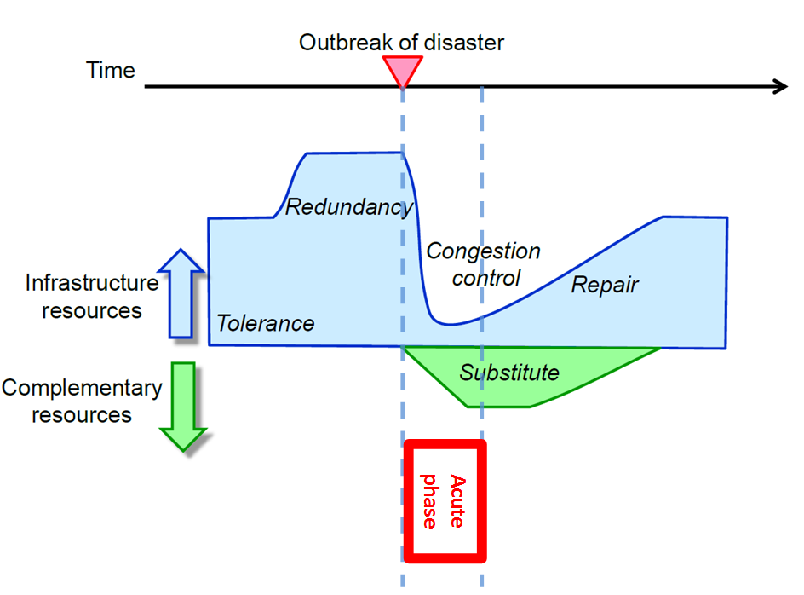

Figure 3-3 Communication resourses after the outbreak of disaster   
( Source: Reference 2 )

Fig_3-4

Figure 3-4 Necessary disaster communication system fuctions in the acute phase

a) In the acute phase (during approx. 72 hours from outbeak of disaster), the disarer information/communication system is needed mostly for;

- Gathering human victim survival and accessibility to disaster area information

- Delivering information to professional team; for rescuing, fiire fighting, emergency activities

- Delivering/sharing information among citizens/civilians; Evacuation site messages, shared safety confirmation messages, logistic messages

b) After the acute phase, this system is needed mostly for;

- Delivering/sharing information among citizens/civilians; Evacuation site messages, shared safety confirmation messages, logistic messages

- Sharing information among citizens/civilians; uploading/downloading various information not included in the above

Therefore, there shall be a governing rule mostly in acute phase to secure the use of priority to emergency activities. Most of the System is running for normal social activities during normal state and there shall be a trigger authority to command entire system to switch to emergency activity mode once an outbreak of disaster occurs.

## ii Architecture of the role mode

As stated in previous section, the necessary approaches for various recovery phases are different. However, actors and role of each actor are basically unchanged. As shown in figure 3-3 below, basic actors and their roles in the System can be identified as follows;

・Professional rescue team; roles are as follows;

- Gathering victim survival and accessibility to disaster area information

- Reporting victim survival and accessibility to disaster area information

- Accessing victim survival and accessibility to disaster area information

- Assessing victim survival and accessibility to disaster area information

・ Professional recovery activity team; roles are as follows;

- Gathering information from citizens/civilians; Evacuation site messages, shared safety confirmation messages, logistic messages.

- Reporting information from citizens/civilians; Evacuation site messages, shared safety confirmation messages, logistic messages.

- Accessing information from citizens/civilians; Evacuation site messages, shared safety confirmation messages, logistic messages.

- Assessing information from citizens/civilians; Evacuation site messages, shared safety confirmation messages, logistic messages.

・ Gathering shared/uploaded information among citizens/civilians

・ Citizens/ civilians; roles are as follows;

- Gathering information among citizens; downloading information not included in above

- Reporting information among citizens; uploading information not included in above

- Accessing information among citizens; retrieving information not included in above

Disaster information/

Communication system

(the System)

Professional rescue team (s)

Professional recovery activity team (s)

Citizens/ civilians(s)

Information/

Communication

Information/

Communication

Information/

Communication

Figure 3-5 Basic actors

As a summary of these roles, figure 3-4 below is an expression of functional architecture of role model of the System. There are three major roles of this system;

- Gathering information

- Using information for rescue activity

- Using information for citizens/civilians activity

The System shall be designed/implemented to satisfy these major roles efficiently and effectively.

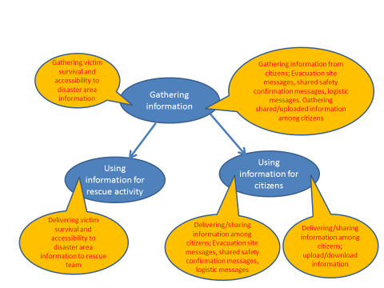

Figure 3-6 Expression of functional architecture of role model of   
disaster information/communication system

## iii Use cases requirements

The use case requirement of the System shall be defined as shown below. Use cases defined in this standard are described as informative purpose only and in the real implementation of the system implementation, some of these use cases shall be modified to fit each countries requirements and circumstances.

Each use case definition shall be described in same type of table as shown below. This particular table shows what each item means.

|  |  |
| --- | --- |
| **Use Case** | **Name of each use case** |
| Description | Brief description of system inter-action when this use case is performed |
| Actor | Who initiate to make the system start this use case into action |
| Assumptions | Condition right before this use case has been started |
| Interactions | Step by step description of system inter-actions when this use case is performed |
| Results | Description of the result right after this use case has been performed |
| Issues | The statement of issues to make this use case perform better;  System improvements  Service improvements  Performance improvements |
| UML diagram | Use case diagram.  Following is shown for the System general use case.  Citizens/ civilians(s)  Professional recovery activity team (s)  Professional rescue team (s) |

|  |  |
| --- | --- |
| **Use Case** | **Calling for help** |
| Description | The citizens/civilians initiate help call |
| Actor | Citizens/civilians |
| Assumptions | System has been running without errors.  Citizens/civilians need help. |
| Interactions | Citizens/civilians request for help by clicking on the help button.  System displays request sent status. |
| Results | Reception of request is confirmed and displayed in display field.  User can expect rescue activity. |
| Issues | Victim without network interface device cannot make request.  Victim without conscious cannot make request. |
| UML diagram | <<uses>>  <<uses>>  Citizens/civilians |

|  |  |
| --- | --- |
| **Use Case** | **Getting information** |
| Description | The citizens/civilians and professional team initiate request for information. |
| Actor | Citizens/civilians and professional team |
| Assumptions | System has been running without errors.  Citizens/civilians and professional team need information. |
| Interactions | Citizens/civilians and professional team request for information by clicking on the designated button  System displays type of information.  Citizens/civilians and professional team selects one or more type from list.  System confirms request and displays result. |
| Results | Reception of request is confirmed and displayed in display field.  Citizens/civilians and professional team use those information for their rescue and/or recovery activities. |
| Issues |  |
| UML diagram | <<uses>>  <<uses>>  Citizens/civilians  and professional teams |

|  |  |
| --- | --- |
| **Use Case** | **Reporting information** |
| Description | The citizens/civilians and professional team initiate to send/report various information. |
| Actor | Citizens/civilians and professional team |
| Assumptions | System has been running without errors.  Citizens/civilians and professional team have important information. |
| Interactions | Citizens/civilians and professional team send information by clicking on the designated button  System displays type of information.  Citizens/civilians and professional team selects one or more type from list and/or type in text messages.  System confirms reception and displays result. |
| Results | Reception of information is confirmed and displayed in display field.  Citizens/civilians and professional team can use those information, reported by other parties, for their own rescue and/or recovery activities. |
| Issues |  |
| UML diagram | <<uses>>  <<uses>>  Citizens/civilians  and professional teams |

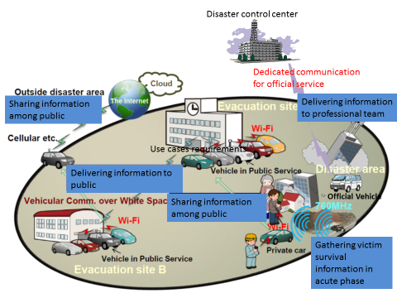

Figure 3-7 General use case models

## iv Operational scenarios

Following operational scenario can be observed when the System is in use.

Acute phase

After acute phase

References:

1) For surviving rate refer to;  
http://reposit.lib.kumamoto-u.ac.jp/bitstream/2298/25024/1/KSK0003\_081-092.pdf   
(Japanese languages only)

2) ITU-T, FG-DR&NRR, TELECOMMUNICATION STANDARDIZATION SECTOR OF ITU, Version 1.0 (05/2014), ITU-T Focus Group on Disaster Relief Systems, Network Resilience and Recovery, Requirements for Network Resilience and Recovery

# 4. Applications models

## i Gathering victim survival and accessibility to disaster area information in acute phase and Delivering information to professional team

This application mode is for acute phase and there are two sub models which are "ad-hoc mode" and "organized mode". The UML use case diagrams are shown below for better understanding of this model.

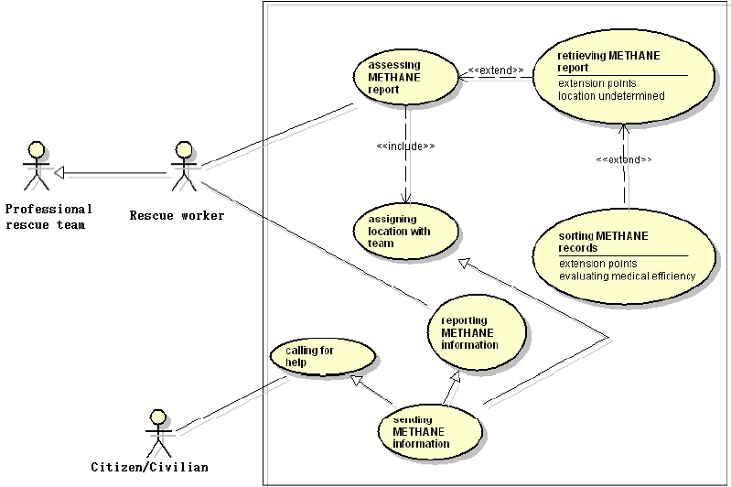

Figure 4-1 Ad-hoc mode sub model

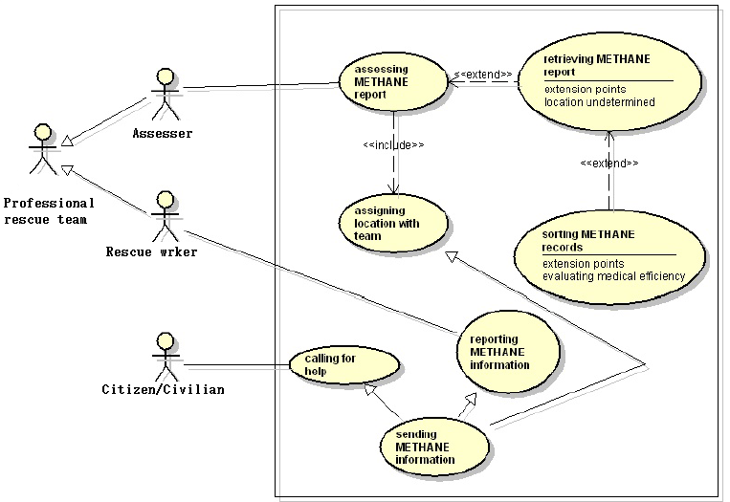

Figure 4-2 Organized mode sub model

For the METHANE format, visit following url for more information.

<https://www.gov.uk/government/publications/methane-properties-uses-and-incident-management>

# 5. Network interface requirements

## i Kind of network interfaces

In some use-cases of Annex III in theses disaster, the following issues have been identified:

・ No power supply on sockets due to disruption of power line network.

・ Zero connectivity on phone call and internet access due to disruption of communication network or power loss.

・ Almost impossible to locate missing family members among hundreds and thousands of evacuation sites.

・ Inefficient operations of rescue supply distribution and priority control of emergency medical service (triage) due to lack of information.

・ Quasi-real-time video and/or photo information of disaster damages is impossible to be distributed to necessary rescue and/or governing organizations.

It turned out that communication was literally vital in a matter of life and death, and the electric power drove that communication. Vehicles would have gas, dynamo (electric generator) and battery. There are emerging activities to introduce radio communication modules such as following network interfaces.

1) Wireless LAN

2) GNSS (Global Navigation Satellites System)

3) DSRC (Dedicated Short Range Communications)

4) White space

5) Satellite

6) Cellular

## ii Communication Interface in Network

WLAN is one of the most popular radio devices. It is also gaining attention around automobile industry. For instance, Toyota has recently announced that vehicles have WLAN as a standard equipment of navigation systems. With WLAN, vehicles can communicate with other vehicles, user smartphones as well as internet hotspots if it turns available.

The major constraints of commercial WLAN are point-to-multipoint link (AP-STAs) and link setup time. All are assuming nomadic use cases with the presence of access points. Therefore, regarding V-HUB use cases, WLAN shall have requirements below:

・ Automatic connection among vehicles, smartphones and internet hotspots.

・ High speed link setup for moving vehicles.

White Space refers to frequencies available for secondary use at locations where spectrum is not being used by licensed services, such as television broadcasting. It has been led mainly by US, UK and Singapore. Since it is capable to transmit over tens of kilometers, it would be the perfect option for communication among scattered and isolated evacuation sites. Before use of White Space, devices have to refer to the geographical White Space database in order to identify the existence of the primary users at targeted frequencies.

Since the database access mostly requires cellular network, the database may not be available or accessible in case of disasters. White Space shall have requirements below:

・ Alternative autonomous decentralized methods for finding primary users

・ Open frequencies that may limit time, area and usage



Figure 5-1. Clear to use White Space

## iii Beacon interface in Network

Sub Giga band DSRC is a beacon broadcast system developed for transportation safety. It has been developed in Japan and introduced into roadside units, vehicles and also pedestrian portable devices. Vehicles may catch the beacon in order to find people trapped under the wreckage. Also by relaying beacon broadcast among vehicles, rapid distribution of imminent tsunami alert around coastal areas can be enabled.



Figure 5-2. Use of Sub Gigaband DSRC

For those purposes Sub Giga band DSRC shall have requirements below:

・ Unique ID assignment

・ Remote on/off control

・ Communication range (300m line-of-sight, 10m under the wreck)

・ Low consumption power (3 weeks with coin battery)

・ Periodical beaconing

・ Small size

## iv Others interfaces

This proposal builds on the emerging development of communications standards that can be implement over robust WiFi and White Space bands. Critical here is to understand the information flow from evacuees and groups of people to rescue vehicles in a variety of circumstances - on the road, on vehicles, and within an evacuation center equipped with information kiosks. The high level system shall have requirements below:

・ Remote ON/OFF operation of Emergency mode

・ Capacity for tremendous amount of short message occurrence

・ Robust network protocol for possible spatial and temporal disruption of communication

・ Message delivery to node of unknown location and/or mobility

・ No end user pre-installation expected (except for professional use)

・ Counter false information distributions

# 6. Application interface requirements

Figure 7-1 show the architecture of this System. The application for disaster using general application tools, for example communication services, bulletin board, M2M communication, location services etc. over network for communication and beacon on some devices, vehicle, PC, smart phone, tablet terminal and wearable terminal.

1) Messaging

2) Web service

3) Dedicated applications

4) Commercial applications

5) E-mail service

6) Tracking

7) Streaming

8) Alerting

# 7. Architecture of V-HUB system

It is the architecture of V-HUB system based on the requirements of network interfaces and application interfaces, Figure 7-1.

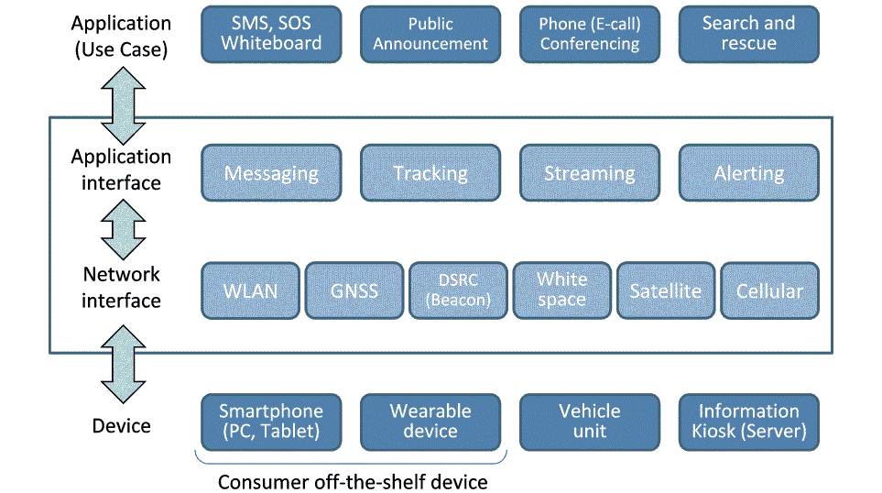

Figure 7-1 Architecture of Application in this System

### ANNEX I Disaster System Use case in Japan



Figure I-1. Disaster System Use case in Japan

## 1. Deliver messages to the evacuation site

|  |  |
| --- | --- |
| Use Case | General message delivery |
| Description | Citizens/civilians send/retrieve messages to/from vehicles. |
| Actor | (Vehicles)  (Terminal devices)  Citizens/civilians |
| Assumptions | Vehicles have web server, storage and WLAN access point.  Citizens/civilians’ terminal devices such as smart phones and PCs have web client and WLAN station. |
| Interactions | 1. Citizens/civilians connect their devices to a vehicle over WLAN. 2. Citizens/civilians access to the website locally hosted in the vehicle. 3. Citizens/civilians send/retrieve messages to/from the vehicle over the website. |
| Results | Vehicles deliver messages among citizens/civilians. |
| Issues | Automatic connection between vehicle and smartphone.  Remote ON/OFF operation of Emergency mode  No end user pre-installation expected (except for professional use) |
| Data Flow |  |

|  |  |
| --- | --- |
| Use Case | Secured message delivery |
| Description | Designated users send authenticated messages to vehicles.  Citizens/civilians retrieve authenticated messages from vehicles. |
| Actor | (Vehicles)  (Terminal Devices)  Designated users (such as authorities and news sources)  Citizens/civilians |
| Assumptions | Assumptions in general message service  A unique account has been issued to every designated user.  Vehicles maintain all account information.  All features at vehicles and devices keep secured well. |
| Interactions | 1. Designated users connect their devices to a vehicle over secured WLAN. 2. Designated users pass the authentication and access to the secured website locally hosted in the vehicle. 3. Designated users send messages to the vehicle over the secured website. 4. Citizens/civilians retrieve authenticated messages from vehicles over the designated website. |
| Results | Vehicles deliver authenticated messages from designated users to citizens/civilians. |
| Issues | Counter false information distributions |
| Data Flow |  |

|  |  |
| --- | --- |
| Use Case | Message sharing among vehicles |
| Description | Vehicles send/retrieve messages to/from each other. |
| Actor | (Vehicles) |
| Assumptions | Vehicles have web server/client, storage and WLAN access point and station. |
| Interactions | 1. Vehicles connect to each other over WLAN. 2. Vehicles send messages to each other using the web-based interface. |
| Results | Vehicles share messages among each other. |
| Issues | Automatic connection among vehicles.  High speed link setup for moving vehicles.  Capacity for tremendous amount of short message occurrence  Robust network protocol for possible spatial and temporal disruption of communication |
| Data Flow |  |

|  |  |
| --- | --- |
| Use Case | Beacon message reception |
| Description | Citizens/civilians’ beacon devices automatically send messages to vehicles. |
| Actor | (Vehicles)  (Citizens/civilians’ beacon devices) |
| Assumptions | Vehicles have M2M server, storage and beacon receiver.  Citizens/civilians’ beacon devices have beacon transmitter. |
| Interactions | 1. Citizens/civilians’ beacon devices periodically broadcast messages. 2. Vehicles near the device capture the messages. |
| Results | Citizens/civilians’ beacon devices automatically send messages to vehicles. |
| Issues | Unique ID assignment  Remote on/off control  Communication range (10m under the wreck)  Low consumption power (3 weeks with coin battery)  Periodical beaconing  Small size |
| Data Flow |  |

|  |  |
| --- | --- |
| Use Case | Beacon alert delivery |
| Description | Designated beacon devices automatically send alert messages to vehicles.  Vehicles automatically send alert messages to Citizens/civilians’ beacon devices |
| Actor | (Vehicles)  (Designated beacon devices)  (Citizens/civilians’ beacon devices) |
| Assumptions | Vehicles have M2M server, storage and beacon transceiver.  Designated beacon devices have hazard detector and beacon transmitter.  Citizens/civilians’ beacon devices have beacon receiver and hazard alarm. |
| Interactions | 1. Designated beacon devices detect hazard and then periodically broadcast alert messages. 2. Vehicles near the designated devices capture the messages and then periodically broadcast the messages. 3. Citizens/civilians’ beacon devices near the vehicles and the designated devices capture the messages and activate the alarm. |
| Results | Vehicles deliver alert messages from designated beacon devices to citizens/civilians. |
| Issues | Communication range (300m line-of-sight) |
| Data Flow |  |

|  |  |
| --- | --- |
| Use Case | Message delivery to stations |
| Description | Designated station servers automatically send/retrieve messages to/from vehicles. |
| Actor | (Vehicles)  (Designated station servers (at the evacuation site and so forth))  Citizens/civilians |
| Assumptions | Assumptions in general message service  Designated station servers have web server/client, storage, WLAN access point/station and monitor. |
| Interactions | 1. Designated station server connects to a vehicle over WLAN. 2. The station server (sends/)retrieves messages (to/)from the vehicle using the web-based interface. 3. The station server shows messages on the monitor. 4. Citizens/civilians connect their devices to the station server over WLAN. 5. Citizens/civilians access to the website locally hosted in the station server. 6. Citizens/civilians send/retrieve messages to/from the station server over the website. |
| Results | Vehicles deliver messages among citizens/civilians via station servers.  (Vehicles deliver messages among station servers.) |
| Issues |  |
| Data Flow |  |

## 2. Share messages among evacuation sites

|  |  |
| --- | --- |
| Use Case | Message sharing among stations |
| Description | Designated station servers send/retrieve messages to/from each other. |
| Actor | (Designated station servers (at the evacuation site and so forth)) |
| Assumptions | Designated station servers have web server/client, storage, whitespace communication module. |
| Interactions | 1. Designated station server connects to another station server over whitespace. 2. Both station servers send messages to each other using the web-based interface. |
| Results | Designated station servers share messages among each other. |
| Issues | Alternative autonomous decentralized methods for finding primary users  Open frequencies that may limit time, area and usage  Message delivery to node of unknown location and/or mobility |
| Data Flow |  |

## 3. Upload messages to the internet

|  |  |
| --- | --- |
| Use Case | Message delivery to the Internet |
| Description | Vehicles send messages to the server on the internet if accessible. |
| Actor | (Vehicles)  (Message servers on the internet) |
| Assumptions | Vehicles have web client, storage and WLAN station.  Message servers are accessible from internet hotspot and have web server and storage. |
| Interactions | 1. Vehicles connect to a message server through internet hotspots. 2. Vehicles upload messages to the server using the web-based interface. |
| Results | Vehicles deliver messages from citizens/civilians to servers on the internet. |
| Issues | Automatic connection between vehicle and internet hotspot. |
| Data Flow |  |

### ANNEX II Use cases of Information and Communications System using Vehicle during Disaster

|  |  |  |  |  |  |  |  |
| --- | --- | --- | --- | --- | --- | --- | --- |
| **NO** | **INPUT Nation** | **Use case Name** | **Description** | **Assumptions** | **Interactions** | **Results** | **Issues** |
| 1 | IRAN | Cell on Wheels (COW) | COW is a mobile cell site that consists of a cellular antenna tower and electronic radio transceiver equipment on a truck or trailer.  COWs can provide fully-functional service, via vehicles such as trailers, vans and trucks, to areas affected by natural disaster.  COW network backhaul communication is enabled via terrestrial microwave, satellite and wired infrastructure. | Vehicles have cellular antenna tower and electronic radio transceiver devices  User devices: Cell phones | 1. People connect their cell phones to a BTS on a vehicle over 2G/3G/LTE  2. BTS on a vehicle connect to cellular network over terrestrial microwave or satellite link  3. People connect to cellular network and can use voice telephony or send/receive data | Providing cellular network coverage in disaster areas |  |
| 2 | AFGHANISTAN | Vehicle Message Delivery | People post/get message from/to Vehicle | Vehicles should be equipped with HF, WLAN and Satellite terminals for transmitting data of the natural disaster warning system to the relevant agencies for public awareness and safety. | 1. Vehicles have equipment to transmit data to the relevant agencies for prevention of loss and damage in area exposed to natural disaster.  2. People connect their devices to the vehicle over WLAN.  3. People post/get message among people as well as natural disaster relevant bodies. | Vehicles deliver message among people as well as natural disaster relevant agencies. | Automatic connection between the vehicles end user and relevant agencies. |
| 3 | THAILAND | Idea of WiFi on vehicle cell | Survivors are able to communicate after the disaster. | 1. Vehicles, drone and networking shall be prepared.  2. Disaster information Application software on ios/android/microsoft OS installed on user device. | Survivors are able to access WiFi from WiFi vehicle cell. | Survivors are able to access WiFi to get important information to survive. | pre-installed software application required. |
| 4 | THAILAND | Mobile Communication System for Disaster Area | Rescue team/People Post and Get information via Vehicles | C2 for HQ and rescue team  - Joint Communications System for Disaster Area  - Digital Trunk Radio for rescue team  -Personal/Vehicles Tracking  -Video Streaming  -Web Conference  -COP Access  -Internet Access |  |  |  |
| 5 | THAILAND | An Cooperative Communications system  (an carrier idea) | When disaster strikes the area, most Communications system would be disrupted.  To alleviate the aftermath and deploy help to those in need, Certain communications system should be restored in timely manner.  Small cells in the size of backpack could be utilized and many of them could establish a cooperative network, which could be brought out to the field by volunteers or rescues.  Communications Backhaul is also crucial. Satellite or Microwave link on mobile could be utilized in a faster response at Main Communications Unit (Main Comm Unit, MCU) |  |  |  |  |
| 6 | THAILAND | TOT Satellite Delivery | People Sent/Receive data to/from TOT Satellite | Satellite have Transmission and Generator  User device mobile phone (Smart phone, Pcs and etc.) | 1. People connect their devices to a TOT Satellite.  2. People Sent/Receive call from your mobile to locally TOT Satellite  3. People post/get call from/to TOT Satellite | Satellite device call among people | Automatic connection between the TOT Satellite. |
| 7 | THAILAND | TOT Mobile Vehicle Delivery | People Sent/Receive data to/from TOT Mobile Vehicles | Satellite have Transmission and Generator  User device mobile phone (Smart phone, Pcs and etc.) | 1. People connect their devices to a Mobile Vehicle  2. People Sent/Receive call from your mobile to locally TOT Mobile Vehicles  3. People post/get call from/to TOT Satellite | Vehicles device call among people | Automatic connection between the TOT Mobile Vehicles. |
| 8 | PAPUA NEW GUINEA | NIL | New - Just an early idea or suggestion | Vehicles have WLAN, WiFi access points | 1. People connect there devices to the vehicle via a Wi-Fi wireless network  2. People access the internet from the vehicle over the satellite link to the central office or via the fiber connection to the surviving telecom building.  3. Incoming and outgoing messages would follow the same medium | Vehicles not only deliver messages to and from but also handle data stream (video clips of the site etc.) | Every activity would be easy and automatic.  Software configurations are needed for system setup.  Users connected on the immediately. |
| 9 | JAPAN | Temporary vehicle ad-hoc network used multi-hop communication | Network recovery by using vehicle ad-hoc network, instead of damaged area infrastructure network | ・ Vehicles equip ITS wireless communications unit (5.8GHz band, 700MHz band, etc.) that have multi-hop communication function. And the vehicles also equip Wi-Fi unit.  ・ Some vehicles also have Multi-Protocol Gateway (MPG) function. | 1. Disaster occurrence, and vehicles dispatch.  2. Locate vehicles while confirming communication quality (Rx power, Packet error rate, etc.) with the neighboring vehicle.  3. Confirm vehicle multi-hop communication link, and Wi-Fi user (smart phone user in the following figure) can communicate each other through vehicle multi-hop communication link. | ・ Reconstructing temporary vehicle ad-hoc NW, instead of damaged infrastructure.  ・ MPG selects the protocol from plural protocol (5.8 GHz band, 700 MHz band, etc.) by the communication quality for the surrounding vehicles, and changes the protocol to transmit and receive different type of packets. | ・ Electric power for the ITS wireless communication units is supplied by the battery of the vehicle.  ・ Distance between end-to-end vehicles is restricted. |
| 10 | THAILAND | Vehicular and Community Wireless Mesh routers for Disaster Emergency Communication and Preparedness | The Internet Education and Research Laboratory (intERLab) at the Asian Institute of Technology (AIT) has developed an emergency communication system which is based on small mobile routers, dubbed “DUMBONET routers”.  These DUMBONET routers can be installed either in disaster-affected villages or emergency vehicles in order to restore communication.  The DUMBONET routers collaboratively form one or more partitions of self-configuring, self-healing multi-hopped networks based on IEEE 802.11n 2.4GHz with Optimized Link State Routing capabilities.  The DUMBONET routers also contains simple, easy-to-use application services.  These include: voice over IP (VoIP), video on demand (VoD), social network app (SN) and disruption tolerant networking (DTN) services. | ・ Pre-disaster vs. Post-disaster deployments  ・ In post-disaster deployment, backup power is available (e.g. from vehicles, battery, or solar) | 1.In pre-disaster deployments, DUMBONET routers can be deployed in  one or more target areas (e.g. villages) and vehicles to provide day-to- day ‘intranet-like’ communication services for the people living in the  target communities. An optional Internet gateway can be installed,  allowing users to access, on a sharing basis, the public Internet. This  will help community people to become familiar with the technology and  utilize the available on a daily basis. When a disaster strikes, these  DUMBONET routers are ready to form self-configuring, self-healing  network when needed.  2. In post-disaster deployments, we can prepare and ship DUMBONET  routers to the disaster-affected locations. DUMBONET routers can then be installed and deployed quickly, either on vehicles, hand-carried, or on premises using a deployment guidelines. Optional Internet gateway technology (e.g. satellite internet, 3G Internet) may still be required if  3. In either cases, the DTN service available on DUMBONET routers allow us to carry information through potentially disruptive VANET or MANET networks. Client devices can deposit data (e.g. images, videos) taken from disaster-affected areas and pass the information via DUMBONET routers which are either installed on vehicles or hand-carried.  4. For long-term disaster recovery operations, DUMBONET routers can provide learning for children in the affected communities using the Video on Demand (VoD), whose contents can be updated through nodes which are attached to vehicles and act as a carrier for newer/updated video medias. | ・ intERLab has experimented with pre-disaster deployments in a few  rural villages in Thailand. The villagers in one of those communities enjoy Internet access through a shared ADSL gateway. Practices on disaster emergency responses  (e.g. VoIP call, reestablishing the network connectivity) are conducted on an occasional basis.  ・ intERLab has prepared DUMBONET routers and shipped to Nepal, in response to the recent earthquake disaster there. DUMBONET routers  were deployed mainly in hospitals for medical aids and patient communications. | intERLab continuously improves and refines the services available on the DUMBONET routers. Recent work is focused on the DTN service that allows routers equipped on the vehicles and in the village to exchange files and information more effectively when network disruptions occur. |
| 11 | PHILIPPINES | Survivor transport, victim finder, power plant, communications hub, and information kiosk using Vehicles in Disaster | ・ Vehicles play crucial roles in Disasters such as survivor transport, victim finder, power plant, communications hub, and information kiosk  ・ White Space Access is Baseline for Philippine in Wide Area Wireless Access -Free WiFi Deployment Nationwide Start 2015  ・ ‘Personal Transponders’ in White Space Bands can be viable for Practiced Evacuation and Finding of Survivors because of penetration of debris.  ・ Delay Tolerant Networks match the interactive media response of early responders and sensor networks, working with vehicles with Wide Area connections over White Space.  ・ IPTV Technology and Social Media Data Processing are crucial for Disaster Risk Reduction | ・ Emerging V2V and V2I Standard can be Modified or Simplified for Disasters Operations into a V-HUB Standard  ・ White Space Access is Baseline for Philippine in Wide Area Wireless Access- Free WiFi Deployment Nationwide Start 2015  ・ IPTV and Social Media Data are be crucial for Disaster Risk Reduction. Combined Aerial Imaging and Transponder Locating, Monitoring and Searching.  ・ First Responders Kiosk will Provide Near Cloud Services, Power and Water, and Interactive Communications to Survivors  ・ White Space Bands in 700 MHz will be crucial for Practiced Evacuation and Finding of Survivors, because of penetration of debris. | 1. Disasters Operations using V2V and V2I Communications.  2. White Space Access is Baseline for Philippine in Wide Area Wireless Access- Free WiFi in Disaster Area.  3. IPTV and Social Media Data are be crucial for Disaster Risk Reduction. Combined Aerial Imaging and Transponder Locating, Monitoring and Searching via Vehicles and/or UVA/Drone.  4. First Responders Kiosk will Provide Near Cloud Services, Power and Water, and Interactive Communications to Survivors.  5. White Space Bands in 700 MHz will be crucial for Practiced Evacuation and Finding of Survivors, because of penetration of debris. |  |  |

### ANNEX III List of Suggestion by Use cases of V-HUB

\*QA: = Answer of Questionnaire Number

|  |  |  |  |  |  |  |  |  |  |  |
| --- | --- | --- | --- | --- | --- | --- | --- | --- | --- | --- |
| **ID** | **Title\*** | **Organization** | **Country** | | **Type of use case** | **Vehicle to User device** | **Vehicle to Vehicle** | **Vehicle to Infrastructure** | **Other Feature** | **Application** |
| USE01 | Calling for help | TTC | JPN | - Calling for Help | | - WLAN |  |  | - Auto activation | - SOS Signaling |
| USE02 | Getting information | TTC | JPN | - Getting Information | | - WLAN |  |  |  | - Searching information |
| USE03 | Reporting information | TTC | JPN | - Reporting Information | | - WLAN |  |  |  | - Reporting information |
| USE04 | General message delivery | TTC | JPN | - Getting Information  - Reporting Information | | - WLAN |  |  | - Auto connection  - Remote activation | - SMS  - White board info for survival |
| USE05 | Secured message delivery | TTC | JPN | - Getting Information  - Reporting Information | |  |  |  | - Digital Signature | - Public announcement |
| USE06 | Message sharing among vehicles | TTC | JPN | - Getting Information  - Reporting Information | |  | - WLAN |  | - Auto and Immediate connection  - Robust network protocol | - SMS  - White board  - Public announcement  - Tracking  - Alerting |
| USE07 | Beacon message reception | TTC | JPN | - Getting Information | | - Beacon |  |  | - Remote activation | - Tracking |
| USE08 | Beacon alert delivery | TTC | JPN | - Getting Information  - Reporting Information | | - Beacon |  |  |  | - Alerting |
| USE09 | Message delivery to stations | TTC | JPN | - Reporting Information | |  |  | - WLAN |  | - SMS  - White board  - Public announcement  - Tracking  - Alerting |
| USE10 | Message sharing among stations | TTC | JPN | - Reporting Information | |  |  | - White space | - Primary user detection | - SMS  - White board  - Public announcement  - Tracking  - Alerting |
| USE11 | Message delivery to the Internet | TTC | JPN | - Reporting Information | |  |  | - WLAN | - Auto and Immediate connection | - SMS  - White board  - Public announcement  - Tracking  - Alerting |
| USE12 | A smart phone display transition in ambulance request case | TTC | JPN | - Calling for help | |  |  |  |  | - e-call |
| USE13 | A system configuration to process the rescue request information | TTC | JPN | - Getting Information  - Reporting Information | |  |  |  |  | - e-call |
| USE14 | Cell on wheels (COW)  <QA.1> | The Ministry of ICT | IRN | - Calling for Help  - Getting Information  - Reporting Information | | - Cellular |  | - SAT  - Terrestrial microwave  - Wired |  | - Phone |
| USE15 | Vehicles message delivery  <QA.2> | ATRA | AFG | - Getting Information  - Reporting Information | | - WLAN |  | - SAT  - HF | - Auto connection | - Data  - SMS |
| USE16 | Idea of wifi on vehicle cell  <QA.3> | CAT Telecom Public Company Limited | THA | - Getting Information  - Reporting Information | | - WLAN |  | - SAT |  | - Info for survival |
| USE17 | Mobile communication systems for disaster area  <QA.4> | National Disaster Warning Center | THA | - Calling for Help  - Getting Information  - Reporting Information | | - WLAN  - Cellular |  | - SAT  - Trunked radio |  | - Phone  - SMS  - Streaming  - Tracking  - Internet |
| USE18 | TOT satellite Delivery  <QA.5> | TOT | THA | - Getting Information  - Reporting Information | | - WLAN |  | - SAT |  | - Phone |
| USE19 | TOT mobile vehicle delivery  <QA.6> | TOT | THA | - Getting Information  - Reporting Information | | - WLAN |  | - Cellular |  | - Phone |
| USE20 | An cooperative communications system. (an early idea)  <QA.7> | TOT PCL | THA | - Getting Information  - Reporting Information | | - Small cell | - Small cell | - SAT  - Microwave |  |  |
| USE21 | NIL  <QA.8> | NICTA | PNG | - Calling for Help  - Getting Information  - Reporting Information | | - WLAN |  | - SAT  - Wired | - Auto and Immediate connection | - SMS  - Streaming |
| USE22 | Temporary Vehicle ad-hoc network used multi-hop communication  <QA.9> | OKI | JPN | - Calling for Help  - Getting Information  - Reporting Information | |  | - DSRC  - WLAN | - DSRC  - WLAN | - MPG | - Network recovery |
| USE23 | Vehicular and community wireless mesh routers for disaster emergency communication and preparedness  <QA.10> | intERLab AIT | THA | - Calling for Help  - Getting Information  - Reporting Information | | - WLAN | - WLAN | - SAT  - Cellular  - Wired | - OLSR  - DTN | - Internet  - Phone  - Streaming |
| USE24 | Survivor transport, victim finder, power plant, communications hub, and information kiosk using Vehicle in Disaster  <QA.11> | Ateneo Univercity | PHL | - Calling for Help  - Getting Information  - Reporting Information | | - Beacon  - WLAN | - White Space  - WLAN | - White Space  - WLAN |  | - IPTV  - KIOSK  - Near Cloud Services |

### APPENDIX I

Example of a smart phone display transition   
in ambulance request case in Japan

(This appendix does not form an integral part of this System.)

In a system current system under study in Japan, named as the Net119, GPS location information in users’ smart phones is assumed to be transferred automatically when “Net119” button is clicked. In case, users’ smart phones cannot have GPS location information, e.g. within a building, the location information of cellular wireless base is used. Furthermore, the local fire/ambulance control centre operator can ask the caller as to their location through the “chat” function in a similar way as done by the Skype. The same applies to a personal computer, which does not have a GPS location information capability.

Figure I.1 illustrates the transition in smart phone display during an ambulance request case.

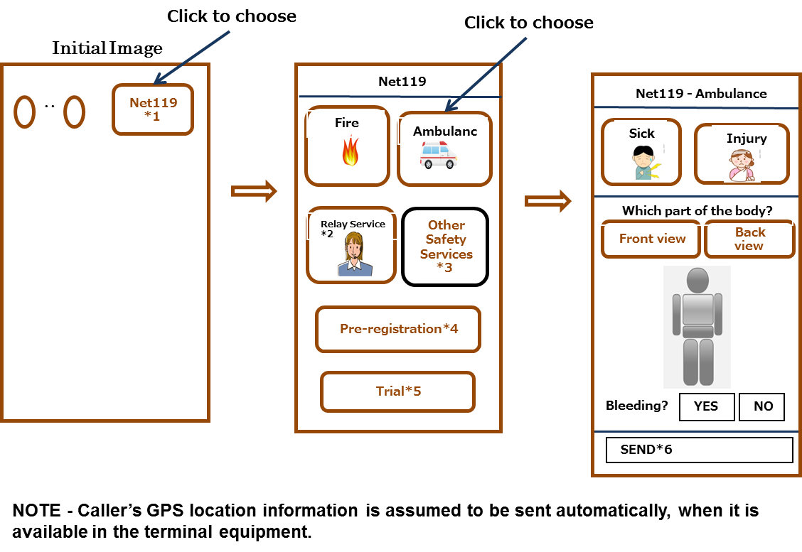

Figure I.1 – Example of smart phone display transition in ambulance request notification

Legend:

\*1 Net119: Japan’s name given to the emergency rescue request system for fire and ambulance request

\*2 Relay service: Click in case people with hearing and speaking difficulties want to ask the help of a Communication Assistant (CA) at a Telecommunication Relay Service Center.

\*3 Other safety services: For further study, for example, police, highway patrol, gas leakage, emergency medical services during night, holidays or week-end. Our current Net119 service in Japan does not provide access to these services yet.

\*4 Pre-registration: Our current Net119 system assumes that potential users to pre-register their names, gender, year of birth, home address, preferred Telecom Relay Service Center (optional), chronic disease (optional) and home doctor or hospital (optional). This was to relieve users from inputting fixed information in case of emergency in the interest of time. This would also prevent tampering with the system by malicious users.

\*5 Trial: This is for users to train themselves to get used to using the system.

\*6 SEND: This button can be clicked anytime, even before all the information is not completely input by the user, to send the information already clicked by the user to the appropriate recipient agencies.

### APPENDIX II

Example of a system configuration   
to process the rescue request information in Japan

(This appendix does not form an integral part of this System.)

The Figure II.1 illustrates a system configuration in Japan to process the rescue request information specified in this Recommendation.

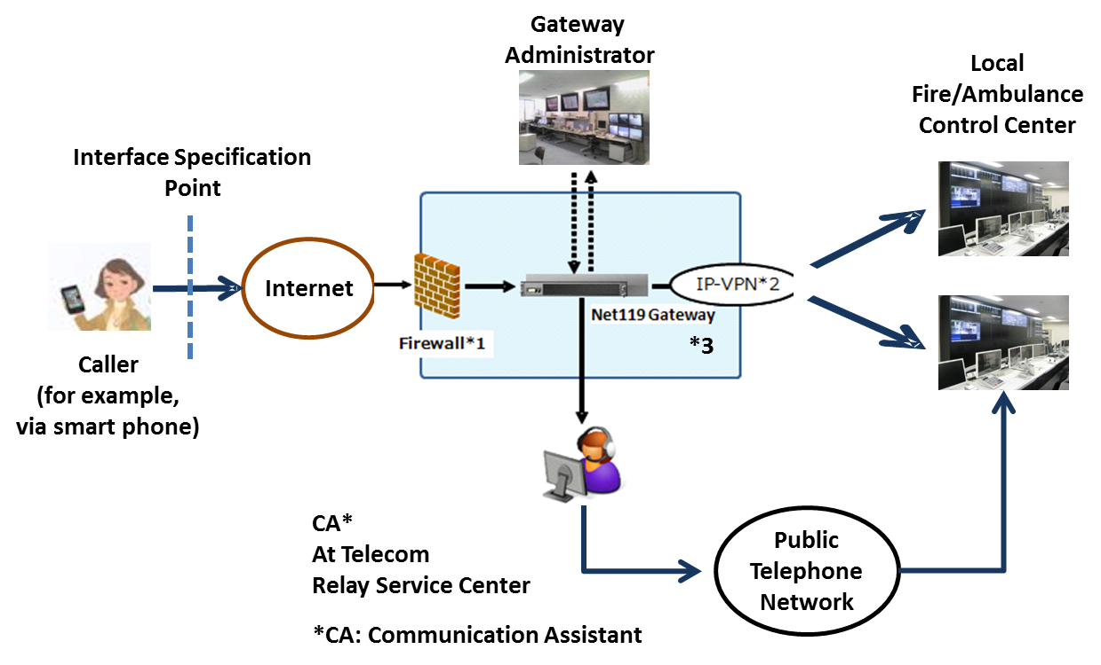

Figure II-1. Example of a system configuration   
to implement an emergency notification system

Legend:

\*1 Firewall: It serves to protect the Net119 Gateway and the Local Fire/Ambulance Control Centre from virus and malicious access from the Internet.

\*2 IP-VPN: Internet Protocol based Virtual Private Network, which sends information from Net119 Gateway to Local Fire/Ambulance Control Centres.

\*3 Net119 Gateway: Its functions are as follows:

Protection of Local Fire/Ambulance Control Centres against spam mails and other malicious access from the Internet

Pre-registration acceptance check and storage

Routing of a call to an appropriate Fire/Ambulance Control Centre based on the location information from the caller’s GPS information

Routing a call to an appropriate Telecom Relay Service Centre based on pre-registered information.

\_\_\_\_\_\_\_\_\_\_\_\_\_\_\_\_\_\_\_\_